Integrated Energy Resource Master Plan (IERMP)
25 July 2025

Submitted to the Ministry of Energy and Mineral Development

25 July 2025

Submitted to the Ministry of Energy and Mineral Development

Demand forecast report

Demand forecast report


Contributors
This report was prepared by:

Economic Consulting Associates Limited
41 Lonsdale Road, London NW6 6RA,
United Kingdom
tel: +44 20 7604 4546
fax: +44 20 7604 4547
www.eca-uk.com


Norconsult AS
Vestfjordgaten 4, 1338 Sandvika.
Norway
+ 47 67 57 10 00
www.norconsult.com

Research for Transformation and Development
Plot 8-10 Kampala Road, Uganda House, 5th Floor,
P.O. Box 25582, Kampala,
Uganda
+256-776-130913
www.rtdug.org

This report (including any enclosures and attachments) has been prepared for the exclusive use and benefit of the Ministry of Energy and Mineral Development Uganda and solely for the purpose for which it is provided. Unless we provide express prior written consent, no part of this report should be reproduced, distributed, or communicated to any third party. We do not accept any liability if this report is used for an alternative purpose from which it is intended, nor to any third party in respect of this report.

Contents
Contributors 1
Contents 2
Tables and figures 3
Abbreviations and acronyms 7
1 Introduction 8
2 Historical energy and electricity demand 10
2.1 Historical primary energy supply and consumption 10
2.2 Historical electricity demand 13
3 Forecasting approach 19
3.1 Overview of demand forecasting approach 20
3.2 Typical demand forecasting methods 20
3.3 Energy demand forecasting approach 22
3.4 Electricity demand forecasting approach 26
4 Demand forecast scenarios and inputs 34
4.1 Scenario definition 34
4.2 Economic and financial assumptions 35
4.3 Average electrical and non-electrical energy consumption per household 40
4.4 Disaggregation of final energy consumption by fuel 48
4.5 Power sector assumptions 48
4.6 Summary of input assumptions by scenario 56
5 Demand forecast, 2024-2050 59
5.1 Energy demand forecast, 2024-2050 61
5.2 Electricity demand forecast, 2024-2050 68
5.3 Comparison with previous demand forecasts 81
Annexes 84
A1 Review of previous demand forecasts 84
A2 2024-2050 Demand forecast 91
A2.1 Energy demand forecast by sector and type of fuel 91
A2.2 Electricity demand forecast 98
A3 Demand forecast model 105
A4 Statistical results from the regression analysis 110
A4.1 Criteria used in the analysis 110
A4.2 Residential econometric equation 110
A4.3 Commercial sales econometric equation 111
A4.4 Medium industries sales econometric equation 112
A4.5 Unsuccessful specifications considered in the analysis 112

Tables and figures
Tables
Table 1 Key electricity data 13
Table 2 Customer number by tariff category 15
Table 3 Types of demand forecasts by use in the electricity sector 19
Table 4 Policy targets for electricity access 39
Table 5 Type of lamps used in households (% of total households) 40
Table 6 Energy demand for lighting per household 41
Table 7 Energy consuming appliances used by households 41
Table 8 Households energy sources for cooking (% of total households per region) 43
Table 9 Economic cost assumptions to assess least cost cooking option 44
Table 10 Average electricity requirements for cooking per household 48
Table 11 Assumed ratios of non-electricity fuels to biofuel and waste by sector 48
Table 12 Total number of customers by scenario (millions of customers) 49
Table 13 Transmission and distribution losses by scenario (% of incoming energy) 51
Table 14 Additional electricity exports by scenario 52
Table 15 Probability-adjusted step-loads by scenario (capacity requirement in MW) 53
Table 16 Summary of input assumptions by scenario 56
Table 17 Energy demand forecast, 2024-2050 59
Table 18 Electricity demand forecast, 2024-2050 60
Table 19 Load forecast by sub-region 78
Table 20 Load forecast by sub-region 80
Table 21 Summary of previous demand forecasts – peak demand 84
Table 22 Summary of previous demand forecasts – energy demand 84
Table 23 Grid Development Plan base scenario assumptions 86
Table 24 Other demand and supply assumptions for NDP III and Vision 2040 scenario 88
Table 25 Energy demand forecast by sector and in total, 2024-2050 91
Table 26 Energy demand forecast by fuel and in total, 2024-2050 94
Table 27 Electricity demand forecast, 2024-2050 98
Table 28 Electricity sales forecast, 2024-2050 101
Table 29 Statistical results for the residential equation 110
Table 30 Statistical results for the commercial sales equation 111
Table 31 Statistical results for the medium industries sales equation 112
Table 32 Unsuccessful models considered in the analysis 113

Figures
Figure 1 Overall approach for the development of the IERMP in Uganda 8
Figure 2 Historical primary energy supply and consumptions, 2010-2023 10
Figure 3 Historical primary energy consumption by sector, 2010-2023 11
Figure 4 Historical primary energy consumption by fuel source, 2010-2023 11
Figure 5 Overview of Uganda’s energy system by fuel and sector, 2021 12
Figure 6 Overview of Uganda’s energy system by fuel and sector, 2000-2021 12
Figure 7 Historical electricity sales and system peak demand, 2010 - 2023 14
Figure 8 Historical electricity demand growth, 2010 - 2023 14
Figure 9 Historical electricity sales by tariff category, 2010 - 2023 15
Figure 10 Umeme customers by tariff category, 2021 16
Figure 11 Historical electricity access rates, 2000-2022 16
Figure 12 Average, maximum and minimum total demand by hour 17
Figure 13 Monthly maximum system and domestic demand, 2023 18
Figure 14 Load curve, May 2024 18
Figure 15 Classification of demand forecast methods 21
Figure 16 Forecasted services sector energy intensity (excluding electricity use) 24
Figure 17 Forecasted industrial sector energy intensity (excluding electricity use) 25
Figure 18 Forecasted other sector energy intensity (excluding electricity use) 26
Figure 19 Backcast with residential econometric equation 28
Figure 20 Backcast with commercial sector econometric equation 29
Figure 21 Backcast with medium industries econometric equation 30
Figure 22 Forecast electrical energy intensity for large and extra large industrial sales 31
Figure 23 Real total GDP growth rate assumptions by scenario 36
Figure 24 Historical and forecast GDP composition 36
Figure 25 Historical and forecast inflation rates 37
Figure 26 Historical and forecast exchange rates 37
Figure 27 Historical and forecast population estimates 38
Figure 28 Historical and forecast average household size 39
Figure 29 Levelised economic cost of cooking per household 46
Figure 30 Forecast fuel use for cooking (% of total households) 47
Figure 31 Average tariffs by customer category 50
Figure 32 Historical network losses (% of incoming energy to the grid) 51
Figure 33 Historical and forecast number of vehicles in circulation 54
Figure 34 Historical and forecast load factor 55
Figure 35 Hourly load profile forecasting process 56
Figure 36 Final energy consumption forecast by scenario 2024-2050 61
Figure 37 Final energy consumption forecast growth by scenario 2024-2050 62
Figure 38 Final energy consumption by type of fuel – Base transition scenario 63
Figure 39 Final energy consumption by type of fuel – Tenfold growth strategy scenario 63
Figure 40 Final energy consumption by type of fuel – Delayed transition scenario 64
Figure 41 Final energy consumption by type of fuel – Policy targets scenario 64
Figure 42 Final energy demand forecast – Residential sector 65
Figure 43 Final energy demand forecast – Services sector 66
Figure 44 Final energy demand forecast – Industrial sector 66
Figure 45 Final energy demand forecast – Transport sector 67
Figure 46 Final energy demand forecast – Other sectors 68
Figure 47 Sent-out electrical energy demand forecast, 2024-2050 69
Figure 48 Compound annual growth rate of sent-out energy demand by scenario 69
Figure 49 Sent-out peak demand forecast 2024-2050 70
Figure 50 Compound annual growth rate of sent-out peak demand by scenario 70
Figure 51 Load factor forecast 2024-2050 71
Figure 52 Load profile for an average day in 2050 by scenario, % of peak demand 72
Figure 53 Sales forecast – Domestic category 73
Figure 54 Sales forecast – Commercial category 73
Figure 55 Sales forecast – Medium industries category 74
Figure 56 Sales forecast – Large industries category 75
Figure 57 Sales forecast – Extra-large industries category 75
Figure 58 Sales forecast – Streetlighting category 76
Figure 59 Sales forecast – Electric vehicles category 76
Figure 60 Consumer’s mix forecast by scenario 77
Figure 61 Final energy consumption forecast comparison 82
Figure 62 Electricity sent-out energy demand and peak demand forecast comparison 83
Figure 63 Energy and peak demand forecast from previous MEMD forecasts 85
Figure 64 Total peak demand (MW) outturn versus previous demand forecasts 85
Figure 65 Total energy demand (GWh) outturn versus previous demand forecasts 86
Figure 66 Grid Development Plan 2023-40 Peak Demand Forecast – Base case 87
Figure 67 Grid Development Plan 2023-40 Energy Demand Forecast (GWh) – Base case 87
Figure 68 Electricity demand by sector in the ETP, 2010-2050 89
Figure 69 Total final consumption by sector and by fuel in the ETP, 2021-2050 89
Figure 70 Gross energy consumption forecast (GWh) - Generation Plan Report (2015) 90
Figure 71 Peak demand forecast (MW) - Generation Plan Report (2015) 90
Figure 72 Demand forecast model cover tab 105
Figure 73 Demand forecast model summary tabs 106
Figure 74 Flow-chart of the demand forecast model 109

Abbreviations and acronyms
AfDB | African Development Bank
BaU | Business as Usual
CUL | CNOOC Uganda Limited
DSM | Demand side management
EAPP | Eastern African Power Pool
ECA | Economic Consulting Associates
EE | Energy Efficiency
ERA | Energy Regulatory Authority
ESIA | Environmental and Social Impact analysis
ETP | Energy Transition Plan
GDP | Grid Development Plans
HIS | Householder Income and Expenditure Survey
IEA | International Energy Agency
IRP | Integrated Resource Plan
IERMP | Integrated Energy Resource Master Plan
LFO | Light Fuel Oil
LPG | Liquefied Petroleum Gas
MEMD | Ministry of Energy and Mineral Development
MEPS | Minimum energy performance standards
NDC | Nationally Determined Contribution
NDP | National Development Plan
NEP | National Energy Policy
PPA | Power Purchase Agreement
PPP | Public-Private Partnerships
PS | Permanent Secretary
REP | Renewable Energy Policy
RES | Renewable energy source
RTD | Research for Transformation and Development Uganda
SG&A | Sales, General, and Administrative
UBOS | Uganda Bureau of Statistics
UEDCL | Uganda Electricity Distribution Company Limited
UEGCL | Uganda Electricity Generation Company Limited
UETCL | Uganda Electricity Transmission Company Limited

Introduction
The Demand forecast report has been prepared by Economic Consulting Associates (ECA), Norconsult AS and Research for Transformation and Development Company (RTDC) for the Development of an Integrated Energy Resource Plan/Masterplan (IERMP) study for Uganda’s Energy Sector. This report aims to analyse Uganda’s historical energy and electricity consumption to identify trends, consumer behaviour, and the underlying key determinants of demand to forecast the expected energy and electricity demand in Uganda for the IERMP. The forecast considers four scenarios which are defined though a combination of economic, financial, and technical variables representing different pathways for Uganda’s energy sector to implement a transition to a high-income low-carbon economy.
The overall approach to develop the IERMP Uganda is illustrated in Figure 1. This Demand forecast report is part of the Preparatory studies needed for the development of the IERMP. Other Preparatory studies include the DSM and EE options assessment, and the Resource assessment, which were developed in parallel to this report.
Figure 1 Overall approach for the development of the IERMP in Uganda
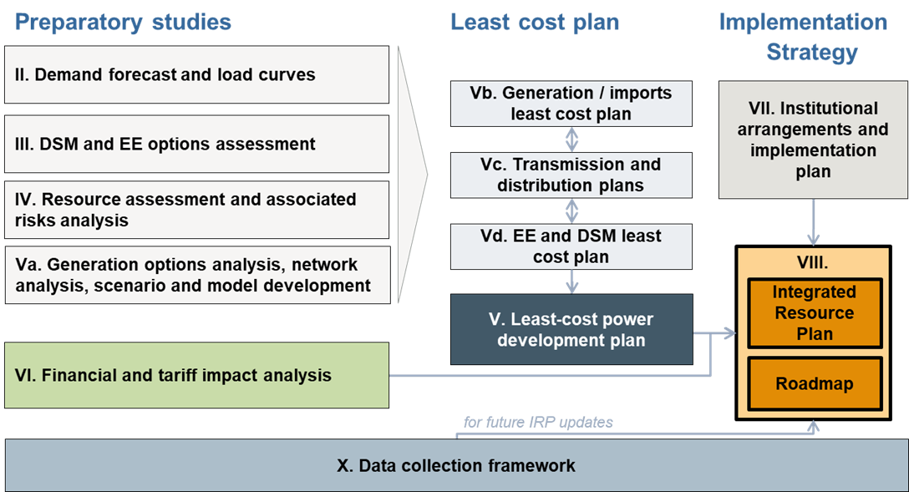
Source: ECA
The structure of the Demand forecast report is as follows:
Section 0 | Summarises the historical evolution of primary energy demand and electricity demand by sector as well as key characteristics of current demand, ongoing trends and new developments to inform the demand forecast.
Section 3 | Specifies the forecasting methodology used for the energy and electricity demand forecasts, presenting the rationale behind the approach chosen as well as the equations derived for forecasting the demand of each sector.
Section 4 | Defines the scenarios guiding the demand forecasts for energy and electricity as well as the input assumptions used for the development of the forecasts.
Section 5 | Presents the results of the primary energy demand and electricity demand forecasts for the period 2024-2050 by scenario for each sector, customer category and in total.

Historical energy and electricity demand
Uganda's rapidly growing economy and ambitious plans for development are driving an urgent and increasing demand for electricity and other forms of energy. The country’s current energy system remains relatively under-developed, with nearly 90% of final energy consumption met by burning solid bioenergy such as wood and charcoal. The remaining 10% of final energy consumption is mainly met by oil and hydro energy resources.
As of 2021, households accounted for about 61% of final energy consumption, followed by industry (22%), public services (9%), and transportation (7%).
Electricity access is still low (at around 45%) despite the government programmes to increase electrification over the past years. The total sales of electricity to consumers connected to the national grid reached 4,330 GWh in 2023 and the system’s peak demand in 2023 was 435 MW.
The following subsections analyse historical energy and electricity consumption to identify trends, consumer behaviour, and the underlying key determinants of demand to inform the development of the demand forecast.

Historical primary energy supply and consumption
The total primary energy supply in Uganda grew at an average rate of 6% per year, from 539 PJ in 2010 to 986 PJ in 2023, as shown in the figure below. An average of 70% of the energy was consumed by end users and the remaining 30% was lost as system losses, losses for the transformation of energy products and for the energy sector own use.
Figure 2 Historical primary energy supply and consumptions, 2010-2023
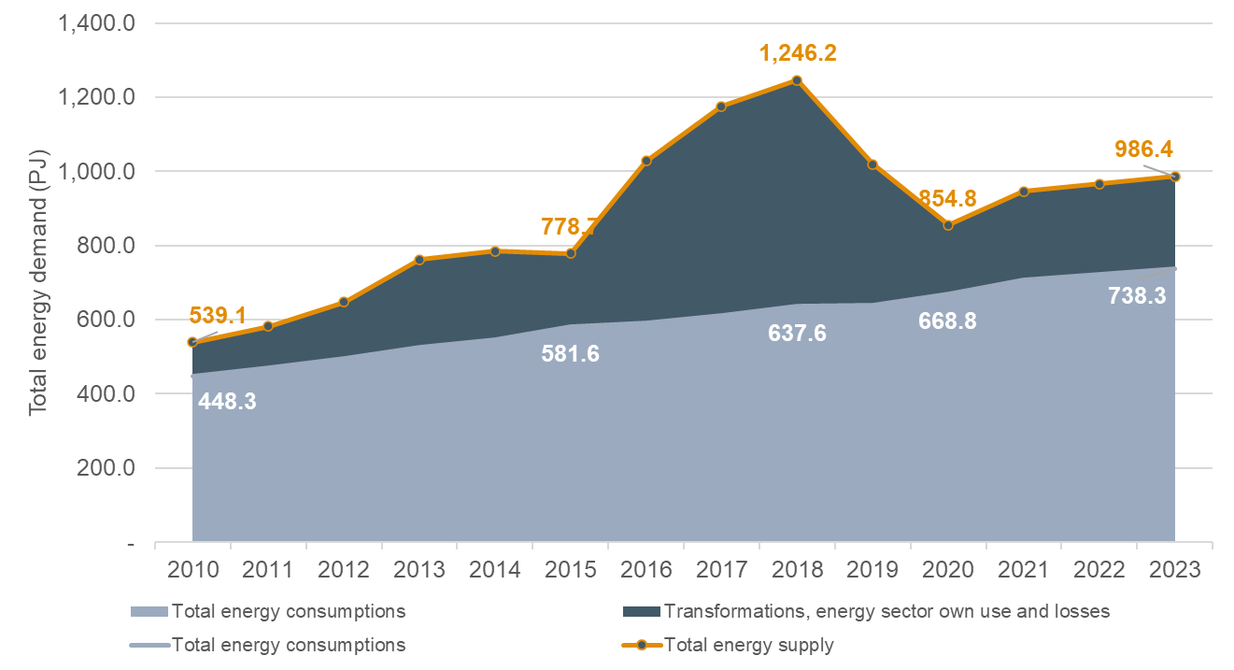
Source: Uganda 2023 Energy Policy Review and Uganda Energy Transition Plan, IEA, 2023
As of 2021, households accounted for about 61% of final energy consumption, followed by industry (22%), public services (9%), and transportation (7%), shown in the figure below. In 2021, total final consumption was around 0.37 toe per capita, up from 0.31 toe in 2000.
Figure 3 Historical primary energy consumption by sector, 2010-2023
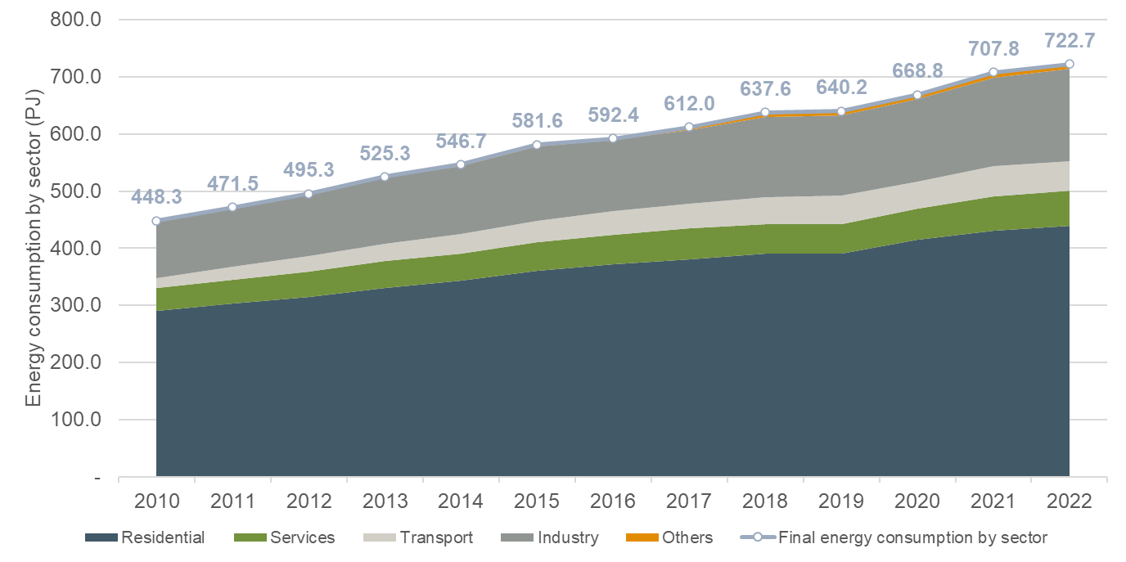
Source: Uganda 2023 Energy Policy Review and Uganda Energy Transition Plan, IEA, 2023
Uganda’s total final energy consumption by fuel source stood at 708 PJ in 2021, with bioenergy, oil products and electricity making up 87%, 11% and 2%, respectively. The consumption of biomass dominates the total consumption mix and almost doubled from 293 PJ in 2000 to 628 PJ in 2021. Despite the policy targets to switch consumption from bioenergy to other fuels, Uganda has not seen a significant shift from bioenergy to modern fuels in its final energy consumption mix. In 2000, bioenergy accounted 93% of total energy consumption and in 2021 87% of total energy consumption.
Figure 4 Historical primary energy consumption by fuel source, 2010-2023
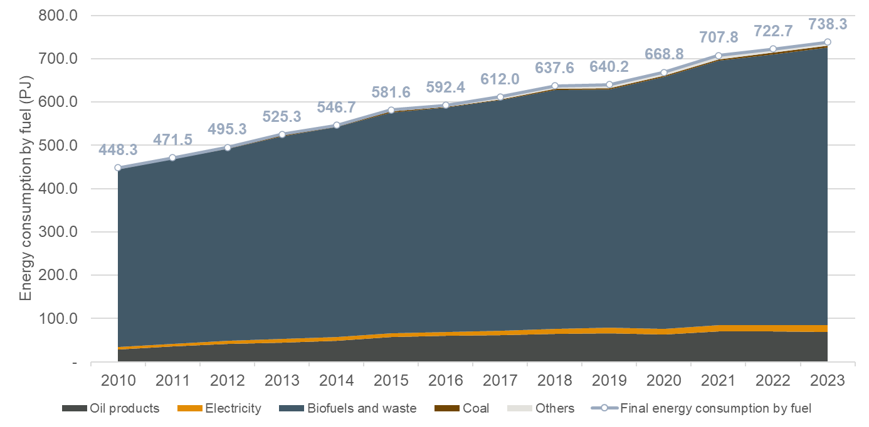
Source: Uganda 2023 Energy Policy Review and Uganda Energy Transition Plan, IEA, 2023
An overview of Uganda’s energy system by fuel and sector for 2021 is shown in the figure below. Electricity accounted for less than 2% of Uganda’s energy demand in 2021, despite electricity consumption growing more than fivefold over the last 20 years. Electrification rates are still low constraining the consumption of electricity. Peak domestic demand reached 785 MW in 2021. According to IEA, by 2040, electricity is expected to rise to become the single largest source of energy consumed, growing to reach 56% of total final consumption by 2050.
Figure 5 Overview of Uganda’s energy system by fuel and sector, 2021
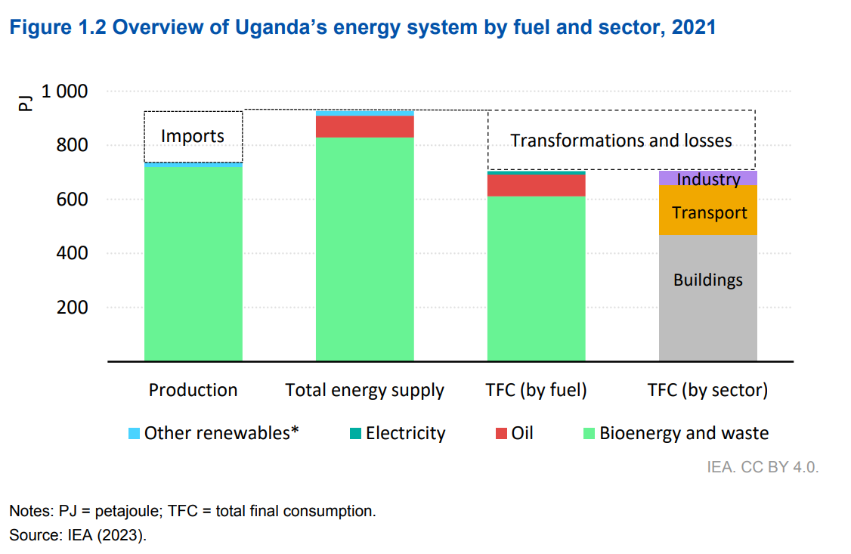
Notes: PJ = petajoule | TFC = total final consumption. Source: Uganda 2023 Energy Policy Review
As shown in the figure below, bioenergy dominates the energy supply mix. Total final consumption, and buildings are the primary demand sector. Continuous modernisation is needed to provide sustainable and reliable energy and electricity supply to a growing population and economy.
Figure 6 Overview of Uganda’s energy system by fuel and sector, 2000-2021
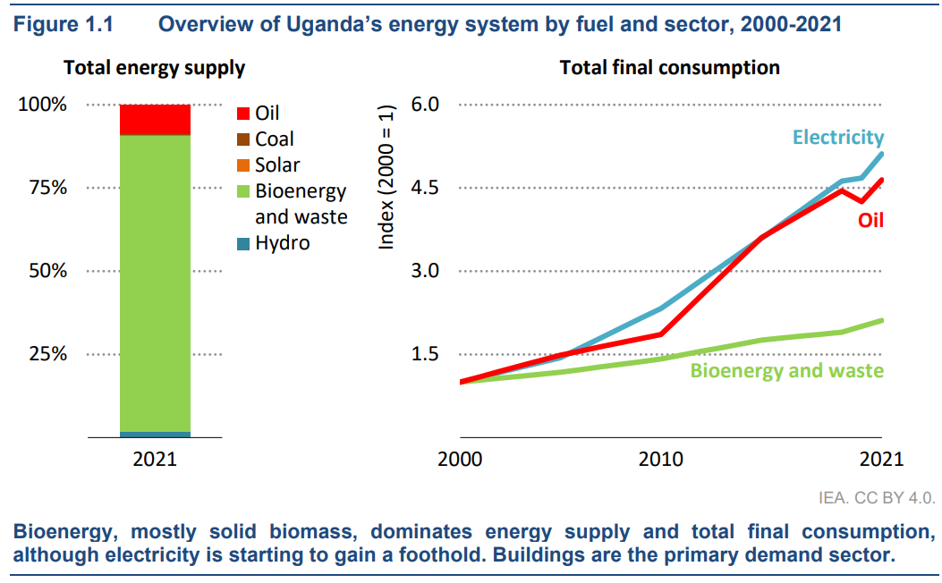
Source: Uganda Energy Transition Plan, IEA, 2023
As identified by the Uganda ETP (2023), key emerging trends and policy targets regarding developments in the country’s energy sector are:
- Growing demand for oil largely coming from the transport sector. Since 2010, Uganda has experienced a 2.5-fold surge in oil consumption, driven by an increasing number of vehicles on the road. Additionally, with the opening of the Tilenga and Kingfisher oil fields in 2025, Uganda is set to become an oil producer and exporter for the first time.
- A noticeable uptick in coal consumption in the cement and steel industries in the last five years, with specific requirements for high heat and coal as a coking reagent.
- Electricity demand grows faster than any fuel in the ETP, with generation accelerating from 5 TWh today to 200 TWh in 2050, substituting for biomass use and providing 56% of total final consumption by the end of the period. This is driven by the targets to provide universal access to electricity and cleaner cooking by 2030.
- There are future plans to import natural gas from Tanzania, which will encourage some industries to switch to gas thereby helping to reduce emissions.

Historical electricity demand
In 2023, Uganda’s electricity generating capacity reached over 1,346 MW, having increased significantly from about 320 MW in 2002. This greatly exceeded 2021 peak demand (785 MW) by a margin of around 58%. The table below provides an overview of the key electricity demand data in Uganda as of 2021.
Table 1 Key electricity data
Key data | As of 2021
Electricity net exports | 0.40 TWh (imports 0.03 TWh, exports 0.43 TWh)
Peak domestic demand | 785 MW
Electricity consumption | 3.8 TWh  - Residential 22%  - Industry 66%  - Commercial 12%
Source: Uganda 2023, Energy Policy Review, IEA

Historical electrical energy and peak demand
The total sales of electricity to consumers connected to the national grid reached 4,330 GWh in 2023, which is a 106% and 41% increase from 2013 and 2018, respectively. The system peak demand, grew from 435 MW in 2010 to 988 MW in 2023, showing a significant increase of 127%. The historical electricity sales and system peak demand from 2010 to 2023 is shown in Figure 6.
According to Uganda 2023 Energy Policy Review, the current electricity sales are constrained by high tariffs and economic factors, even when initial connections are subsidised. There is an ongoing effort by the government to reduce the cost of power without subsidising consumption and promote the productive uses of electricity.
Figure 7 Historical electricity sales and system peak demand, 2010 - 2023
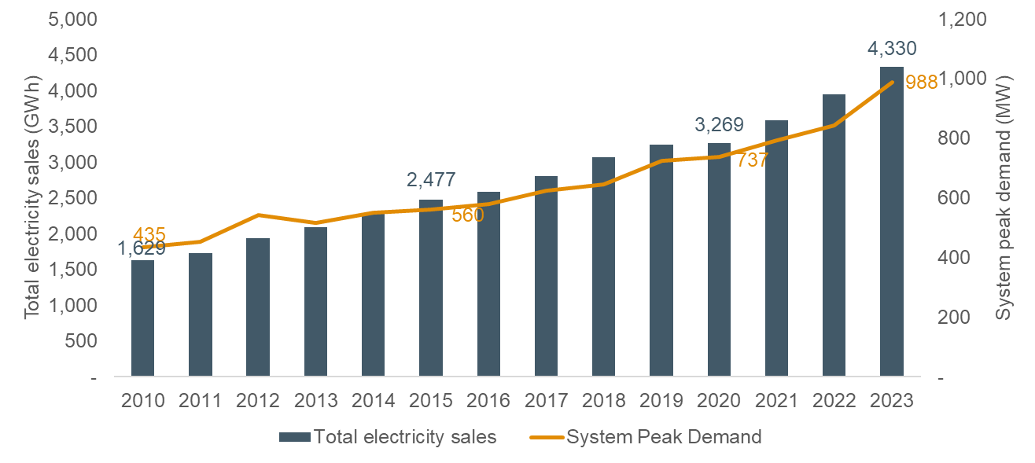
Source: ECA analysis of ERA provided data
The average growth rate of electricity sales over the past 13 years was 7.8% and the average annual growth rate of peak demand 6.7% as shown in Figure 8. Electricity sales growth in Uganda remained at high levels over the past 5 years despite global economic instability, geopolitical tensions, and regional conflicts.
Figure 8 Historical electricity demand growth, 2010 - 2023
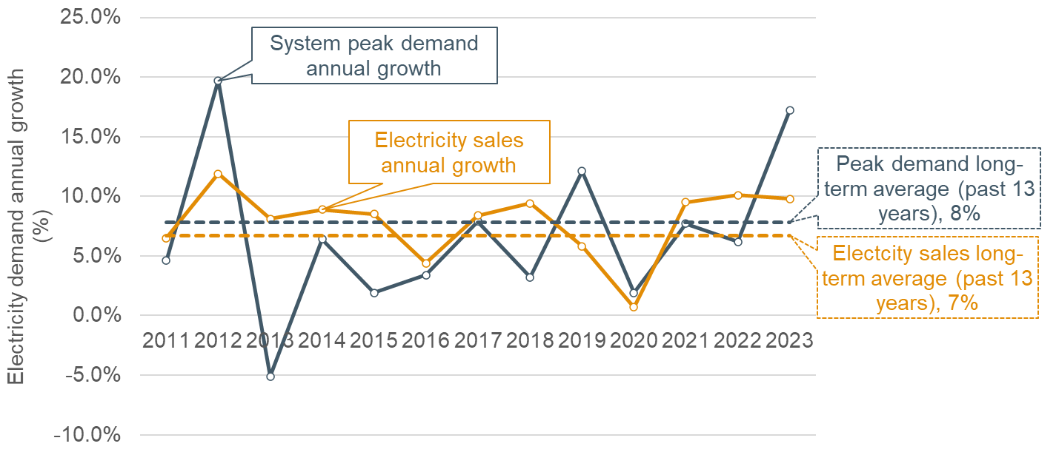
Source: ECA analysis of ERA provided data

Demand by customer type
While large industries customers made up less than 0.1% of the customer base in terms of numbers, their electricity demand was 27.4% of the total sales in 2023, the highest of all customer categories, followed up by extra large industries, domestic, medium industries and commercial customers, who contributed 24.5%, 22.3%, 14% and 11.7% to the sales, respectively. Historically, the share of each customer type, except for large industries and extra large industries, did not see major fluctuations. Prior to 2017, there were not any extra large industrial customers, and large industrial customers made up around 50% of total electricity sales. Demand from extra large industrial customers have since grown to reach 1,060 GWh in 2023, exceeding the 1,187 GWh demand from large industrial customers in 2023. Looking more closely at domestic customers the average domestic customer consumption 2023 was 40 kWh/month.
Figure 9 Historical electricity sales by tariff category, 2010 - 2023
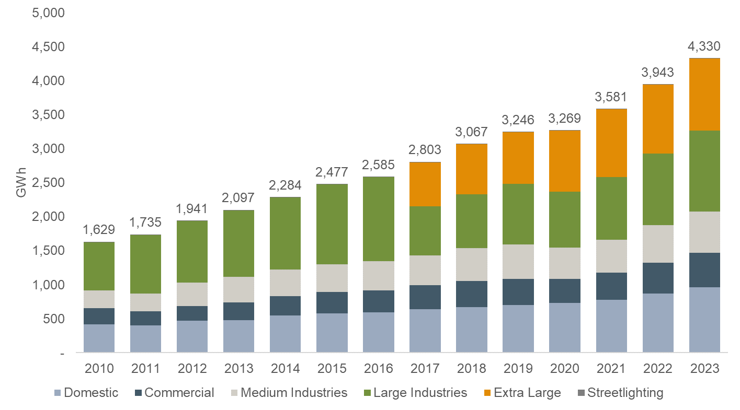
Source: ECA analysis of ERA provided data
Domestic customers make up more than 90% of the customer base, with the number of domestic customers reaching more than 2 million in 2023, however, as discussed above, their demand have historically been around 20% of the total electricity sales, less than those of large and extra large industrial customers.
Table 2 Customer number by tariff category
Category | 2010 |  | 2015 |  | 2020 |  | 2023
 | Number | % | Number | % | Number | % | Number | %
Domestic | 355,050 | 92.0 | 791,338 | 91.7 | 1,538,066 | 94.3 | 2,008,044 | 95.3
Commercial | 29,029 | 7.5 | 68,710 | 8.0 | 88,874 | 5.4 | 95,068 | 4.5
Medium Industries | 1,194 | 0.3 | 2,534 | 0.3 | 2,994 | 0.2 | 3,709 | 0.2
Large Industries | 324 | 0.1 | 513 | 0.1 | 585 | 0.04 | 690 | 0.03
Extra Large |  | - |  | - | 49 | 0.003 | 49 | 0.002
Streetlighting | 195 | 0.1 | 311 | 0.04 | 201 | 0.01 | 346 | 0.02
Total | 385,792 |  | 863,406 |  | 1,630,769 |  | 2,107,906
Source: ECA analysis of ERA provided data
The Uganda 2023 Energy Policy Review reports customer type data from Umeme, whose service territory is primarily urban and peri-urban, and accounts for well over 90% of the country’s distributed electricity. During Q2 of 2021, households represented over 94% of Umeme’s customers but only accounted for about 21% of electricity sold and around 30% of revenue. Large and extra-large industrial customers together represented less than 1% of Umeme’s total customer base but accounted for about 54% of electricity sold and around 40% of revenue.
Figure 10 Umeme customers by tariff category, 2021
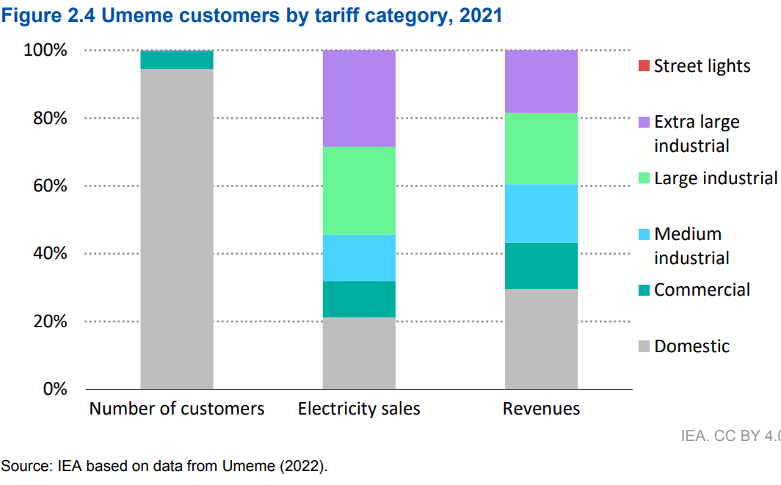
Source: Uganda 2023 Energy Policy Review

Electricity access
With respect to electricity access, as of 2022, around 20% of the Ugandan population had access to electricity from the national grid, while a further 10% received electricity from solar home systems capable of providing a basic package of energy service. Electricity access in urban and rural areas differs significantly. Urban centres have much higher electrification rates, around 80%, while the electrification rate in urban areas was lower than 20%.
Figure 11 Historical electricity access rates, 2000-2022
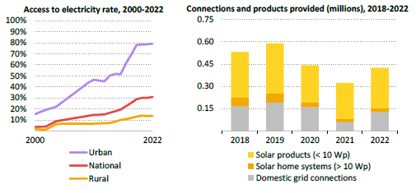
Source: Uganda 2023 Energy Policy Review
Uganda has made significant efforts over the past seven years to increase electrification access with targeted government policies and programmes, such as the Rural Electrification Strategy and Plan and the Electricity Connections Policy, that include both grid and off-grid solutions. However, there still is much to be done to achieve electricity access and clean cooking policy targets.

Profile of electricity demand
UETCL has provided daily demand profile data for the year 2023, and for May 2024 separately. To obtain an indicative hourly total demand profile, we have calculated the average, maximum and minimum total demand for a particular hour using data from the month of May in 2024, as shown in the figure below. The total demand peaked during the evening hours between 20:00 and 21:00 before dropping at 22:00. A smaller peak is also observed between 10:00 and 12:00 around midday.
Figure 12 Average, maximum and minimum total demand by hour
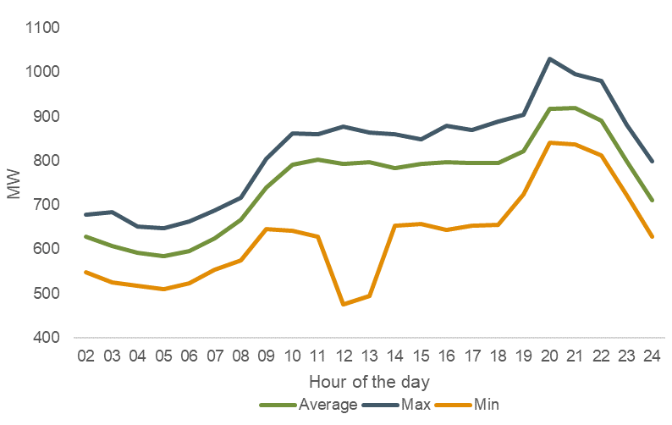
Note: Using total demand data from 1 May 2023 to 31 May 2024.
Source: ECA analysis of UETCL provided data
Seasonal variations in maximum system demand can also be observed when shown on a monthly basis. Specifically, maximum system demand peaks in the hot winter months, reaching 988 MW in December while hitting a trough of 813 MW in the summer month of May.
Figure 13 Monthly maximum system and domestic demand, 2023
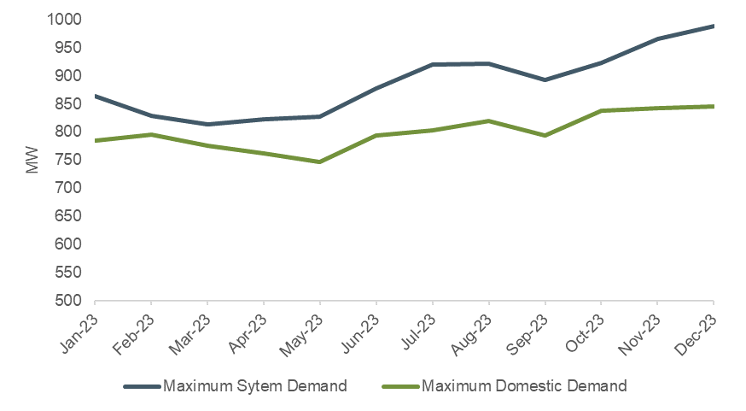
Source: MEMD
The figure below presents the hourly profile for the entire month of May 2024, illustrating the range of daily profiles that can emerge within this month with demand ranging between 475 MW and 1,030 MW.
Figure 14 Load curve, May 2024
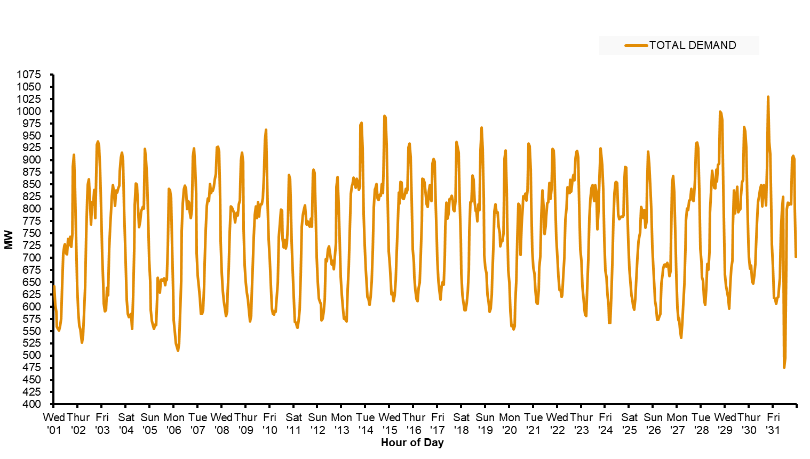
Source: UETCL

Forecasting approach
Demand forecasts have multiple uses in the energy and power sectors, including planning, budgeting, scheduling maintenance, tariff setting, policy setting, system operation, among others. Depending on the purpose of use, demand forecasts vary based on their spatial or temporal scopes as well as the measure to be forecasted. Table 3 summarises the main uses of demand forecasts in the power sector and their key characteristics.
Table 3 Types of demand forecasts by use in the electricity sector
Type of electricity demand forecast by use | Time horizon | Geographical scope/spread | Components
 |  |  | Energy demand | Peak demand | Time of Use pattern (Load profile)
Generation planning | Long term (>20 years) | National level | ü | ü | ü
Contracting and purchasing of wholesale/bulk electricity | Long term (>15 years) | Varied | ü | ü | -
Transmission planning | Medium term (10-20 years) | Primary substation or lower | - | ü | -
Distribution planning | Medium term (5-10 years) | Primary substation and lower | - | ü | -
Tariff setting | Short to Medium term (<5 years) | Tariff category | ü | ü | ü
System operation | Short term (Day ahead) | No | ü | ü | ü
Source: ECA Analysis
The demand forecast to be developed for the Integrated Energy Sector Master Plan in Uganda is for planning purposes. For least cost development planning, a forecast of annual energy and maximum demand of the grid is required in the medium to long run. For the IEMP the planning horizon is set up to 2050. This is because generation and transmission assets have long economic lives, and the investment decision should assess the costs of the asset over the entire economic life of the asset.
The geographical distribution of the demand is also necessary to assess capacity requirements by primary substation for the networks least cost plan.
Finally, the hourly profile of the demand is also required to assess the operation of power plants on an hourly basis (dispatch of power plants) to consider the intermittent nature of renewables and technoeconomic constraints of power stations to supply the demand.

Overview of demand forecasting approach
The demand forecast of the Integrated Energy Sector Master Plan in Uganda applies a bottom-up approach, forecasting initially the demand by consumer category at an annual level and then the total annual demand by aggregating the sectorial forecasts. A combination of methodologies is used to forecast the demand of each customer category as detailed below. The forecast for the electricity sector is connected to the broader energy sector forecast capturing changes in energy uses of key customer groups, mainly:
- Residential customers: As household gains access to electricity, it is expected that some may start using electricity for lighting, cooking, or heating, which were previously met by other more inefficient sources of energy. Likewise, some users may switch from traditional fuels such as firewood to modern cooking solutions such as LPG. In order to assess the aggregate impact of these changes, the residential sector’s energy and electricity demand are linked to capture switches from one form of energy to another.
- Transport sector: As forecasted by the IEA, Uganda is bound to experience a rapid expansion of Electric Vehicles (EVs) in circulation, reaching as high as 75% of all personal vehicles by 2050. The energy requirements for EVs and ICE vehicles are thus considered separately to ensure that these changes are properly reflected in the electricity and energy demand forecasts.

Typical demand forecasting methods
The existing literature on demand forecasting is extensive, however, there is no clear classification of the different forecasting methods. In general, most authors recognise a distinction between traditional methods, which include regression, time series, and end-use methods; modified traditional methods, including Auto-Regressive Integrated Moving Average (ARIMA) models; and computing-based approaches such as Artificial Neural Network (ANN), Genetic Algorithms (GA), and Fuzzy logic systems.
Modified traditional methods and computing-based approaches are more suitable for short term demand forecasts. For long-term electricity demand forecasts three main methodologies are dominant:
- Trend – trend analysis involves an extrapolation of past growth trends into the future. It involves fitting a line through past electricity demand and assuming future growth will follow a similar trajectory.
The advantage of the trend approach is that it is simple and easy to understand. The disadvantage is that it ignores the underlying factors that have led to past demand growth. If the underlying factors change in the future, the future demand will not follow a similar trajectory and the forecast will be inaccurate.
- End-use – involves a detailed assessment of the usage of electricity by different types of consumers and how those consumers will change their consumption habits in the future and how the consumer mix changes over time.
The major disadvantage of end-use forecasts is that they are very data intensive and time consuming to maintain and update. Typically, the forecast would require large amounts of detailed engineering and demographic data (it would normally tend to ask about the ownership of lightbulbs, TVs, radios, fans, etc). Consequently, it is time consuming to prepare and user’s may get lost in the details jeopardising the accuracy of the forecast.
- Econometric – An econometric approach is grounded in a theory of causation (eg, that increased income leads to increased spending power that leads to increased appliance ownership and/or increased use of owned appliances and therefore to increased electricity load). It uses mathematical equations to describe the relationship between the primary driver (eg, GDP or GDP per capita) and total electricity consumption or electricity consumption per capita. It uses econometric analysis to test whether the theory of causation is confirmed by the historical data and to provide parameter estimates. The mathematical equations in combination with projections of the external drivers (population, GDP, etc.) are then used to forecast future electricity load.
The major disadvantage is that it requires long historical datasets to effectively run the statistical analysis to estimate the coefficients. The advantage of this approach is that Econometric models often provide precise and reliable forecasts by incorporating historical data and relevant economic indicators, allowing them to forecast electricity demand accurately under normal conditions.
It is rare to find one approach being used in a demand forecast and most forecasts use a combination of the above approaches. The choice of the appropriate approach to use is often determined by the country circumstances, the scope of the forecast and data availability.
Figure 15 presents an overview and the main characteristics of short-term, medium term and long term load forecasting methods.
Figure 15 Classification of demand forecast methods
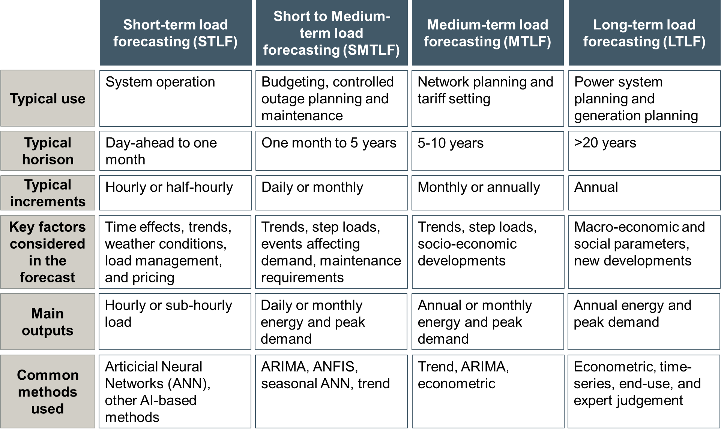
Source: Elakrmi & Shikhah, Mir et Al, 2020.

Energy demand forecasting approach
The energy demand forecast in Uganda is calculated following a bottom-up approach. Energy demand forecasts are initially developed for each sector at an annual level and then the total annual energy demand is calculated by aggregating the sectorial forecasts. The energy demand forecast is then disaggregated by fuel. The methodology applied to forecast the energy demand of each sector and by fuel is analysed in the subsections below.

Domestic sector
Residential energy usage in Uganda is characterised by a high use of biofuels and waste for daily activities, with the vast majority of energy used for cooking. Energy use for cooling and heating is minor due to the tropical climate in Uganda which experiences moderate temperatures throughout the year. Other typical usage of energy for residential consumers includes energy for lighting and for the operation of typical household appliances (eg TV, refrigerator, computers, mobile phone charging, radio, electric fan, iron, kettle, hair dryer, etc).
The current electrification rate in Uganda for grid connected consumes is still low at around 24%. ETP has set a target to increase electrification access to 100% by 2030. This target will enable households to purchase electrical appliance once they connect to the grid and increase the overall electricity consumption. Additionally, it will provide the opportunity to abandon biofuels for cooking and adopt cleaner sources of energy, such as LPG or electric stoves. LPG and electric stoves for cooking are considerably more efficient and safer than the current use of wood and charcoal, which according to the ETP accounted for over 80% of household cooking technologies.

Forecast method for residential energy demand
The method adopted to forecast the energy demand of residential consumers was an end-use approach. It involved a detailed assessment of energy uses by different types of domestic consumers (urban and rural consumers) through the Energy Use survey and an analysis of how domestic consumers will change their consumption habits in the future and how the consumer mix changes over time due to electrification, population and economic growth.
The Energy Use survey was conducted to identify energy uses, volumes and the timing of use for residential consumers. It also included an analysis of what type of energy consuming appliances are used in urban and rural households. The average consumption per urban and rural household was then assessed by aggregating the demand of each appliance and energy use in a typical urban and rural household. The assessment also incorporated forecast switches from wood and charcoal to other forms of energy for cooking, increases in energy usage due to economic growth and higher income levels, and policy targets.
The estimated average energy use per urban and rural household of each year was the multiplied by the forecast number of rural and urban consumers (adopting electrification targets and forecast population growth) to forecast the nationwide energy demand for residential consumers.
The equation used to forecast the energy demand of residential consumers was:
$$Domestic energy_{t}=\# of rural households_{t}*\left[Cooking energy {use}_{rural, t}+Non-cooking energy {use}_{rural, t}\right]+\# of urban households_{t}*\left[Cooking energy {use}_{urban, t}+Non-cooking energy {use}_{urban, t}\right]$$
$Cooking energy {use}_{ t}$ includes the amount of energy requirements for cooking per household. $Non-cooking energy {use}_{ t}$ includes the amount of energy requirements to operate energy consuming appliances per household. The disaggregation between the two was used to capture switches in the use of charcoal and firewood for cooking. Section 0 discusses the assumptions used to estimate the average energy consumption of urban and rural households for cooking and non-cooking energy uses.

Services sector
The energy demand of the services sector is forecasted using the energy intensity of the services sector and forecast GDP. The energy intensity is forecast to decrease over time reflecting switches to electricity and efficiency gains as foreseen in the ETP.
As of 2023, the energy intensity of the services sector was 739 GJ/billion UGX with biofuels accounting for 94.5% of the sector’s total energy consumption. By 2030, this share is expected to decrease for a non-electricity energy intensity of 495 GJ/billion UGX, reaching a minimum of 80 GJ/billion UGX in 2050 with a substantial increase in electricity usage replacing energy demand from biofuels and waste, as well as oil products.
The total energy demand forecast of the sector is calculated through the formula:
$$Services energy_{t}={Non-electricity energy intensity}_{t}*{Services GDP}_{t}+Commercial electricity sales_{t}$$
The non-electricity energy intensity for the services sector is calculated using the 2030 and 2050 targets as per the ETP 2023, with intermediary years interpolated using an exponential trend.
The forecast non-electricity energy intensity for the forecast period is shown below.
Figure 16 Forecasted services sector energy intensity (excluding electricity use)
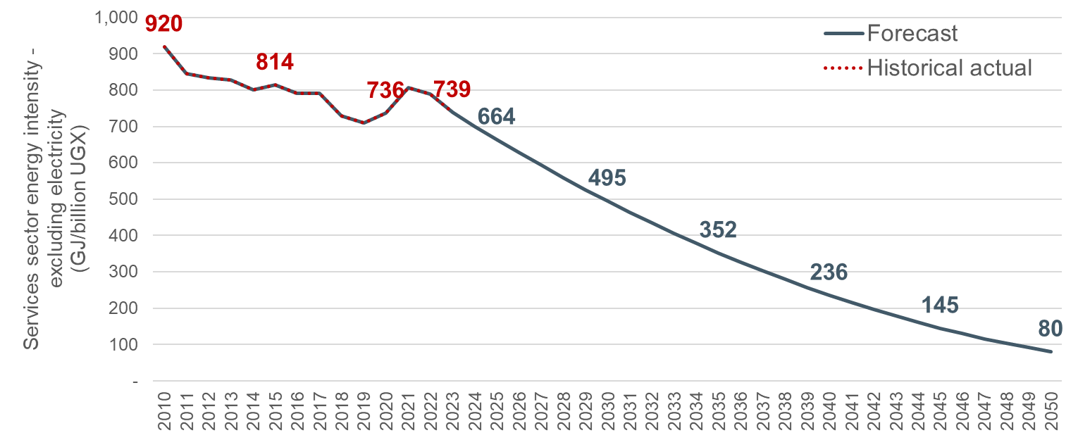
Source: ECA analysis based on the ETP 2023. Note: The energy intensity excludes electrical use. It is forecasted to decrease over time reflecting the switch to electricity and efficiency gains as foreseen in the ETP.

Industrial sector
As with the services sector, the energy demand of the industrial sector is forecasted through the energy intensity of the industrial sector and forecast GDP. The energy intensity of the industrial sector is also forecasted to decrease over time reflecting the switch to electricity as foreseen in the ETP.
As of 2023, the energy intensity of the industrial sector was 3137 GJ/billion UGX with biofuels accounting for 76.6% of the sector’s total energy consumption and oil products accounting for 15% of the sector’s total energy consumption. By 2030, the oil product share is expected to increase, while the share of biofuel usage is expected to decrease, resulting in a non-electricity energy intensity of 1,665 GJ/billion UGX, reaching a minimum of 450 GJ/billion UGX in 2050.
The total energy demand forecast of the sector is calculated through the formula:
$$Industrial energy_{t}={Non-electcity energy intensity}_{t}*{Industrial GDP}_{t}+Industrial electricity sales_{t}$$
The non-electricity energy intensity for the industrial sector is calculated using the 2030 and 2050 targets as per the ETP 2023, with intermediary years interpolated using a quadratic trend.
The forecast non-electricity energy intensity for the forecast period is shown below.
Figure 17 Forecasted industrial sector energy intensity (excluding electricity use)
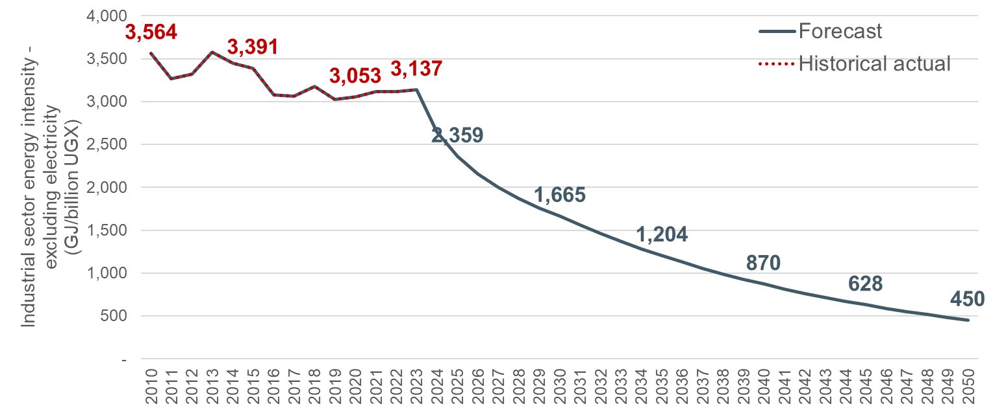
Source: ECA analysis based on the ETP 2023. Note: The energy intensity excludes electrical use. It is forecasted to decrease over time reflecting the switch to electricity and efficiency gains as foreseen in the ETP.

Transport sector
The energy demand of the transport sector is forecasted through an end-use approach which considers the energy requirements per Electric Vehicle (EV) and the energy requirements per non-electric vehicle and the expected number of each type of vehicle in circulation as per the following formula:
$Transport energy_{t}=Average energy requirement_{nonelectric}*nonelectric vehicles_{t}+Average energy requirement_{electric}electric vehicles*electric vehicles_{t}$
The average energy requirement of non-electric vehicles was estimated using the average energy consumption of vehicles in Uganda over the last four historical years (2019-2022). The number of vehicles was sourced from the Uganda Revenue Authority which records the number of registered motor vehicles. The average energy requirement for electric vehicles was estimated as a fixed GWh/vehicle value according to the IEA’s projections for the sector in the ETP 2023.
The number of vehicles (electric and non-electric) follow the estimates of the ETP, which states that a seven-fold increase in vehicles is expected in 2050 with respect to the 2021 number of vehicles, with the share of electric vehicles increasing to 25% in 2030 and reaching 75% by 2050.

Other sectors energy use
The energy demand of other sectors (eg other than residential, services, industrial and transport) is forecasted through the energy intensity of other sectors and forecast GDP using the following formula.
$$Other energy_{t}={Energy intensity}_{t}*{Total GDP}_{t}$$
The energy intensity is assumed to decrease over time following the historical trend of the energy intensity (a logarithmic trend).
The forecast non-electrical energy intensity of other sectors for the forecast period is shown below.
Figure 18 Forecasted other sector energy intensity (excluding electricity use)
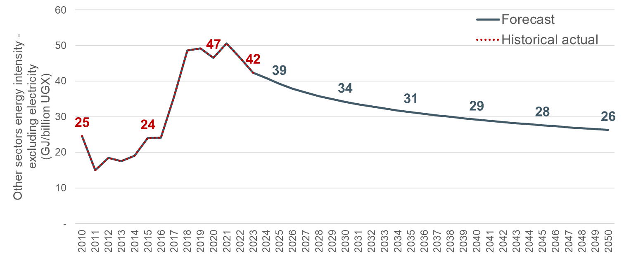
Source: ECA analysis based on the ETP 2023

Electricity demand forecasting approach
As with the energy demand forecast, the demand forecast for the electricity sector is calculated through a bottom-up approach. The demand of each customer category is forecasted separately. The sectorial forecasts are then aggregated together with transmission and distribution losses, step-loads, and the impact of DSM measures to form the national demand.

Residential
The electricity demand forecast for residential users is estimated using a combination of end-use, trend and econometric approaches. Initially the average consumption per urban and rural household is estimated for the base year (eg 2023) using an end use approach and historical actual average consumption per urban and rural connection from actual sales data.
The electricity demand of residential customers is dependent on the economic growth in Uganda, population growth, and the country’s success of implementing electrification targets. The sector electricity demand is expected to increase with population growth with newly connected households acquiring appliances over time to fulfil their needs. Additionally, as the incomes of households increase, they are able to purchase more appliances or increase the use of existing ones, resulting in an increase in the sector’s electricity demand. This growth of demand, however, is expected to be constrained by the price of electricity, with increases of electricity tariffs discouraging consumption from households and thus having a negative impact on the sector’s electricity demand.
The base year average consumption per urban and rural household is assumed to grow each year at a growth rate calculated through an econometric equation. The econometric equation uses GDP per capita (ie Total GDP/total population), the lagged average tariff for residential users (ie Domestic category average tariff in the previous period), and electrification rate as the determinant variables. The forecast average consumption per urban and rural household of each year is then multiplied by the forecast number of residential connections to estimate the electrical energy demand for residential users.
The equation used for the development of the residential electrical energy forecast is:
$LN\left({Average consumption per household}_{t}\right)=-21.261 + 2.143*LN\left({GDP per capita}_{t}\right)-0.153*LN{\left(Residential tariff increase\right)}_{t-1}-0.303*LN\left({Number of domestic customers}_{t}\right)$.
Where:
- $GD{P per capita}_{t}:$ GDP per capita in real terms (billion UGX, 2023/24 price level) at year t.
- $Residential tariff increase_{t-1}:$ Average tariff of the residential sector (UGX/KWh, 2023/24 price level) at year t-1.
- ${Number of domestic customers}_{t}:$ Total number of domestic connections at year t.
GDP growth per capita was found to be positively correlated with the average household consumption, with a 1% increase in the GDP per capita increasing the household average consumption by 2.1%. It assumes that increases in household incomes are expected to increase electricity consumption.
Increases in the price of electricity, reflected in the average residential tariff, were found to decrease the overall household demand. A 1% real-term increase in the average residential tariff is expected to decrease average consumption by 0.15% in the next year.
Finally, as the number of connected customers increases, the overall average consumption per household is expected to decrease as well. Newly connected households are mainly poorer households with lower average consumption per household than already connected consumers in urban centres. Thus, the average consumption of connected consumers drops. A 1% increase in the number of connected customers decreases the overall average household consumption by 0.3%.
To test the performance of the econometric equation, historical forecasts (derived from the econometric equation) were compared with actual historical sales data. The comparison is shown in the figure below and resulted in a forecast error lower than 3%.
Figure 19 Backcast with residential econometric equation
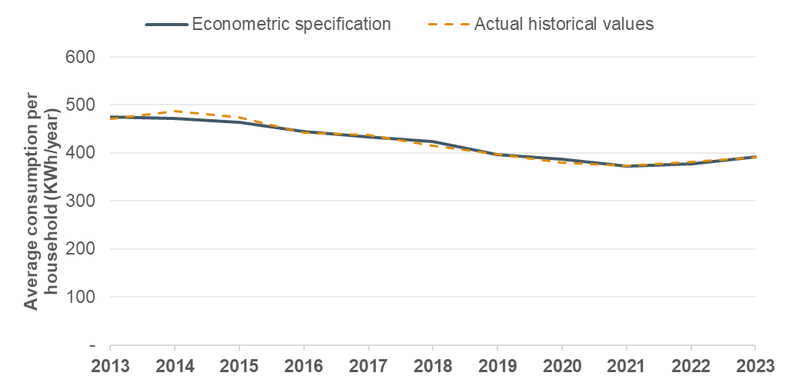
Source: ECA analysis

Incorporating electrical energy for cooking to the forecast
The average consumption per household of the base year (2023) does not include electricity use for cooking. In 2023, 99.3% of households used other forms of energy for cooking as discussed in Section 3.3.1. Therefore, the average consumption per household resulting from the above econometric equation will not include electrical demand for cooking.
The average electrical energy requirement for cooking per household was added to the average consumption per household estimated from the econometric equation shown above based on the parameters presented in Table 10. Though, it was added only to the portion of households expected to switch from charcoal/firewood to electrical energy for cooking each year.

Commercial
Electricity demand of commercial consumers was forecasted through an econometric equation using the Services sector GDP and the average tariff of the previous year of Commercial consumers as the determinant variables.
As with residential users, economic growth is expected to increase the use of electricity in the commercial sector with higher incomes of households resulting in higher demand for goods and services, which requires higher use of appliances by businesses. As the country’s economy transitions towards a services-based economy, the share of incomes of businesses increases, resulting in a higher electricity demand. Nonetheless, increases in electricity tariffs may reduce businesses electricity demand over time due to the price of goods and services offered increasing, which then reduces demand, and thus the electricity required for their provision.
The equation used to forecast sales of commercial consumers was:
$LN\left({Commercial sales}_{t}\right)=-13.429 + 1.867*LN\left(Services GDP_{t}\right)-0.206*LN{\left(Commercial tariff increase\right)}_{t-1}-0.120*{Pandemic}_{t}- 0.084*{Sales anomaly}_{t}$.
Where:
- $Services GDP_{t}:$ GDP of the services sector in real terms (billion UGX, 2023/24 price level) at year t.
- $Commercial tariff increase_{t-1}:$ Average tariff of the commercial sector (UGX/KWh, 2023/24 price level) at year t-1.
- ${Pandemic}_{t}:$ Dummy variable equal to 1 in 2020 during the Covid-19 pandemic.
- ${Sales anomaly}_{t}:$ Dummy variable equal to 1 in years when an unexpected value of commercial sales is seen (2012) and 0 otherwise.
The econometric equation links electricity consumption of commercial consumers with economic growth. Increases in businesses’ incomes are expected to increase their usage of appliances as they require additional electricity to provide services or to accommodate customers. Economic growth will also result in new commercial businesses. The elasticity of Commercial sales with the GDP of the services sector was found to be 1.8 which implies that a 1% increase in the Services GDP increases commercial electricity sales by 1.8%.
In contrary, increases of electricity tariffs are expected to reduce electricity consumption. This impact is not immediate, as businesses take time to assess the impact of tariff increases and plan accordingly for the following year. A 1% real-term increase in the average commercial tariff is expected to decrease commercial sales by 0.2% in the next year.
The resulting econometric equation of the services sector was used to forecast the demand in historical years and compare the forecast with actual historical sales data. The comparison is shown in the figure below and resulted in a forecast error lower than 3%.
Figure 20 Backcast with commercial sector econometric equation
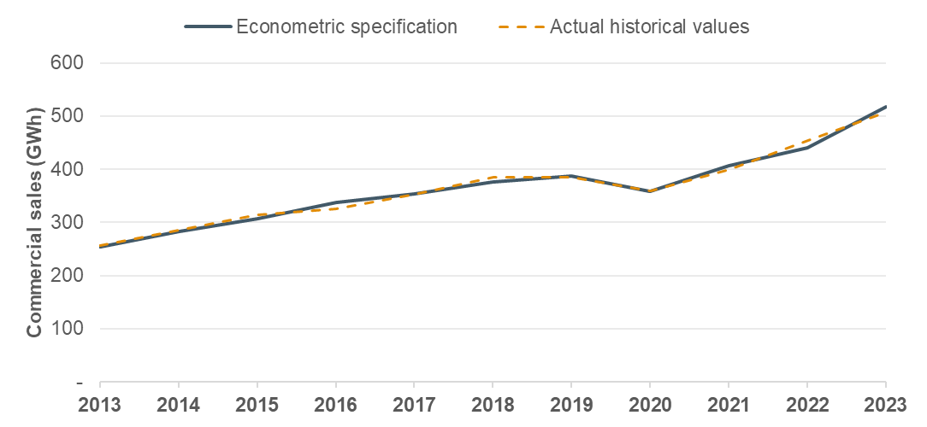
Source: ECA analysis.

Medium industries
The medium industries category includes industrial users connected to the LV network. The electricity demand of the medium industries category was forecasted through an econometric equation using the Total GDP of the country as well as a dummy variable to assess the impact of the Covid-19 pandemic in 2020 as the determinant variables. No statistically significant impact of average tariffs was identified for this category.
Thus, the equation used for the development of the forecast for medium industries was:
$LN\left({Medium industries sales}_{t}\right)=-7.918 + 1.176*LN\left(Total GDP_{t}\right)-0.094*{Pandemic}_{t}$.
Where:
- $Total GDP_{t}:$ Total GDP of the country in real terms (billion UGX, 2023/24 price level) at year t.
- ${Pandemic}_{t}:$ Dummy variable equal to 1 during the Covid-19 pandemic (2020) and 0 otherwise.
The results of the econometric equation show that a 1% increase in the Total GDP increases medium industries’ electricity sales by 1.1%.
The comparison of actual historical sales and forecast sales using the above econometric equation for historical years is shown in the figure below.
Figure 21 Backcast with medium industries econometric equation
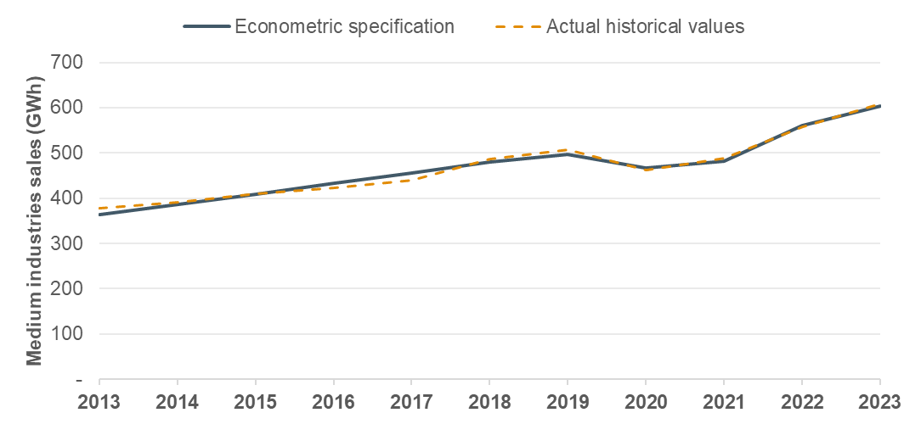
Source: ECA analysis.

Large and extra-large industries
Electricity demand of large and extra-large industrial consumers was forecasted through the energy intensity of electricity of the sector and forecast GDP. The demand forecast of the combined category was calculated through the formula:
$$Large and extra large industrial {sales}_{t}={Energy intensity(industrial)}_{t}*{Total GDP}_{t}$$
The energy intensity of electricity was estimated through a trend approach (follows an exponential path) which reflects switches of industrial users from other forms of fuels to electricity and efficiency gains. It has the opposite trend to the non-electrical energy intensity of the industrial sector, which is assumed to drop over time to reflect that consumers will be shifting from other forms of energy sources to electricity.
Figure 22 Forecast electrical energy intensity for large and extra large industrial sales
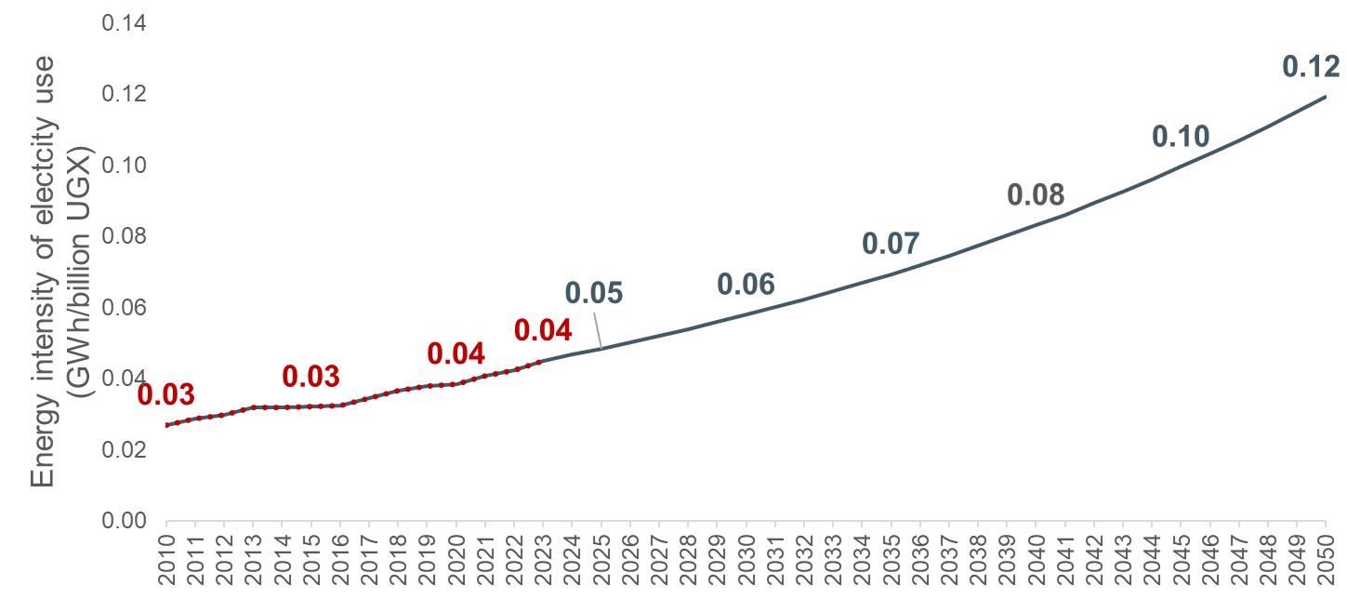
Source: ECA analysis
As of 2023, the energy intensity of this category was 0.04 GWh/billion UGX. By 2030, the electricity energy intensity continues to increase at a slower pace to 0.06 GWh/billion UGX, reaching 0.12 GWh/billion UGX in 2050.
The forecasted sales through this method are then divided between large industries and extra-large industries according to the ratio of each in the base year.

Treatment of step loads
New large loads (industrial, rail, hydrogen production or other) expected to connect to the transmission system should be added to the forecast individually as step-loads. These step loads may be at different stages of planning. Their development may still be uncertain and may depend on factors inside or outside their control. To overcome this uncertainty, probabilities should be assigned to step loads based on the likelihood that these loads will materialise. The probability assessment should be based, to the extent possible, on objective criteria such as whether feasibility studies have been completed, the recommendations of those feasibility studies, and the financial standing of the proposed developers.
However, it was assumed that new large projects are already accounted in the forecast GDP and therefore captured in the sales estimated through the forecasting formulas described above. While no specific step-loads are currently included in the forecast, the demand forecasting model allows for the addition of up to 50 step-loads, with the user being able to select if these are expected to be accounted as large industry sales or extra-large industry sales.

Streetlighting
The streetlighting category represents by far the smallest share of total electricity sales in Uganda. For this category it is assumed that growth will match the growth rate of electrification. The expected annual increase in sales has been calculated based on the formula:
$${Streetlighting sales}_{t}={Streetlighting sales}_{t-1}*(1+growth rate electrified households_{t})$$

Treatment of exports
The IERMP is a national plan which focuses on the electricity demand in Uganda and does not extend to potential demand beyond the borders of Uganda. A plan that seeks to predict export demand would require a substantially different approach and modelling of the EAPP as a whole.
However, the national generation least cost plan will have to incorporate capacity and energy to satisfy existing or planned export contracts. Energy and capacity requirements of export contracts is added as a separate sector to the forecast at the transmission level.

Treatment of EE and demand side measures
DSM and EE measures aim to reduce or shift demand in order to reduce the generation capacity needed. As with generation candidate plants, these measures have implementation and running costs that can vary over time as more customers are targeted.
The impact of ongoing or committed should be accounted in the demand forecast as their implementation is certain and will be subtracted from the demand forecast.
Candidate measures are assessed in the DSM and EE measures report and will be included as candidate options for implementation in the least cost planning analysis. If a measure is deemed to be the least-cost option to fulfil the demand, then it will be selected for the IERMP.

Treatment of new emerging technologies/challenges
Increasing renewable energy penetration at the distribution level, electric vehicle demand and self-generation and other emerging challenges also impact the demand for electricity from the grid.
The demand forecast adds on top of the sectorial sales the demand from the electrification of sectors (eg transport sector) and the impact this may have on the load profile. The expansion of distributed generation, expected in the residential, commercial, and industrial sectors, will also be added to the relevant sector on top of their respective forecast.

Treatment of losses
Forecasts of sales will be increased annually by an appropriate loss factor to estimate the demand at generation sent-out level. Forecasts of loss factors are based on historical trends, loss reduction plans and consultations with stakeholders as detailed in the next section of the report.

Peak demand forecast
The peak demand forecast at the national level will be obtained at the sent-out generation level and calculated using a representative load factor for the system and the forecast of electrical energy demand of each year. The consumption mix of forecast years is expected to be similar to 2023 consumption mix (as per the ETP). Thus, no significant variations in the load factor are expected over the forecast period and historical load factors can be considered as representative for forecast years as well.

Geographical disaggregation of forecast
The outputs of the national demand forecast are disaggregated by subregions reflecting the location of load centres and primary substations. The demand is disaggregated by subregion considering the historical split of sales and peak demand by subregion but also coincidence factors, population growth by region and electrification increases as needed. The demand is also disaggregated by transmission zone as described in the 2023 National Energy Policy.

Demand forecast scenarios and inputs

Scenario definition
Four scenarios have been developed to capture future outlooks of the energy sector in Uganda which encompass a wide range of possible paths for energy demand due to macroeconomic and demographic changes, policy goals, and other sectorial variables:
- Base transition scenario (BT) – Assumes the implementation of current policies and plans following ongoing trends, and commitments. Economic growth is forecast to grow at an average rate of 5.4% per year. The country continues its drive to industrialisation and the adoption of electricity as the main source of energy. This continues the transition towards an industrial and services-based economy.
Industrial developments, tariff reform, electrification of transport, adoption of clean cooking, energy efficiency measures, and loss reduction measures are assumed to be implemented as planned. Nonetheless, the probability of occurrence for uncertain projects and measures is assumed to be low (50% probability) following historical trends.
- Delayed transition scenario (DT) – This scenario tries to capture impacts of unprecedented events which may result in slower economic growth and a delay in the implementation of existing plans and policy targets. Such events may include climate change impacts (cyclones, temperature changes, droughts, etc), global conflicts affecting the international market (as the wars seen recently in Ukraine and the Middle East), pandemics (as with COVID-19 pandemic) and others. In this scenario, GDP is forecasted to grow at 3.8% per year on average.
As a result, official plans and policies are implemented with a delay or not at all due to constraint finances from low economic growth. Industrial investments, electrification of transport and adoption of clean cooking solutions are not fully implemented, while other DSM and loss reduction measures are implemented with less success (10% probability).
- Tenfold growth strategy scenario (TGS) – This scenario assumes that high sustained economic growth is kept along the forecast period, allowing Uganda to meet its target of increasing its nominal GDP to 500 billion US$ by 2040. This scenario follows the evolution of the energy sector as forecasted in the 2023 IEA’s Energy Transition Plan for Uganda with average GDP growth of 7.3% each year until 2040 and then slowing to a rate of 4% by 2050 as the economy matures. These high rates of growth are accompanied with ambitious goals for the electrification of transport, adoption of clean cooking, and emissions’ reductions across all sectors of the economy.
All new industrial loads, DSM and loss reduction measures are fully implemented (100% probability) due to the high attraction of investments in the country, which results in a high increase in the use of efficient energy sources, mainly electricity.
- Policy targets scenario (PT) – This scenario reflects the power sector targets set by the National Energy Policy 2023 in addition to all other targets of the Tenfold growth strategy scenario. High economic growth increases electricity demand above all other scenarios reaching 52 GW in 2040. Thereafter, the economy has reached high maturity, which reduces its annual growth rates to ~1% reflecting levels seen in other advanced economies.

Economic and financial assumptions

Gross domestic product
The compound average growth rate (CAGR) of total GDP in Uganda has been 4.4% over the last ten years (2013-2023). However, Uganda anticipates much high GDP growth rates in the future due to the upcoming oil production in 2025.
For the demand forecast, the IMF World Economic Outlook estimates have been used for the 2024-2029 period in the BT and TGS scenarios (average growth rate of 7% in this period). For the DT scenario, the historical average growth has been utilised (4.4%), while for the PT scenario an average growth rate of 18% has been set in this period.
For the period 2030-2050, the BT scenario assumes the long-term growth rate of the ETP (6.5% per annum) up to 2040 and then linearly decreasing to 3.5% by 2050. The DT scenario assumes a slow decrease reaching 3% by 2050. The TGS scenario assumes an average growth of 7% (according to the annual growth targets in the TGS) per annum until 2040 and then a linear decrease to 4% by 2050. Lastly, the PT assumes an average annual growth rate of 10% between 2030 and 2040 and slowing down to 1% by 2050.
The forecast growth rates by scenario are shown in the figure below.
Figure 23 Real total GDP growth rate assumptions by scenario
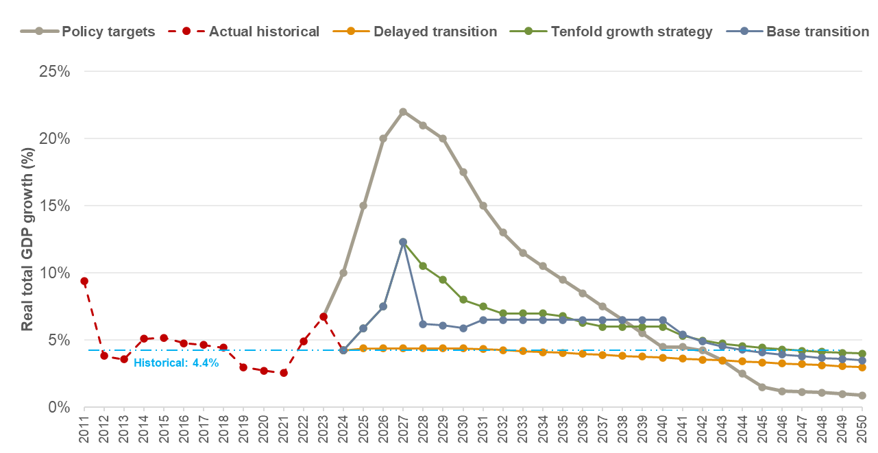
Source: IMF World Economic Outlook, ECA assumptions

GDP composition is assumed to reflect the ongoing process of industrialisation and transition to a service-based economy in Uganda with growing services and industrial sectors and a gradual reduction of the agricultural share of total GDP. This evolution is kept the same across scenarios and is depicted in the figure below.
Figure 24 Historical and forecast GDP composition
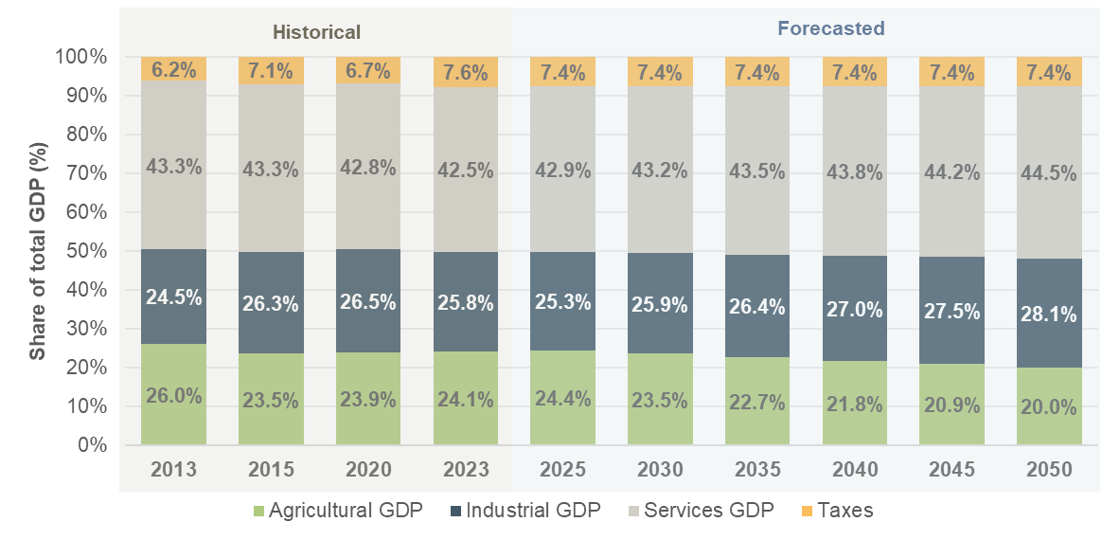
Source: ECA analysis

Inflation and exchange rates
Following a period of high inflation rates in the early 2010s, Uganda has experienced relatively stable levels of inflation in the 2013-2023 period, with IMF estimates of annual inflation rates for the period ranging from 2.1% to 7.2%. For the forecasted period, the IMF projections are assumed over the 2024-2029 period, with the 2029 value assumed to be the long-term inflation rate for the 2030-2050 period.
Figure 25 Historical and forecast inflation rates
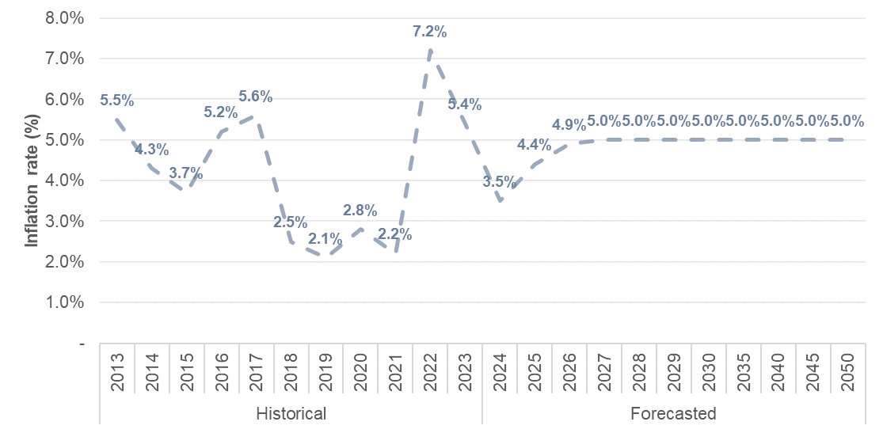
Source: IMF World Economic Outlook
Historical exchange rates to the USD have been provided by the MEMD during the data collection stage. As can be seen in Figure 26, since 2016 the exchange rate has remained stable and only increasing slightly each year. For the forecasted period, it is assumed that the same trend continues until the end of the forecasted period.
Figure 26 Historical and forecast exchange rates
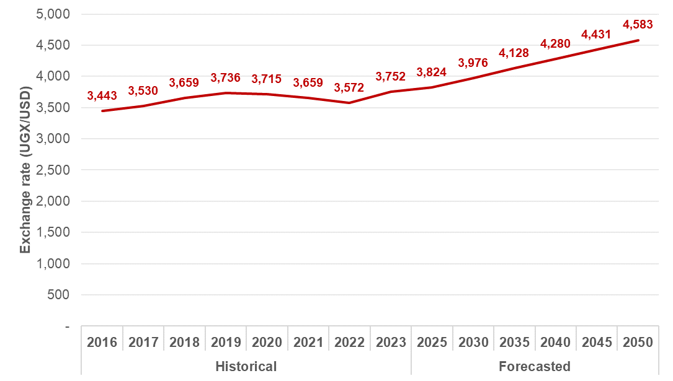
Source: Data provided by MEMD, ECA assumptions

Population growth and household size
In the 2013-2023 period, the total population in Uganda has increased from 33 million to over 45 million people. Most of the population lives in rural areas (73% as of 2023), however, there has been a continuous growth of the urban population of the country which has increased by five million people or over 75% within the same time period, this has been facilitated by the growing services and industrial sectors. Total historical population estimates have been provided by MEMD during the data collection stage of the assignment; these have been divided to urban and rural based on the historical share of the urban and rural population each year according to the World Bank databank.
For the demand forecast, forecast population growth rates and forecast population were sourced from UBOS for the 2021-2050 period. For the split between urban and rural households of urban and rural populations, the World Bank projections have been kept and scaled to match the 2024 estimate of total population provided by MEMD.
The population forecast is assumed to be the same for all scenarios and is presented below.
Figure 27 Historical and forecast population estimates
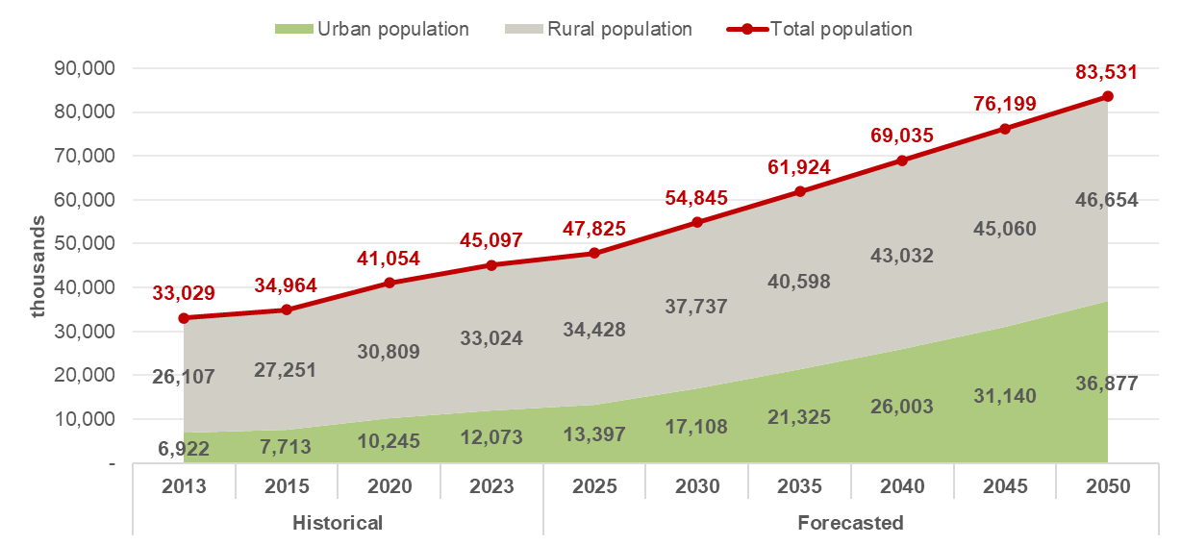
Source: Data provided by MEMD, UBOS 2021-2050 population projections, World Bank population estimates (DataBank)
Increasing incomes and a growing urban population are also expected to result in a gradual decrease in the average household size of urban and rural areas. According to the preliminary results of the 2024 Census, the average household size in Uganda has decreased from 4.8 people per household in 2014 to 4.4 in 2024. While no estimates of urban and rural household sizes are provided, the 2019/2020 household survey by the Uganda Bureau of Statistics (UBOS) provides estimates for 2010, 2013, 2017, and 2020. For the purpose of this analysis, a linear trend is assumed for the average rural household size reduction, reaching 3.8 by 2050, and an exponential trend is assumed for urban household size decreases, reaching 3.2 in 2050 as can be seen below.
Figure 28 Historical and forecast average household size
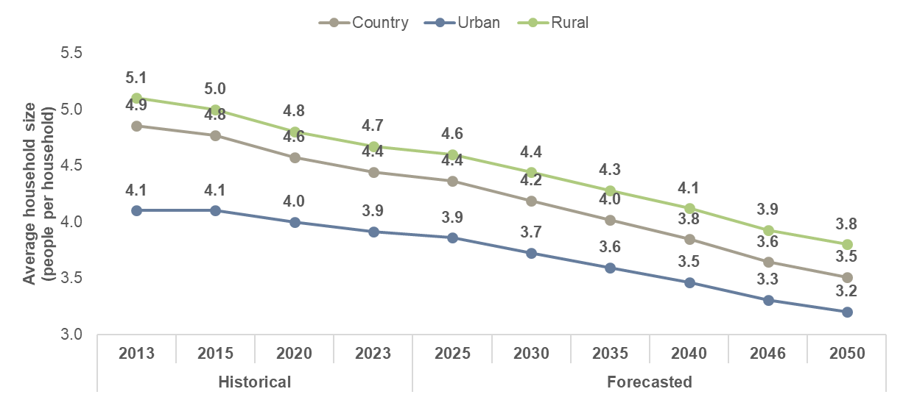
Source: 2024 preliminary census results, 2019/20 household survey, ECA assumptions

Electrification rates
Uganda presents low electrification rates, with estimates ranging from 20% to 47% including grid and off-grid access. For the purpose of this analysis, the electrification rates presented refer to on-grid access only and have been calculated based on the 2023 estimates from the International trade Association (ITA), and the reported access to grid electricity for rural and urban households in the 2014 Census.
Forecasted electrification rates vary by scenario as these would depend on the success of electrification programmes, investment from developers of off-grid solutions, and the incomes of the population to overcome connection costs.
In the BT, TGS, and PT scenarios, the electrification target for the country is set to 90% by 2050 as per the IEA’s ETP 2023. It is assumed that all urban households and 80% of rural households will be connected to the grid or to mini-grids, with the rest of rural household gaining access to electricity through other off-grid solutions. In the DT scenario, electrification efforts are assumed to be less successful due to constrained finances reaching 70% by 2050.
Table 4 shows the electrification targets defined for each scenario for 2030, 2040, and 2050.
Table 4 Policy targets for electricity access
Policy  document | National electricity access target | Grid electricity access target | Off-grid based access target | Rural access target
Vision 2040 | 80% by 2040 | - | - | -
2023 Energy Policy Review | 100% by 2040 | 65% by 2040 | - | -
Rural Electrification Strategy and Plan | - | - | - | 51% by 2030  100% in 2040
Electricity Connections Policy | Aims at 300,000 new connections annually to reach 3 million new connections by 2027.
National Electrification  Strategy | 80% by 2040 | 60% by 2027 | 33% by 2027 | -
IERMP study | Base transition scenario
 | 100% by 2040 | 80% by 2050 | 20% by 2050 | 80% by 2050
 | Tenfold growth strategy scenario
 | 100% by 2040 | 80% by 2050 | 20% by 2050 | 80% by 2050
 | Delayed transition scenario
 | 80% by 2040 | 70% by 2050 | 30% by 2050 | 60% by 2050
 | Policy targets scenario
 | 100% by 2040 | 80% by 2050 | 20% by 2050 | 80% by 2050
Source: Uganda 2023 Energy Policy Review

Average electrical and non-electrical energy consumption per household

Historical average energy consumption per household
According to the IEA’s data, each household has an average final energy consumption of 44 GJ each year, of which 98.9% comes from biofuels and waste and only 1.1% from electricity or oil products.

Energy use for lighting per household
According to the Energy use survey, in 2023, over 99% of households use energy for lighting, with LED, fluorescent, and incandescent lightbulbs accounting for over 91% of the household lighting demand. The type of lamps used by urban and rural households and the portion of households that possess each type of lamp is shown in Table 5.
Table 5 Type of lamps used in households (% of total households)
Type of household | “Traditional” incandescent bulbs | Compact Fluorescent lamps | Fluorescent lamps | Halogen lamps | LED | Others -small round bulbs, solar lamp head | None/ NA
Urban | 24.65 | 12.53 | 7.68 | 5.86 | 45.86 | 3.03 | 0.40
Rural | 16.86 | 14.05 | 6.09 | 4.68 | 43.56 | 13.58 | 1.17
Total | 21.04 | 13.23 | 6.94 | 5.31 | 44.79 | 7.92 | 0.76
Source: Uganda Energy Use Survey data, January 2025
The energy demand for lighting in the base year (eg in 2023) was determined assuming the average time of usage of lighting per household per day (four hours per day), the number of lightbulbs used per household (4.8 for urban households and 3.9 for rural households) and the assumed capacity of each type of lightbulb (7 W for LED, 11 W for fluorescent, and 40W for incandescent). The calculation and the estimated average electrical energy demand per household for lighting in 2023 is shown in the table below.
Table 6 Energy demand for lighting per household
Type of bulb | Type of household | Average number of lamps | Average capacity of lamp (kW) | Days of use per year | Hours of use per day | Energy demand for lighting (kWh per year) | Share of households (% of total households)
CFL lightbulb | Urban | 4.8 | 0.011 | 365 | 4 | 77.2 | 22%
 | Rural | 3.9 | 0.011 | 365 | 4 | 63.3 | 6%
LED lightbulb | Urban | 4.8 | 0.007 | 365 | 4 | 49.2 | 33%
 | Rural | 3.9 | 0.007 | 365 | 4 | 40.3 | 13%
Incandescent  lightbulb | Urban | 4.8 | 0.040 | 365 | 4 | 280.9 | 14%
 | Rural | 3.9 | 0.040 | 365 | 4 | 230.1 | 7%
Weighted average | Urban | - | - | - | - | 105.1 | -
 | Rural | - | - | - | - | 96.7 | -
Source: Uganda Energy Use Survey data, January 2025

Energy use for heating/cooling, and other household appliances
Heating and cooling are highly uncommon in Uganda due to the minor differences between seasons temperatures. According to the Energy use survey results, over 95% of households do not heat spaces and over 96% do not cool spaces in their homes.
The Energy use survey also defined energy consuming appliances that are being used by a typical urban and rural household in Uganda. They include TV, radio, refrigerators, phone chargers, computers, kettle, hair dryer, iron, fan and chest freezers. The current share of use, number of appliances, and usage patterns of each appliance for a typical urban and rural household are listed in the table below.
Table 7 Energy consuming appliances used by households
Appliance/ Type of household | Number of appliances | Average capacity (KW) | Number of times used per week | Duration of use per time (hours) | Current usage (% of urban or rural households)
Electric radiator
Urban | 0 | 2.00 | 0.00 | 0.00 | 0%
Rural | 0 | 2.00 | 0.00 | 0.00 | 0%
Air conditioning
Urban | 0 | 3.25 | 0.00 | 0.00 | 0%
Rural | 0 | 3.25 | 0.00 | 0.00 | 0%
Electric fan
Urban | 2 | 0.12 | 2.00 | 2.00 | 8%
Rural | 2 | 0.12 | 2.00 | 2.00 | 3%
Mobile phone charging
Urban | 2 | 0.00 | 15.20 | 3.22 | 70%
Rural | 2 | 0.00 | 12.91 | 3.25 | 59%
TV
Urban | 1 | 0.02 | 14.25 | 2.95 | 43%
Rural | 1 | 0.02 | 11.31 | 3.10 | 30%
Radio
Urban | 1 | 0.01 | 12.39 | 2.42 | 31%
Rural | 1 | 0.01 | 13.08 | 2.75 | 28%
Iron
Urban | 1 | 1.00 | 3.65 | 2.47 | 35%
Rural | 1 | 1.00 | 3.44 | 2.47 | 15%
Kettle
Urban | 1 | 1.20 | 10.16 | 1.77 | 13%
Rural | 1 | 1.20 | 9.00 | 2.00 | 6%
Refrigerator
Urban | 1 | 0.10 | 9.69 | 3.71 | 6%
Rural | 1 | 0.10 | 7.20 | 4.17 | 1%
Computer
Urban | 1 | 0.05 | 7.00 | 1.50 | 8%
Rural | 1 | 0.05 | 7.00 | 1.50 | 1%
Chest freezer
Urban | 1 | 0.03 | 9.69 | 6.00 | 6%
Rural | 1 | 0.03 | 7.20 | 5.00 | 1%
Refrigerator with freezer
Urban | 1 | 0.15 | 9.69 | 6.00 | 6%
Rural | 1 | 0.15 | 7.20 | 5.00 | 1%
Hair dryer
Urban | 1 | 1.50 | 7.00 | 0.08 | 2%
Rural | 1 | 1.50 | 7.00 | 0.08 | 1%
Source: Uganda Energy Use Survey data, January 2025
The energy demand of the above appliances was used to determine the average energy consumption (excluding cooking) per household for urban and rural areas for the base year of the forecast.
The resulting average energy demand per household is 39 KWh/month in urban areas and 17 KWh/month for rural areas which is aligned with the historical average consumption per household identified from historical electricity sales data.
From this base, the average consumption per household is forecast to grow using the econometric equation described in Section 3.4.1.

Energy use for cooking
The Energy Use survey results indicated that over 99.3% of households use firewood, charcoal, or LPG for cooking, with charcoal being the dominant fuel in urban areas and firewood the dominant fuel in rural areas. The energy sources residential consumers use for cooking and the portion of households using each source are shown in Table 8.
Table 8 Households energy sources for cooking (% of total households per region)
Type of fuel | Region |  |  |  |  |  | Type of household
 | Central | Eastern | Mid-western | Northern | Western | Total | Urban | Rural
Firewood | 49.79 | 53.71 | 46.37 | 49.76 | 69.72 | 52.95 | 28.14 | 77.86
Charcoal | 46.89 | 41.70 | 50.28 | 49.76 | 26.76 | 43.90 | 66.92 | 20.80
LPG | 2.90 | 3.18 | 2.23 | 0.49 | 3.52 | 2.48 | 4.18 | 0.76
Biogas | 0.41 | 0.35 | 0.56 | 0.00 | 0.00 | 0.29 | 0.19 | 0.38
Electricity | 0.00 | 0.00 | 0.56 | 0.00 | 0.00 | 0.10 | 0.19 | 0.00
Wood dust / Maize cobs | 0.00 | 0.35 | 0.00 | 0.00 | 0.00 | 0.10 | 0.19 | 0.00
Source: Uganda Energy Use Survey data, January 2025
However, following the policy targets of the ETP to provide universal access to electricity and cleaner cooking by 2030, it is expected that households will switch from burning firewood and charcoal to other forms of energy for cooking.
Potential alternative sources for cooking in Uganda are:
- Electricity – once a household connects to the grid, it could utilise electrical stoves or ovens for cooking. Electricity is considered a much more efficient and cleaner source for cooking with economic, health, environmental and financial benefits in comparison to charcoal, firewood, or agricultural residues.
- Natural gas – natural gas is currently not available in Uganda. There are plans to develop a natural gas pipeline with Tanzania, but this is still at conceptual stage and if it materialises it will be outside of the planning horizon of this study to supply re4sidential consumers. Therefore, natural gas was excluded as an option for cooking from the demand forecast.
- LPG – Uganda currently imports LPG but plans to produce LPG domestically with the opening of the Tilenga and Kingfisher oil fields in 2025. Therefore, LPG could be considered as a viable option for cooking as a much cleaner and efficient source.
- Ethanol – while not commonly used, ethanol has been considered as a fuel source for cooking due to the high potential in the country for the development of biofuels. This option presents similar benefits to LPG as it is considered a clean source of fuel for cooking with relatively high efficient stoves.
The economic costs of each option were analysed in detail to assess the least cost option of consumers to switch to. Economic costs include the cost of each cooking technology, the cost to purchase the fuel, the cost of externalities (environmental and health impacts) as well as the opportunity costs from the time spent collect the fuel and cook. The following table summarises the input assumptions used for the comparison of the costs of alternative clean cooking options.
Table 9 Economic cost assumptions to assess least cost cooking option
Item | Electricity | Firewood | Charcoal | LPG | Ethanol
Cost of cooking appliance | 280,000 UGX | 270,000 UGX | 250,000 UGX | 155,000 UGX | 170,000 UGX
 | Reflects the cost of a new appliance available in the market.
Model assumed | HOFFMANS Double Electric Infrared Cooker HM-9099 | Burn Kuniokoa Efficient Firewood Stove | Double Burner Charcoal Stove ICS | Capital store – 3 Gas stove cooker automatic | Koko Ethanol Stove
Fuel cost | 565 UGX/KWh | Urban: 374 UGX/Kg  Rural: 133 UGX/Kg | Urban: 406 UGX/Kg  Rural: 1,848 UGX/Kg | 10,000 UGX/Kg | 5,000 UGX/lt
 | Reflects the cost to purchase the fuel. In the case of LPG, the expected annual growth of the international price is assumed to reflect the opportunity cost from not exporting LPG to international markets. In the case of electricity, it assumes the current electricity tariff and in the case of charcoal and firewood the current market price in Uganda. Charcoal price is assumed to increase 5.6% annually and LPG to decrease 2.9% annually. The price of ethanol is forecasted to remain constant in real terms for the forecasted period as no discernible trend has been identified and set as per Mambo, W. et al (2024). Comparative Performance Evaluation of Bioethanol Stove and Alternative Cooking Technologies in Domestic Setting: Implications on Cost, Time and User Perception.
Source | Based on current electricity tariff for domestic customers and expected monthly stove consumption  Based on reported volume and cost used per month in the Energy Use survey.
Monthly consumption of fuel | 150 KWh | Urban: 176Kg  Rural: 528Kg | Urban: 147Kg  Rural: 36Kg | Urban: 11Kg  Rural: 17Kg | Urban: 15.8Kg  Rural: 24.9Kg
 | Reflects the volume needed to achieve the same output.
Source | As calculated in Table 10 | Based on the reported monthly volume of fuel used for cooking in the Energy use survey. |  |  | Based on usage requirement estimated by Uganda Investment Authority
Time lost to obtain the fuel per month (h) | 0 | Urban: 4.0  Rural: 5.2 | Urban: 3.6  Rural: 3.9 | Urban: 4.9  Rural: 8.1 | Urban: 4.9  Rural: 8.1
 | Reflects the opportunity cost faced by households from the time spent to collect the fuel. Calculated using the time spent per month purchasing fuel and the minimum hourly wage in Uganda. To assess the opportunity costs from the time spent to obtain the fuel instead of spending the same time to gain income, we consider the minimum wage in Uganda: 130,000 UGX/month.
Source | Instantaneous with electricity connection | Based on reported number of times spent obtaining fuel, and the duration of each time in the Energy Use survey. |  |  | Assumed to be the same as LPG.
Average time spent for cooking each month | 56.7 hours | 90 hours | 67.5 hours | 60 hours | 65.7 hours
 | Reflects the opportunity cost faced by households due to the time spent cooking with different fuels due to the efficiency of each stove.
Source | Based on the minimum wage in Uganda and the average time spent cooking for households using firewood reported in the Energy Use survey, time required for other fuels following the ratios in the Middle scenario of Jeuland and Pattanayak, 2012, Benefits and Costs of Improved Cookstoves: Assessing the Implications of Variability in Health, Forest and Climate Impacts. For Ethanol, this is calculated based on the ratio with LPG as shown in Mambo, et al., 2024, Comparative Performance Evaluation of Bioethanol Stove and Alternative Cooking Technologies in Domestic Setting: Implications on Cost, Time and User Perception.
Reforestation cost | Cost of tree replacement: 0.01 US$/Kg
 | Reflects the environmental cost of deforestation from households using firewood for cooking.
Source | As per the middle scenario in Jeuland and Pattanayak, 2012, Benefits and Costs of Improved Cookstoves: Assessing the Implications of Variability in Health, Forest and Climate Impacts
Carbon emissions (grCO2eq/MJ) | 30 | 225 | 410 | 108 | 51.4
 | Cost of carbon: 20 US$/tonne*
 | Reflects the cost of carbon emissions due to the direct use of a specific fuel such as firewood, charcoal, and LPG, or, in the case of electricity, the emissions from electricity generation.
Source | Determined through the carbon intensity, the energy conversion factor, and the cost of carbon by technology in the middle scenario in Jeuland and Pattanayak, 2012, Benefits and Costs of Improved Cookstoves: Assessing the Implications of Variability in Health, Forest and Climate Impacts. For Ethanol based on Scully, et al., 2021, Carbon intensity of corn ethanol in the United States: state of the science.
Cost of respiratory illness per household | 0 US$ | 22.5 US$ | 22.5 US$ | 7.5 US$ | 7.5 US$
 | Reflects the health impact of different cooking technologies on household occupants due to pollutants emitted during the combustion process
Source | As per the middle scenario in Toman and Bluffstone, 2017, Challenges in Assessing the Costs of Household Cooking Energy in Lower-Income Countries, while the paper calculates the savings relative to firewood, for this analysis the costs relative to electricity (assumed to have zero cost) are calculated instead using the same parameters.
Source: ECA analysis and Uganda Energy Use Survey data.
Considering the present value of the costs indicated in the table above for the entire forecasting period, divided by the present value of the total energy required for cooking over the same period, results in the levelized cost of cooking by type of fuel.
As can be seen in Figure 29, the least-cost option for households is electricity with a levelised cost of 240 UGX/MJ in urban areas and 241 UGX/MJ in rural areas, followed by LPG (258 UGX/MJ urban and 362 UGX/MJ rural) and Ethanol (279 UGX/MJ urban and 392 UGX/MJ rural). The dominant sources (ie firewood and charcoal) have the highest economic costs due to significant emission costs and higher cooking time requirements.
Figure 29 Levelised economic cost of cooking per household
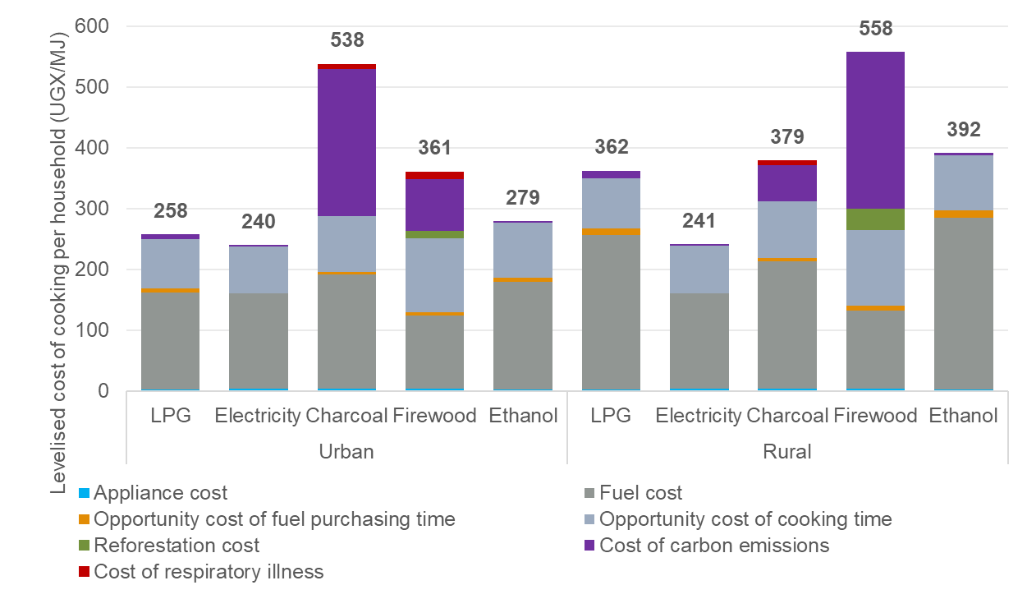
Source: ECA analysis
Therefore, it is assumed that households would first switch to electricity for cooking as the least cost option. Not all customers will have access to electricity in the former years of the forecasting period and LPG is assumed to be adopted as well. It was assumed that the number of consumers who will switch to LPG will equal the volume of the available domestic LPG production.
The switch from biofuels and waste (firewood and charcoal) to oil products (LPG) and electricity is assumed to follow the forecasted share of biofuel and waste analysed in the 2023 ETP, with electricity being the preferred option once the cap for LPG availability has been reached. For households that are assumed to continue the usage of biofuels and waste for cooking, a gradual efficiency improvement is assumed reaching 30% by 2050, reflecting the expected gains from the adoption of Improved Cookstoves (ICS) for firewood and charcoal.
The resulting share of households by cooking fuel that was used to forecast electrical and non-electrical energy demand for cooking of residential consumers is shown in Figure 30.
Figure 30 Forecast fuel use for cooking (% of total households)
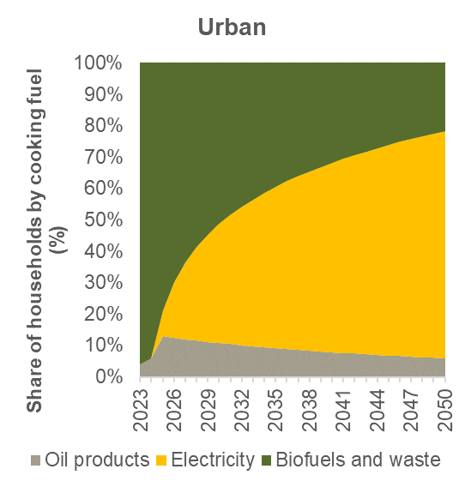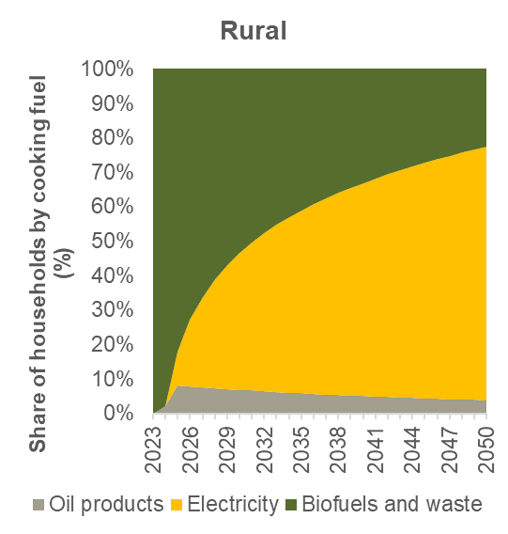
Source: ECA analysis
The assumed average energy electricity requirements per urban and rural household for cooking are analysed in the table below. The average electrical energy requirement for cooking per household was added to the average consumption per household estimated from the econometric equation. Though, it was added only to the portion of households expected to switch from charcoal/firewood to electrical energy for cooking each year (as shown in Figure 30).
Table 10 Average electricity requirements for cooking per household
 | Item | Unit | Urban households | Rural households
A | Average number of electric stoves per household | number | 1.0 | 1.0
B | Average capacity of electric stove | kW | 1.4 | 1.4
C | Average weeks per year | number | 52 | 52
D | Average number of cooking times per week | times | 16.8 | 16.6
E | Average duration of cooking | hours | 1.5 | 1.5
 | Electricity requirements for cooking per household per year (= A x B x C x D x E) | kWh/year | 1,831.2 | 1,810.4
Source: ECA analysis using data from the Uganda Energy Use Survey report, Table 8 of this report and Table 9 of this report.

Disaggregation of final energy consumption by fuel
The ratios used to disaggregate the energy demand forecast by type of fuel were assumed to be the same for all scenarios and are shown in the table below.
Table 11 Assumed ratios of non-electricity fuels to biofuel and waste by sector
Sector | 2023 | 2025 | 2030 | 2035 | 2040 | 2045 | 2050
Services
Oil to biofuel | 0.0 | 0.0 | 0.2 | 0.3 | 0.5 | 0.7 | 1.0
Coal to biofuel | - | - | - | - | - | - | -
Transport
Oil to biofuel | - | 123.3 | 35.4 | 19.0 | 12.6 | 9.2 | 7.2
Coal to biofuel | - | - | - | - | - | - | -
Industry
Oil to biofuel | 0.1 | 0.3 | 0.5 | 0.5 | 0.6 | 0.6 | 0.6
Coal to biofuel | 0.0 | 0.1 | 0.1 | 0.1 | 0.1 | 0.1 | 0.1
Source: ECA analysis using the targets set in the ETP, the results of the electrical energy demand forecast and the assumptions presented in this section for the electrification of sectors and potential switches in fuel source by end users.

Power sector assumptions
In addition to the input assumptions presented in Section 4.2 and 4.3, the development of the electricity demand forecast requires further assumptions regarding network and commercial losses, tariffs, number of customers by consumer category, exports, electric vehicles and DSM and EE measures.

Number of customers
The historical total number of customers by consumer category has been provided by MEMD during the data collection stage. As of 2023, domestic customers accounted for 95% of all electricity customers in the country with the second largest group being commercial users at 4.5%.
To estimate the demand of residential consumers from the average electrical energy demand per urban or per rural household, it is necessary to assess the number of connected consumers each year. This is set by the number of households in the country and the electrification rate assumed each year. The number of households is assessed through the forecast population and average person per household presented above. The electrification rate is assumed to increase linearly to achieve the electrification targets mentioned in Table 4 and the ability to achieve the targets by scenario.
The table below compares the total number of customers assumed to be connected to the grid across scenarios.
Table 12 Total number of customers by scenario (millions of customers)
 | 2023 (historical) | 2030 | 2040 | 2050
Base transition
Total | 2.11 | 5.71 | 11.81 | 17.49
Residential | 2.01 | 5.59 | 11.68 | 17.35
Non-residential | 0.10 | 0.28 | 0.58 | 0.86
Tenfold growth strategy
Total | 2.11 | 5.71 | 11.81 | 17.49
Residential | 2.01 | 5.59 | 11.68 | 17.35
Non-residential | 0.10 | 0.28 | 0.58 | 0.86
Delayed transition
Total | 2.11 | 3.80 | 8.05 | 14.15
Residential | 2.01 | 3.61 | 7.67 | 13.48
Non-residential | 0.10 | 0.18 | 0.38 | 0.67
Policy targets
Total | 2.11 | 5.71 | 11.81 | 17.49
Residential | 2.01 | 5.59 | 11.68 | 17.35
Non-residential | 0.10 | 0.28 | 0.58 | 0.86
Source: Data provided by MEMD, ECA assumptions

Average tariffs
In nominal terms, the average tariffs charged to end-users in Uganda have increased for all customer categories (with the exception of streetlighting) between 2013 and 2023. In real terms, tariffs have remained broadly the same excluding the 2019-2022 period when real term tariffs were decreasing.
The figure below showcases the historical evolution of each customer category’s average tariff (in real terms) compared to the average tariff at the system level. For the demand forecast it was assumed that tariffs will increase following the forecast inflation. In real terms, tariffs were assumed to remain constant.
Figure 31 Average tariffs by customer category
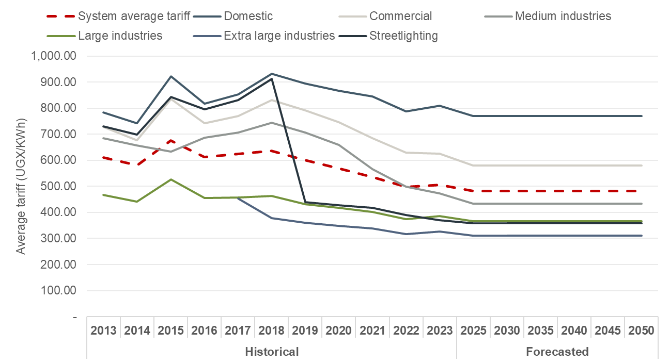
Source: Data provided by MEMD and ERA, ECA assumptions

Transmission and distribution system losses
Historical transmission and distribution system losses have been taken from the latest distribution statistics and transmission statistics from the Uganda Electricity Regulatory Authority (ERA), which provides an overview of sales, losses, and purchases by utility (including UEDCL, UMEME, among others) and for UETCL.
According to these publications, the transmission losses in the country stand at 4.8% of sent-out energy while distribution losses stand at 17.3% of incoming energy as shown in Figure 32.
Figure 32 Historical network losses (% of incoming energy to the grid)
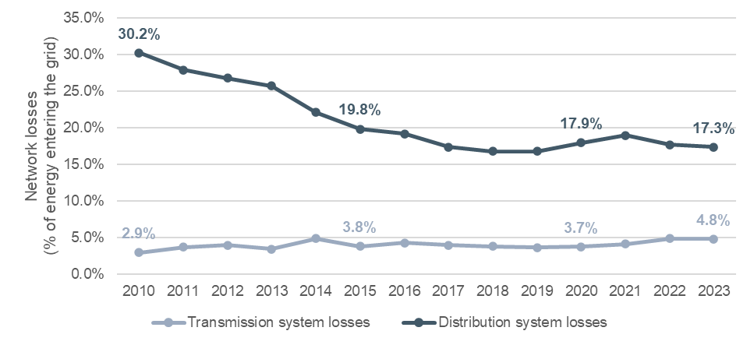
Source: Uganda Electricity Regulatory Authority (ERA)
It is expected that higher incomes in the country would ensure that financing is available for network maintenance and improvements which would also be required to accommodate the increasing electricity demand. Conversely, if economic growth is low, ensuring enough financing for network improvements may prove challenging, with only routine maintenance being performed to avoid deterioration of the networks. In order to forecast these parameters, 2050 estimates have been assumed based on benchmarks from a CEER report on power losses as shown in Table 13 below.
Table 13 Transmission and distribution losses by scenario (% of incoming energy)
 |  | 2023 (historical) | 2030 | 2040 | 2050
 | Base transition
 | Transmission | 4.8% | 4.4% | 3.8% | 3.2%
 | Distribution | 17.3% | 16.1% | 14.3% | 12.5%
 | Tenfold growth strategy
 | Transmission | 4.8% | 4.3% | 2.9% | 2.9%
 | Distribution | 17.3% | 15.4% | 10% | 10%
 | Delayed transition
 | Transmission | 4.8% | 4.5% | 4.0% | 3.5%
 | Distribution | 17.3% | 16.7% | 15.9% | 15%
Policy targets
Transmission |  | 4.8% | 4.3% | 2.9% | 2.9%
Distribution |  | 17.3% | 15.4% | 10% | 10%
Source: Data from ERA, CEER Report on Power Losses, ECA assumptions

Electricity exports
For planning purposes, only firm commitments for exports should be entered to the demand forecast. The generation least cost plan will seek to satisfy the forecast demand and if non-firm export commitments (based on ambitions) are entered to the demand forecast, it will seek to develop capacity that may or may not be utilised for exports.
No information was provided regarding existing or planned Power Purchase Agreements (PPAs) to export electricity to other countries. For the IERMP, it was assumed that the current level of exports reflect existing PPA contracts (firm commitment for exports) and the additional export capacity included in UETCL grid development plan reflects potential export contracts that may materialise in the future. To reflect this uncertainty, probabilities of materialisation were assigned to the forecast exports indicated in UETCL grid development plan, as shown in the table below.
According to ERA’s transmission statistics, Uganda exported 485 GWh of electricity to neighbouring countries (mainly Kenya, Rwanda, and Tanzania) in 2023. According to UETCL grid development plan 2023-2040, Uganda is expected to increase its exporting capacity to Tanzania, Rwanda, DRC, and South Sudan over the 2024-2040 period from the current capacity. The maximum capacity shown below has been added to all scenarios assuming the same load factor as the historical exports reported to each country.
Table 14 Additional electricity exports by scenario
 | Base transition | Tenfold growth strategy | Delayed transition | Policy targets
Export capacity of existing contracts (firm commitments)
Total export capacity | 170 MW | 170 MW | 170 MW | 170 MW
Kenya | 100 MW | 100 MW | 100 MW | 100 MW
Tanzania | 30 MW | 30 MW | 30 MW | 30 MW
Rwanda | 40 MW | 40 MW | 40 MW | 40 MW
Load factor (%) – Kenya | 32% | 32% | 32% | 32%
Load factor (%) – Tanzania | 54% | 54% | 54% | 54%
Load factor (%) – Rwanda | 18% | 18% | 18% | 18%
Probability of occurrence | 100% | 100% | 100% | 100%
Potential additional exporting capacity from new contracts (Non-firm commitments)
Total capacity | 480 MW | 480 MW | 480 MW | 480 MW
Tanzania | 150 MW | 150 MW | 150 MW | 150 MW
Rwanda | 20 MW | 20 MW | 20 MW | 20 MW
DRC | 50 MW | 50 MW | 50 MW | 50 MW
South Sudan | 260 MW | 260 MW | 260 MW | 260 MW
Load factor (%) – Tanzania | 54% | 54% | 54% | 54%
Load factor (%) – Rwanda | 18% | 18% | 18% | 18%
Load factor (%) – DRC | 57% | 57% | 57% | 57%
Load factor (%) – South Sudan | 40%* | 40%* | 40%* | 40%*
Probability of occurrence | 50% | 100% | 0% | 100%
Source: UETCL Grid Development Plan 2023-2040, ECA assumptions. * Weighted average of all other countries.

Step-loads
As mentioned in Section 3.4.5, step-loads are added to the forecast through an end-use approach considering the specific power requirements of each large project alongside their probability of occurrence for each scenario. Step loads are assumed to connect to the transmission system (ie not incurring distribution losses) and categorised as either large industrial or extra-large industrial customers. In the case of data centres, where a capacity of 770 MW has already been committed through PPA, their associated demand is included with a 100% certainty in all scenarios with the exception of the DT scenario, where a low probability is maintained. The step-loads assumed in the demand forecast are provided in Table 15.
Table 15 Probability-adjusted step-loads by scenario (capacity requirement in MW)
 | 2024 | 2030 | 2040 | 2050
Base transition (50% probability of occurrence)
Data centres | 13 MW | 859 MW | 907 MW | 907 MW
Iron and steel plants | 8 MW | 27 MW | 1,305 MW | 1,305 MW
Industrial parks | 56 MW | 717 MW | 3,730 MW | 3,730 MW
Phosphates | - | 13 MW | 75 MW | 75 MW
SGR | - | 28 MW | 268 MW | 268 MW
Tenfold growth strategy (100% probability of occurrence)
Data centres | 15 MW | 988 MW | 1,044 MW | 1,044 MW
Iron and steel plants | 15 MW | 54 MW | 2,611 MW | 2,611 vMW
Industrial parks | 112 MW | 1,435 MW | 7,460 MW | 7,460 MW
Phosphates | - | 26 MW | 149 MW | 149 MW
SGR | - | 56 MW | 535 MW | 535 MW
Delayed transition (10% probability of occurrence)
Data centres | 2 MW | 99 MW | 104 MW | 104 MW
Iron and steel plants | 2 MW | 5 MW | 261 MW | 261 MW
Industrial parks | 11 MW | 14 MW | 746 MW | 746 MW
Phosphates | - | 3 MW | 15 MW | 15 MW
SGR | - | 6 MW | 54 MW | 54 MW
Policy targets (100% probability of occurrence)
Data centres | 15 MW | 988 MW | 1,044 MW | 1,044 MW
Iron and steel plants | 15 MW | 54 MW | 2,611 MW | 2,611 MW
Industrial parks | 112 MW | 1,435 MW | 7,460 MW | 7,460 MW
Phosphates | - | 26 MW | 149 MW | 149 MW
SGR | - | 56 MW | 535 MW | 535 MW
Source: Data provided by MEMD, ECA assumptions

Electric vehicles
The electricity demand from EV charging is assessed through an end-use approach considering the average power requirements per EV, an EV charging profile, and forecasted number of EV in circulation. The current total number of vehicles in circulation has been sourced from URA based on the published number of registered motor vehicles. The forecast number of vehicles in circulation, and the expected share of EVs were sourced from 2023 ETP.
The expected rollout of EV in circulation was carried out fully in the TGS and PT scenarios, with the BT scenario assuming a probability of occurrence of 50% and the DT scenario assuming that the expected rollout only occurs with a 10% probability.
Figure 33 Historical and forecast number of vehicles in circulation
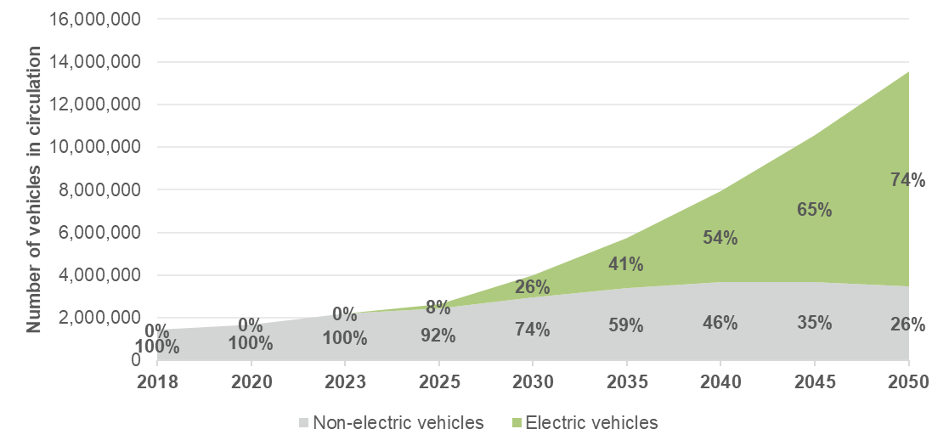
Source: Uganda Revenue Authority, IEA ETP 2023, ECA assumption

Demand-side Management (DSM) and Energy efficiency (EE) measures
Currently Uganda does not implement any official EE or DSM measures to account them in the forecast. EE measures and efficiency gains undertaken by consumers historically are assumed to be maintained in the future through the demand forecast approach selected and presented in Section 3.
Candidate measures are assessed in the DSM and EE measures report and will be included as candidate options for implementation in the least cost planning analysis. If a measure is deemed to be the least-cost option to fulfil the demand, then it will be selected for the IERMP.

Load factor
Over the past ten years, the load factor in Uganda has remained in the 67%-74% range, with the 2023 load factor standing at 69.5%. The load factor represents the ratio of total electricity usage with respect to the maximum utilisation possible and can be used to determine the peak demand of the existing loads in the system.
For the purpose of this analysis, the load factor is assumed to remained unchanged with respect to the 2023 value for the forecasting period. Nonetheless, the introduction of electric vehicles, step-loads, and DSM measures, which vary by scenario, are expected to have a small impact in the system load profile which may increase or decrease the forecasted load factor.
Figure 34 Historical and forecast load factor
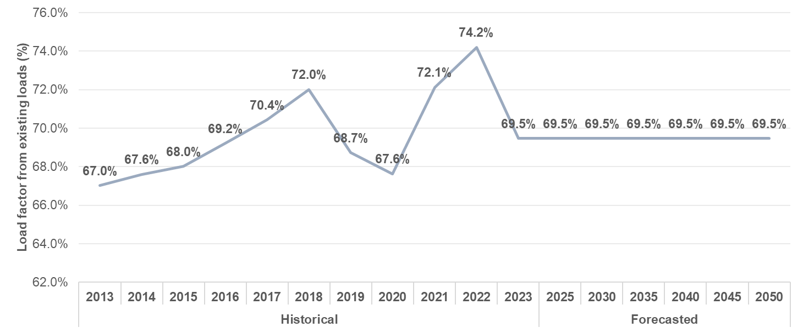
Source: ECA assumption

Load profile
The representative load profile chosen for the development of the electricity demand forecast is from the year 2023 as provided by MEMD. This profile will then be scaled to according to the forecasted electrical energy and peak demand after including the impact of EVs, step-loads, and DSM measures on the load profile.
The process to estimate the hourly load of each year is described in the figure below.
Figure 35 Hourly load profile forecasting process
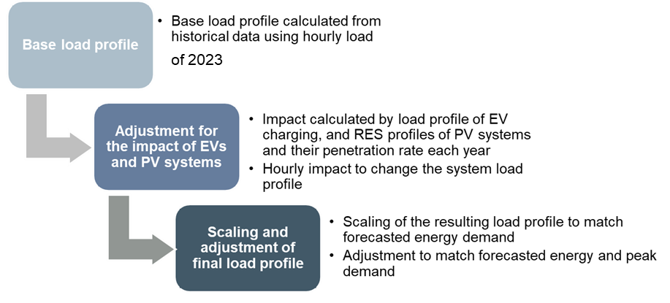
Source: ECA analysis

Summary of input assumptions by scenario
The following table summarises the main input assumptions used for the development of the energy and electricity demand forecast for each scenario.
Table 16 Summary of input assumptions by scenario
 |  |  | Year
Parameter | Unit | Scenario (average) | 2025 | 2030 | 2035 | 2040 | 2045 | 2050
GDP growth | % | DT (3.8%) | 4.4% | 4.4% | 4.1% | 3.7% | 3.4% | 3.0%
 |  | BT (5.7%) | 5.9% | 5.9% | 6.5% | 6.5% | 4.1% | 3.5%
 |  | TGS (6.2%) | 5.9% | 8.0% | 6.8% | 6.0% | 4.4% | 4.0%
 |  | PT (8.6%) | 15.0% | 17.5% | 9.5% | 4.5% | 1.5% | 0.9%
GDP composition | % of total GDP | DT | Increase of the services’ sector from 42.5% of GDP in 2024 to 44.5% in 2050; industrial sector increasing from 25.2% to 28.1%, and agricultural sector decreasing from 24.6% to 20%.
 |  | BT | Increase of the services’ sector from 42.5% of GDP in 2024 to 44.5% in 2050; industrial sector increasing from 25.2% to 28.1%, and agricultural sector decreasing from 24.6% to 20%.
 |  | TGS | Increase of the services’ sector from 42.5% of GDP in 2024 to 44.5% in 2050; industrial sector increasing from 25.2% to 28.1%, and agricultural sector decreasing from 24.6% to 20%.
 |  | PT | Increase of the services’ sector from 42.5% of GDP in 2024 to 44.5% in 2050; industrial sector increasing from 25.2% to 28.1%, and agricultural sector decreasing from 24.6% to 20%.
Population | Million people | DT | 47.8 | 54.8 | 61.9 | 70.5 | 76.2 | 83.5
 |  | BT | 47.8 | 54.8 | 61.9 | 70.5 | 76.2 | 83.5
 |  | TGS | 47.8 | 54.8 | 61.9 | 70.5 | 76.2 | 83.5
 |  | PT | 47.8 | 54.8 | 61.9 | 70.5 | 76.2 | 83.5
Average tariff increases Real terms) | % | DT | No real-term increases assumed (tariffs adjusted to inflation)
 |  | BT | No real-term increases assumed (tariffs adjusted to inflation)
 |  | TGS | No real-term increases assumed (tariffs adjusted to inflation)
 |  | PT | No real-term increases assumed (tariffs adjusted to inflation)
Step-loads | % | DT | Plans implemented with a delay. Low probability of uncertain projects to materialise (10%)
 |  | BT | Plans implemented as planned. Average probability of uncertain projects to materialise (50%)
 |  | TGS | Plans implemented as planned. High probability of uncertain projects to materialise (100%).
 |  | PT | Plans implemented as planned. High probability of uncertain projects to materialise (100%).
EVs fleet | Units by 2050 | DT | Up to 10.1 million as indicated in the Energy Transition Plan, with a low probability of occurrence (10%)
 |  | BT | Up to 10.1 million as indicated in the Energy Transition Plan, with a medium probability of occurrence (50%)
 |  | TGS | Up to 10.1 million as indicated in the Energy Transition Plan, with a high probability of occurrence (100%)
 |  | PT | Up to 10.1 million as indicated in the Energy Transition Plan, with a high probability of occurrence (100%)
Transmission losses (electricity) | % of energy entering transmission | DT | 4.7% | 4.5% | 4.2% | 4.0% | 3.7% | 3.5%
 |  | BT | 4.7% | 4.4% | 4.1% | 3.8% | 3.5% | 3.2%
 |  | TGS | 4.7% | 4.3% | 4.0% | 3.6% | 2.9% | 2.9%
 |  | PT | 4.7% | 4.3% | 4.0% | 3.6% | 2.9% | 2.9%
Distribution losses (electricity) | % of energy entering distribution | DT | 17.2% | 16.7% | 16.3% | 15.9% | 15.4% | 15.0%
 |  | BT | 17.0% | 16.1% | 15.2% | 14.3% | 13.4% | 12.5%
 |  | TGS | 16.8% | 15.4% | 14.1% | 12.7% | 10.0% | 10.0%
 |  | PT | 16.8% | 15.4% | 14.1% | 12.7% | 10.0% | 10.0%
Load factor | % | DT | 69.5% | 69.5% | 69.5% | 69.5% | 69.5% | 69.5%
 |  | BT | 69.5% | 69.5% | 69.5% | 69.5% | 69.5% | 69.5%
 |  | TGS | 69.5% | 69.5% | 69.5% | 69.5% | 69.5% | 69.5%
 |  | PT | 69.5% | 69.5% | 69.5% | 69.5% | 69.5% | 69.5%
Source: ECA assumptions

Demand forecast, 2024-2050
Using the methodology specified in Section 3, as well as the input assumptions and scenarios defined in Section 4, a country-wide energy and electricity demand forecast has been developed for the period 2024-2050. The main results of the forecast for each scenario are summarised in the tables below and described in detail in the remainder of this section. Detailed tables with the annual demand forecasts are included in Annex A2.
Table 17 Energy demand forecast, 2024-2050
Parameter | Unit | 2023 | 2025 | 2030 | 2035 | 2040 | 2045 | 2050
 | Base transition
Final energy consumption | PJ | 738 | 673 | 666 | 721 | 854 | 890 | 934
Oil products | PJ | 68 | 98 | 127 | 144 | 153 | 149 | 133
Electricity | PJ | 17 | 30 | 105 | 191 | 351 | 434 | 535
Biofuels and waste | PJ | 641 | 530 | 415 | 363 | 323 | 278 | 235
Coal | PJ | 5 | 7 | 10 | 10 | 11 | 10 | 9
Others | PJ | 8 | 8 | 11 | 13 | 17 | 20 | 23
 | Tenfold growth strategy
Final energy consumption | PJ | 738 | 679 | 721 | 829 | 1,052 | 1,103 | 1,175
Oil products | PJ | 68 | 98 | 131 | 151 | 160 | 155 | 140
Electricity | PJ | 17 | 36 | 139 | 273 | 527 | 625 | 753
Biofuels and waste | PJ | 641 | 530 | 428 | 379 | 335 | 289 | 245
Coal | PJ | 5 | 7 | 11 | 11 | 12 | 11 | 10
Others | PJ | 8 | 8 | 12 | 15 | 19 | 22 | 26
 | Delayed transition
Final energy consumption | PJ | 738 | 688 | 635 | 636 | 653 | 658 | 669
Oil products | PJ | 68 | 100 | 123 | 133 | 135 | 129 | 115
Electricity | PJ | 17 | 22 | 43 | 75 | 122 | 161 | 212
Biofuels and waste | PJ | 641 | 550 | 451 | 409 | 377 | 348 | 322
Coal | PJ | 5 | 8 | 9 | 9 | 8 | 7 | 6
Others | PJ | 8 | 8 | 9 | 10 | 11 | 13 | 14
 | Policy targets
Final energy consumption | PJ | 738 | 712 | 971 | 1,348 | 1,770 | 1,881 | 1,866
Oil products | PJ | 68 | 102 | 175 | 233 | 254 | 236 | 193
Electricity | PJ | 17 | 40 | 203 | 491 | 939 | 1,159 | 1,287
Biofuels and waste | PJ | 641 | 552 | 553 | 565 | 507 | 414 | 319
Coal | PJ | 5 | 8 | 19 | 26 | 27 | 24 | 19
Others | PJ | 8 | 10 | 21 | 34 | 43 | 48 | 48
Source: ECA analysis
Table 18 Electricity demand forecast, 2024-2050
Parameter | Unit | 2023 | 2025 | 2030 | 2035 | 2040 | 2045 | 2050
 | Base transition
Sent-out energy demand | GWh | 6,012 | 9,971 | 32,971 | 59,604 | 107,940 | 133,444 | 163,996
Sent-out peak demand | MW | 988 | 1,757 | 5,061 | 8,998 | 16,020 | 20,410 | 25,672
Load factor | % | 69.5% | 64.8% | 74.4% | 75.6% | 76.9% | 74.6% | 72.9%
Energy sales | GWh | 4,815 | 8,412 | 29,043 | 53,093 | 97,454 | 120,428 | 148,475
Domestic | GWh | 966 | 1,755 | 7,838 | 15,684 | 27,794 | 39,953 | 54,175
Commercial | GWh | 507 | 630 | 1,264 | 2,307 | 4,212 | 6,528 | 9,293
Industrial* | GWh | 2,854 | 4,521 | 18,153 | 32,851 | 62,525 | 70,132 | 80,082
Streetlighting | GWh | 3 | 3 | 7 | 11 | 15 | 18 | 22
Electric Vehicles | GWh | - | 71 | 351 | 809 | 1,477 | 2,366 | 3,472
Exports | GWh | 485 | 1,430 | 1,430 | 1,430 | 1,430 | 1,430 | 1,430
 | Tenfold growth strategy
Sent-out energy demand | GWh | 6,012 | 11,532 | 42,368 | 81,473 | 153,702 | 182,870 | 220,987
Sent-out peak demand | MW | 988 | 2,058 | 6,407 | 11,998 | 22,120 | 27,260 | 33,956
Load factor | % | 69.5% | 64.0% | 75.5% | 77.5% | 79.3% | 76.6% | 74.3%
Energy sales | GWh | 4,815 | 10,007 | 38,606 | 75,926 | 146,388 | 173,655 | 209,178
Domestic | GWh | 966 | 1,755 | 8,478 | 17,379 | 30,501 | 44,512 | 62,136
Commercial | GWh | 507 | 630 | 1,497 | 2,871 | 5,042 | 7,928 | 11,748
Industrial* | GWh | 2,854 | 5,324 | 25,771 | 51,896 | 105,725 | 114,313 | 126,175
Streetlighting | GWh | 3 | 3 | 7 | 11 | 15 | 18 | 22
Electric Vehicles | GWh | - | 143 | 702 | 1,619 | 2,954 | 4,732 | 6,944
Exports | GWh | 485 | 2,151 | 2,151 | 2,151 | 2,151 | 2,151 | 2,151
 | Delayed transition
Sent-out energy demand | GWh | 6,012 | 7,490 | 14,451 | 24,736 | 39,678 | 52,621 | 69,131
Sent-out peak demand | MW | 988 | 1,312 | 2,403 | 3,985 | 6,252 | 8,418 | 11,178
Load factor | % | 69.5% | 65.2% | 68.7% | 70.9% | 72.4% | 71.4% | 70.6%
Energy sales | GWh | 4,815 | 6,038 | 11,890 | 20,741 | 33,837 | 44,756 | 58,807
Domestic | GWh | 966 | 1,509 | 4,163 | 7,600 | 12,086 | 17,803 | 24,931
Commercial | GWh | 507 | 614 | 931 | 1,384 | 1,996 | 2,787 | 3,772
Industrial* | GWh | 2,854 | 3,413 | 6,237 | 11,102 | 18,965 | 23,194 | 28,907
Streetlighting | GWh | 3 | 3 | 5 | 7 | 10 | 13 | 17
Electric Vehicles | GWh | - | 14 | 70 | 162 | 295 | 473 | 694
Exports | GWh | 485 | 485 | 485 | 485 | 485 | 485 | 485
 | Policy targets
Sent-out energy demand | GWh | 6,012 | 12,916 | 63,940 | 152,796 | 284,573 | 352,689 | 390,774
Sent-out peak demand | MW | 988 | 2,286 | 9,952 | 23,717 | 43,624 | 55,164 | 61,855
Load factor | % | 69.5% | 64.5% | 73.3% | 73.5% | 74.5% | 73.0% | 72.1%
Energy sales | GWh | 4,815 | 11,107 | 56,306 | 136,273 | 260,755 | 322,060 | 357,555
Domestic | GWh | 966 | 2,172 | 17,819 | 53,640 | 103,085 | 138,148 | 153,330
Commercial | GWh | 507 | 813 | 4,553 | 13,171 | 24,022 | 32,815 | 36,748
Industrial* | GWh | 2,854 | 5,826 | 31,073 | 65,681 | 128,527 | 144,196 | 158,360
Streetlighting | GWh | 3 | 3 | 7 | 11 | 15 | 18 | 22
Electric Vehicles | GWh | - | 143 | 702 | 1,619 | 2,954 | 4,732 | 6,944
Exports | GWh | 485 | 2,151 | 2,151 | 2,151 | 2,151 | 2,151 | 2,151
Source: ECA analysis. Note: * Includes medium, large, and extra-large industrial customers

Energy demand forecast, 2024-2050
The final energy consumption in Uganda reached 738 PJ in 2023 growing with an annual average growth rate of 3.5% in the last 10 years.
The energy demand forecast for all scenarios and sector is shown in Figure 36. Energy demand is expected to grow at an average annual rate of 0.9% in the BT scenario, 1.7% in the TGS scenario, -0.4%% in the DT scenario, and 3.5% in the PT scenario by 2050.
Energy demand in Uganda is expected to decrease in the short term as households rapidly adopt modern energy sources for activities such as lighting and, more impactfully, cooking. The improved energy efficiency of electricity and LPG in comparison to charcoal and firewood reduces the overall energy requirements. From 2030 onwards, demand increase due to the assumed high economic growth and rapid electrification. By 2050, energy demand is expected to increase to between 669 and 1,175 PJ with a maximum of 1,866 PJ under sustained growth rates above the ETP projections.
Figure 36 Final energy consumption forecast by scenario 2024-2050
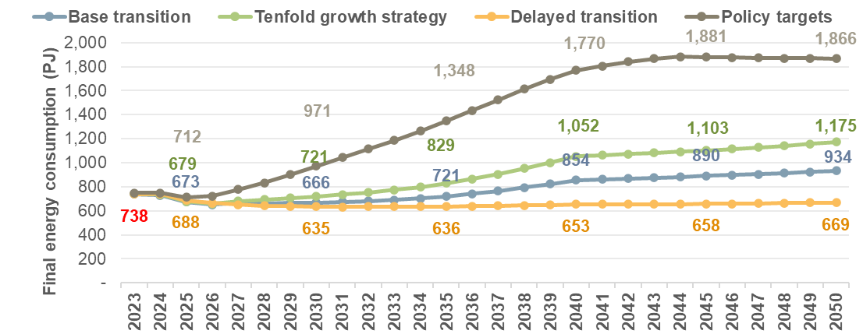
Source: ECA analysis

Figure 37 Final energy consumption forecast growth by scenario 2024-2050
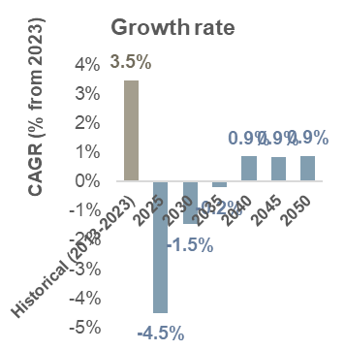  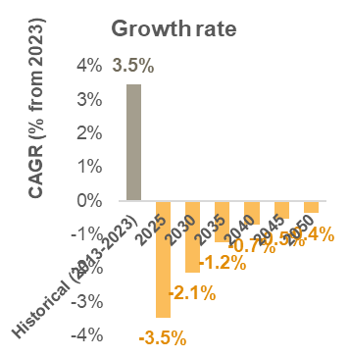 | 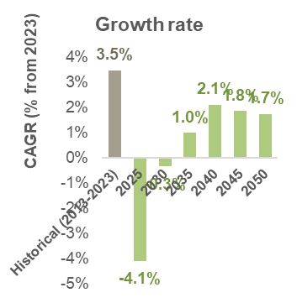  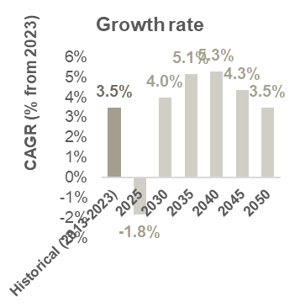
Source: ECA analysis
Final energy consumption is also forecasted by sector and type of fuel considering fuel switches due to electrification, rollout of EVs, and the electrification of industrial customers. As the use of electricity by households and industrial customers increase, a switch from biofuels and waste is foreseen in all scenarios. Whereas the rollout of EVs is expected to facilitate a switch from oil products to electricity, resulting in an increase of electricity demand in the energy demand mix, reaching almost 64% of the final energy consumption in the TGS scenario and almost 70% in the PT scenario. The final energy consumption by type of fuel for each scenario is presented in the figures below.
Figure 38 Final energy consumption by type of fuel – Base transition scenario
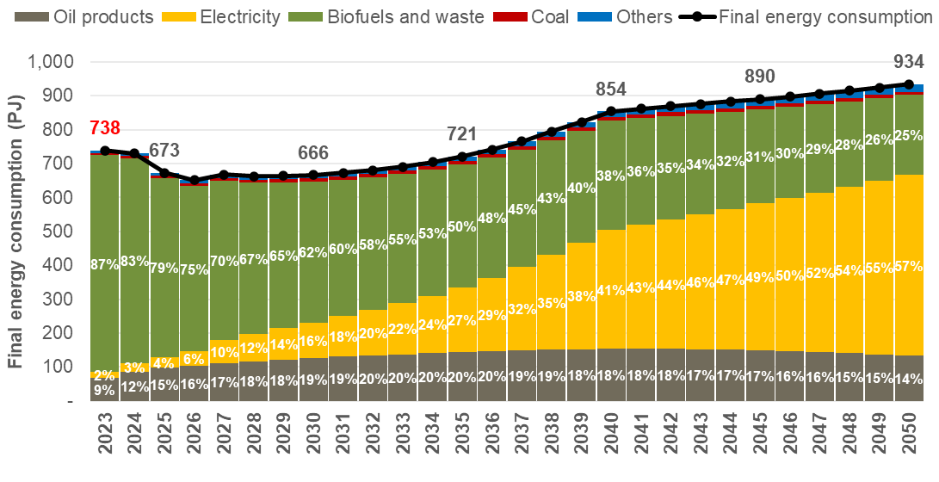
Source: ECA analysis
Figure 39 Final energy consumption by type of fuel – Tenfold growth strategy scenario
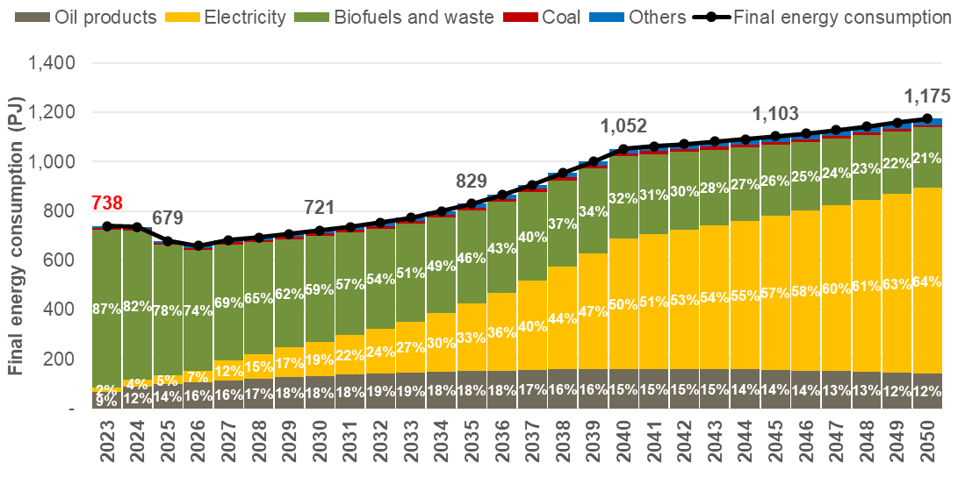
Source: ECA analysis
Figure 40 Final energy consumption by type of fuel – Delayed transition scenario
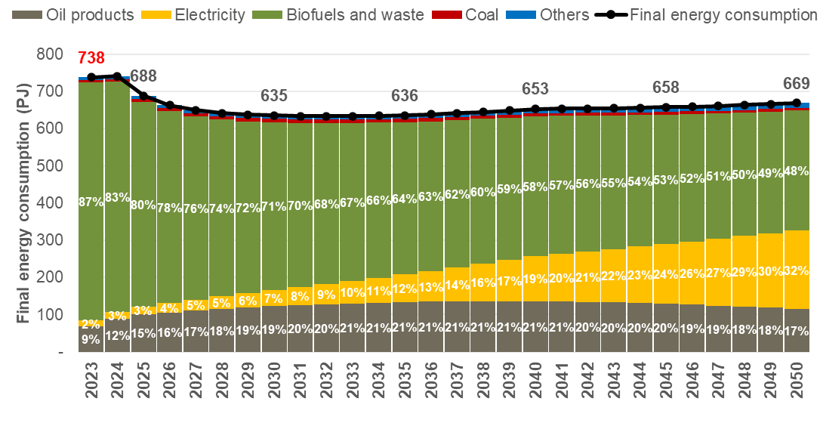
Source: ECA analysis
Figure 41 Final energy consumption by type of fuel – Policy targets scenario
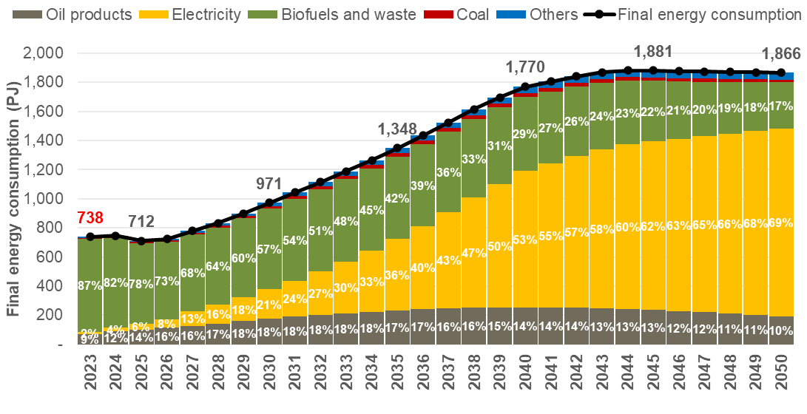
Source: ECA analysis

Energy demand forecast by sector

Residential sector
The residential sector accounted for 61% of final energy consumption in 2023. Characterised by high usage of biowaste and biomass for cooking, it is expected that households will opt to switch to LPG or electricity as incomes increase and electrification efforts reach the poorly served rural areas. This is expected to reduce the overall energy requirements of the sector due the higher efficiency of clean fuels. The total energy demand for this sector is expected to return to its current levels with small differences between scenarios, as shown below.
Figure 42 Final energy demand forecast – Residential sector
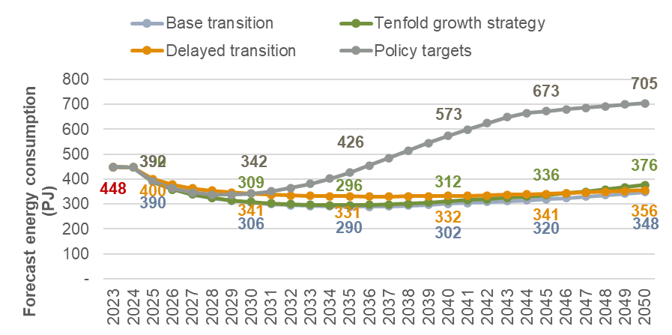
Source: ECA analysis

Services sector
In contrast to with the residential sector, the services sector is expected to increase their energy demand over the 2024-2050 period with an average growth rate of between -1.6% and 4.9%, reaching a final energy demand of between 41 PJ in the DT scenario and 92 PJ in the TGS scenario, with the PT scenario reaching 228 PJ (see Figure 43). The main drivers of the increase in demand are strong GDP growth and electrification.
Figure 43 Final energy demand forecast – Services sector
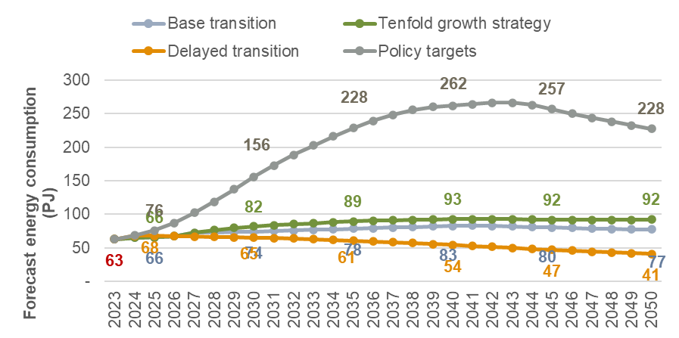
Source: ECA analysis

Industrial sector
The industrial sector in Uganda is also expected to increase its energy demand at a lower rate than the historical average (3.8%) in the DT and BT scenarios while increasing at higher rates in the TGS and PT scenarios due to the increasing use of electricity and oil products replacing biofuels and waste. As can be seen in the figure below, the final energy consumption for this sector is expected to increase from 168 PJ in 2023 to between 172 PJ in the DT scenario (0.1% annual growth) and 565 PJ in the Policy targets scenario (4.6% annual growth), if a higher GDP growth rate is assumed, the expected final energy consumption for the sector reaches 770 PJ (5.8% annual growth).
Figure 44 Final energy demand forecast – Industrial sector
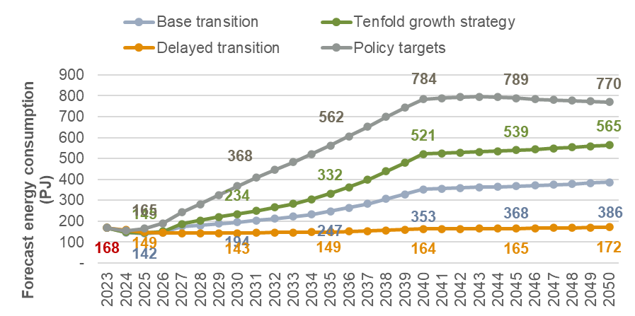
Source: ECA analysis

Transport sector
While for all other sectors their final energy demand is contingent upon the expansion of the sector due to increasing incomes or new investments, for the transport sector there are two determinants of final energy consumption. First, the increase of vehicles in circulation, including motorbikes, personal vehicles, and freight, which is increases the demand. And secondly, the adoption of EVs to replace the existing vehicles, with EVs requiring considerably less energy per vehicle than the current ones fuelled by oil products. As EVs represent a larger share of the total amount of vehicles in circulation after 2040, the energy demand falls reflecting the higher efficiency of the overall fleet.
Figure 45 Final energy demand forecast – Transport sector
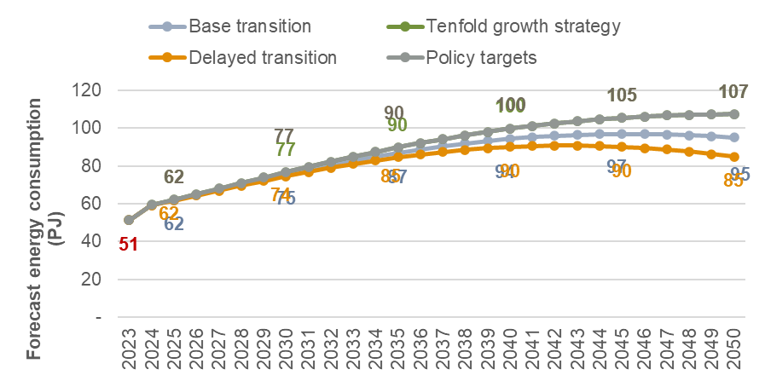
Source: ECA analysis

Other sectors
Other uses of final energy consumption represent a negligible share in the total final energy consumption, accounting for only 8 PJ in 2023 or 1.1% of the final energy consumption in Uganda. This is forecasted using a linear trend reflecting historical data, where each scenario considers a sample of years with high and low growth for the sector, while for the PT scenario, an exponential trend is assumed to reflect sustained growth considerably above the historical period.
Figure 46 Final energy demand forecast – Other sectors
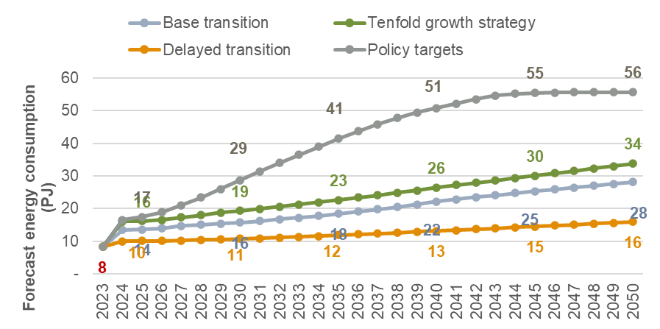
Source: ECA analysis

Electricity demand forecast, 2024-2050

Sent-out energy demand forecast
The sent-out energy demand for Uganda in 2023 reached 6,012 GWh, averaging an annual growth rate of 7.1% since 2013. The main contributor to electricity demand was the industrial sector, accounting for almost 60% of demand when including medium industrial (12%), large industrial (25%), and extra-large industrial customers (22%). The high levels of economic growth forecasted for the 2024-2050 period are expected to increase the energy demand for all sectors outpacing historical growth.
The electrification targets, industrialisation efforts, and adoption of Electric Vehicles, are expected to increase the sent-out energy demand in the country to between 69.1 TWh and 220.9 TWh by 2050. If a considerably higher growth rate is assumed, sent-out energy demand can be expected to reach as high as 390.7 TWh in the same time period. This represents annual increases of 9.5% for the DT scenario, 13.0% for the BT scenario, 14.3% for the TGS scenario, and 16.7% in the PT scenario. The figures below illustrate the sent-out energy demand forecast by scenario for the 2024-2050 period.
Figure 47 Sent-out electrical energy demand forecast, 2024-2050
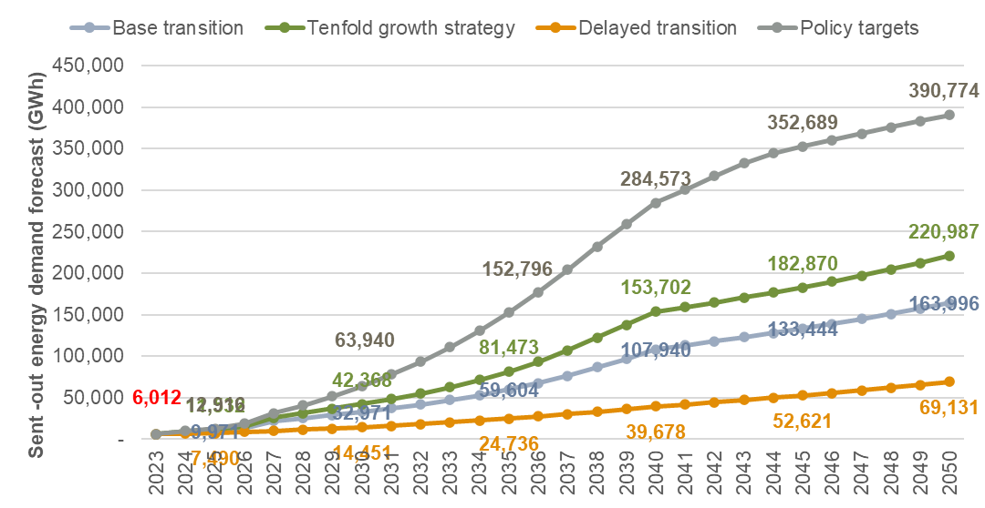
Source: ECA analysis
Figure 48 Compound annual growth rate of sent-out energy demand by scenario
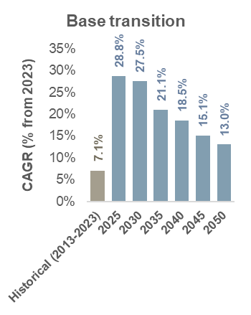 | 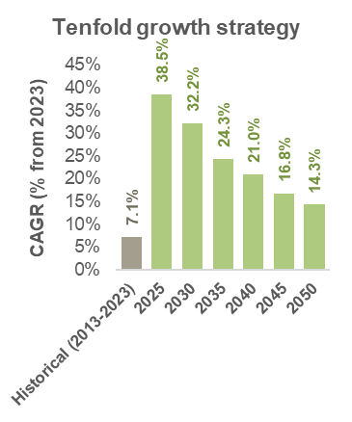
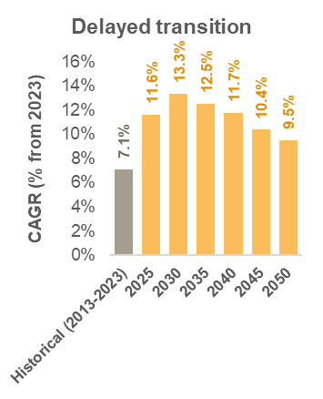 | 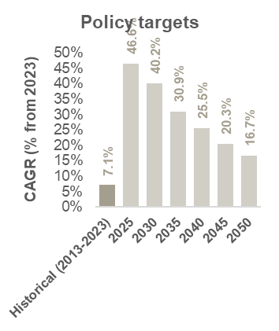
Source: ECA analysis

Sent-out peak demand forecast
The sent-out peak demand in Uganda reached 988 MW in 2023 with an average annual growth rate of 6.7% over the past 10 years. As with sent-out energy demand, peak demand is expected to increase mainly due to electrification of households, adoption of electric vehicles, and the increasing demand of industrial and commercial users.
By 2050, the sent-out peak demand is expected to reach 11.1 GW in the DT scenario, 25.7 GW in the BT scenario, 23.9 GW in the TGS scenario, and 61.8 GW in the PT scenario. This represents an annual increase of between 9.4% and 16.6%, with growth expected to be lower in the later years of the forecasted period due to the assumed maturity of the economy and universal access (new connections grow with population growth rates only). This can be seen in the figure below.
Figure 49 Sent-out peak demand forecast 2024-2050
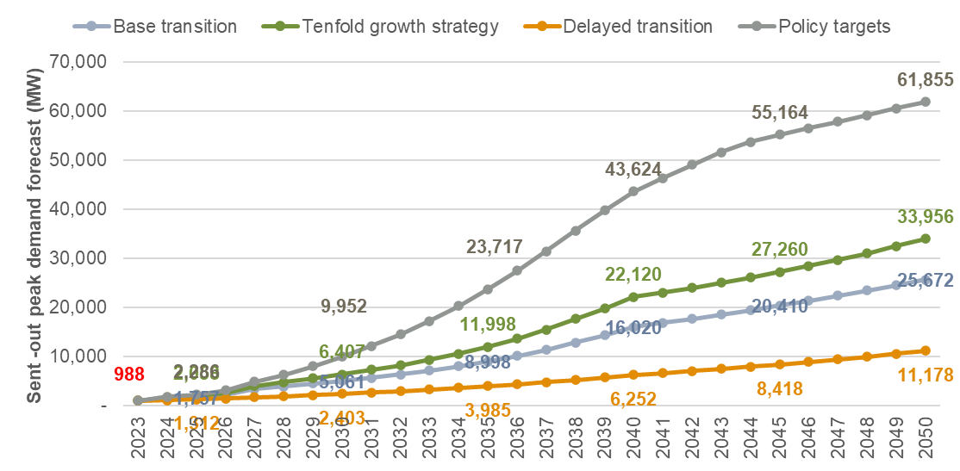
Source: ECA analysis
Figure 50 Compound annual growth rate of sent-out peak demand by scenario
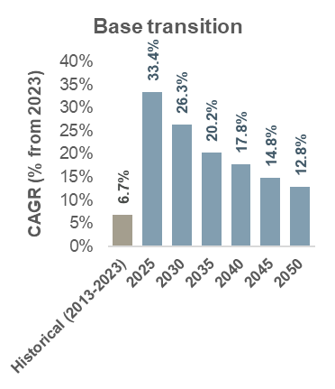 | 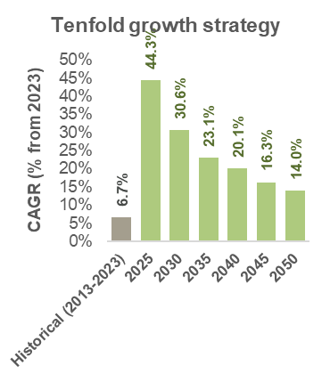

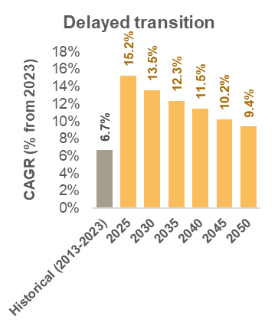 | 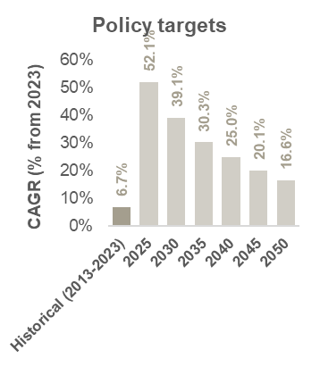
Source: ECA analysis

Load factor and load profile forecast
As of 2023, the load factor at the sent-out level was 69.5%. This factor is assumed to remain constant for existing customers with no substantial change assumed in the consumer’s mix. For the forecasted period, changes in the load factor are attributed to the adoption of EVs, the addition of step-loads, and additional export commitments. EVs and export agreements are expected to slightly improve the load factor to between 70.6% and 74.3% by 2050, which is driven by the connection of industrial loads with high load factors, as can be seen below.
Figure 51 Load factor forecast 2024-2050
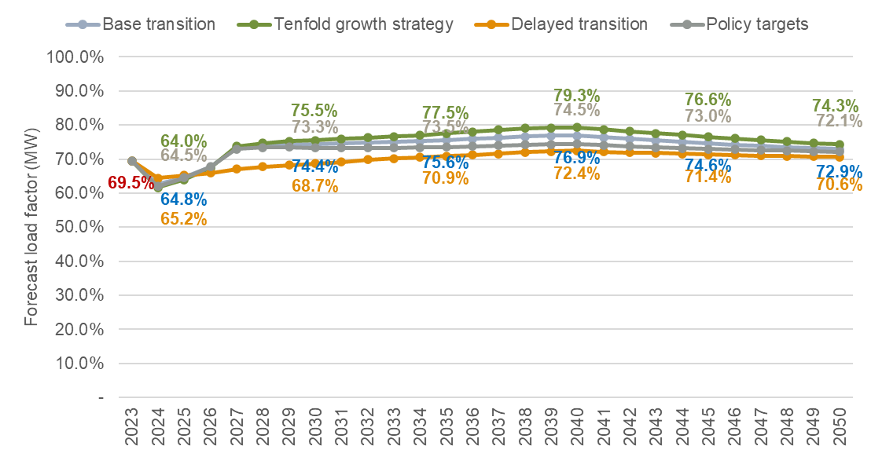
Source: ECA analysis
The decrease in the load factor due to the increase in the rollout of electric vehicles can be seen when comparing the average hourly load factor in 2023 with the forecasted average hourly load factor in 2050 for each of the proposed scenarios, as well as the charging profile used for EV. As illustrated below, the charging profile assumed concentrates EV charging between 18:00 and 20:00, just before the system peak at 21:00, whereas charging during the day is considerably lower. With the ambitious rollout expected in the TGS and PT scenarios, this is almost enough to shift the peak to one hour earlier and increase the afternoon and early evening load by up to 5%.
Figure 52 Load profile for an average day in 2050 by scenario, % of peak demand
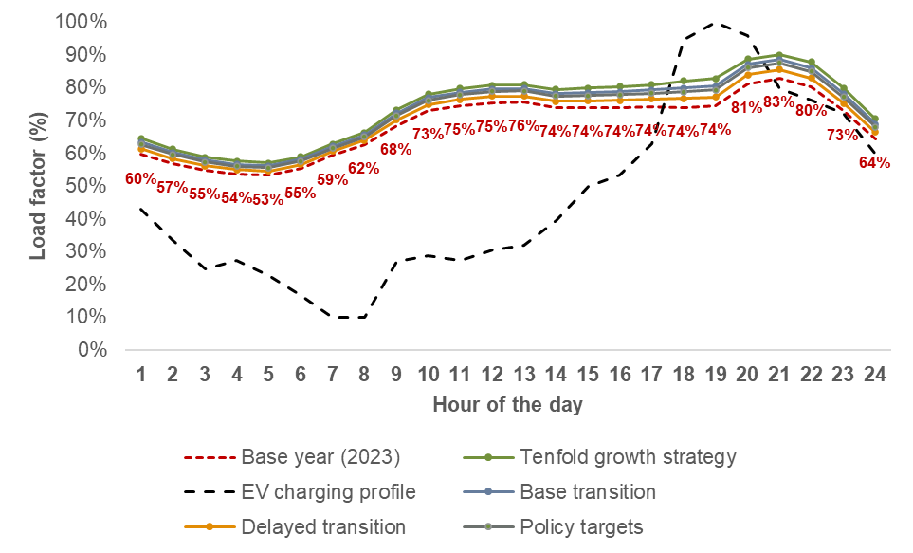
Source: ECA analysis

Sales forecast by customer category

Domestic
As of 2023, the total energy sales from domestic customers added to 966 GWh with an average growth rate of 7.2% over the past 10 years. This growth rate is expected to be higher in the forecasted period as new households gain access to electricity from the grid, especially in urban areas. Furthermore, it is expected that these customers increase their average consumption over time due to the economic growth. Energy sales for domestic customers are expected to increase rapidly in the 2024-2050 period, reaching average growth rates of between 12.8% and 16.7%, with higher economic growth resulting in a domestic sales’ average growth rate of 20.6% and sales of 153 TWh. This results in energy sales forecasted to reach over 62 TWh in the TGS scenario, 54.2 TWh in the BT scenario, and 24.9 TWh in the DT scenario, as shown below.
Figure 53 Sales forecast – Domestic category
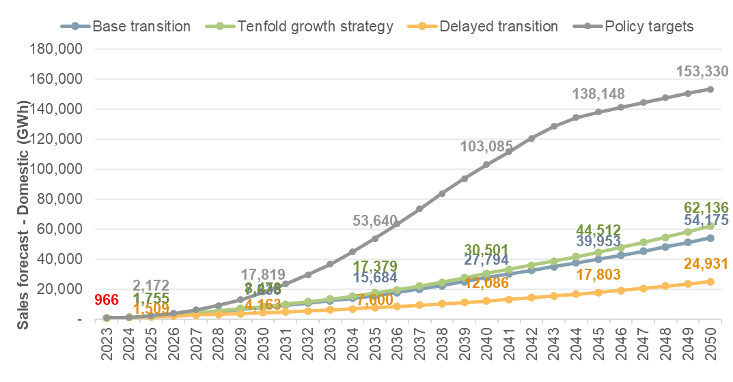
Source: ECA analysis

Commercial
By 2050, it is expected that commercial sales will reach 11.7 TWh in the TGS scenario, 9.3 TWh in the BT scenario, and 3.8 TWh in the DT scenario. This represents an average annual growth rate of between 7.7% and 12.3%. The assumed economic growth, with higher GDP growth than the average historical growth for all scenarios, is the key determinant for the high growth rate of commercial sales demand. Under the PT scenario, commercial sales increase much more rapidly, to a total of 36.7 TWh in 2050.
Figure 54 Sales forecast – Commercial category
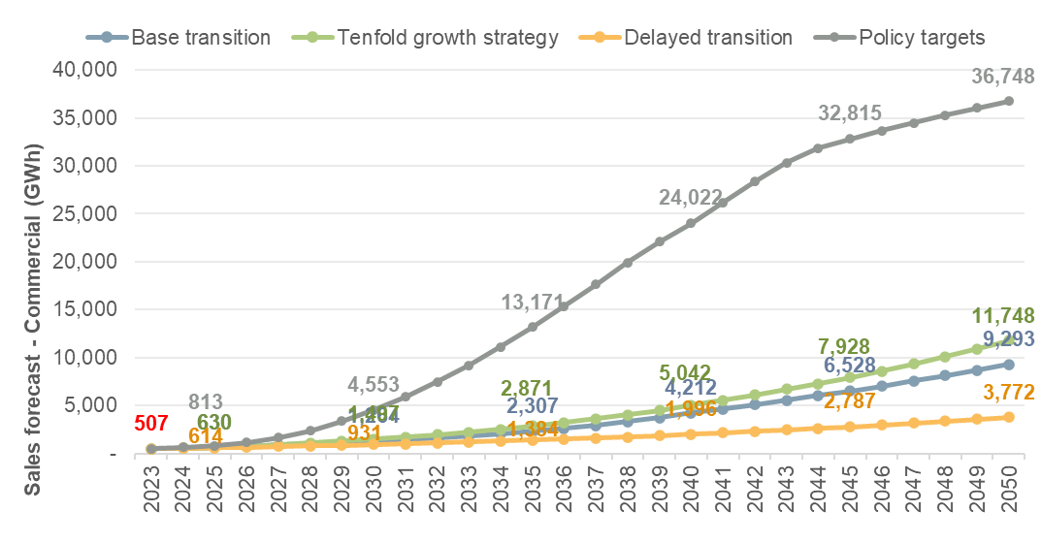
Source: ECA analysis

Medium industries
Medium industrial customers’ electricity sales added to 607 GWh in 2023 with an average annual growth rate of 4.8% over the past 10 years. As with commercial customers, the demand of medium industrial customers relies on the economic growth projections assumed in the forecast. While this results in average growth higher than the historical average, for these customers the increase is not as pronounced as for other customer groups. By 2050, the sales for medium industrial customers are expected to reach 2 TWh in the DT scenario, 3.5 TWh in the BT scenario, 4.1 TWh in the TGS scenario, and 8.4 TWh in the PT scenario.
Figure 55 Sales forecast – Medium industries category
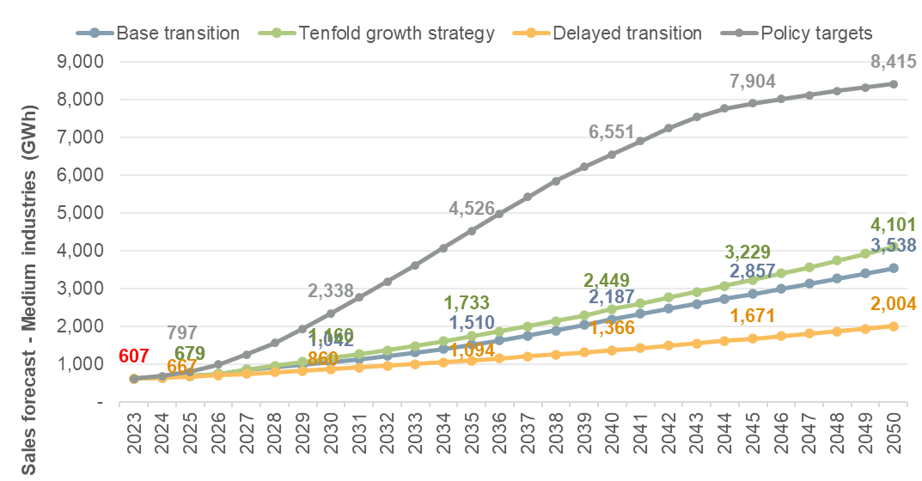
Source: ECA analysis

Large and extra-large industries
Large and extra-large customers have experienced a sustained growth over the last six years, when both categories were split, reaching average annual growth rates of 8.7% and 8.6% respectively. Combined, these customers accounted for 47% of electricity sales in 2023 or 2,247 GWh. For the forecasted period, both categories are expected to grow significantly due to the planned oil production in 2025 and the connection of industrial step-loads and data-centres. This results in combined forecasted sales of 26.9 TWh in the DT scenario, 76.5 TWh in the BT scenario, 122 TWh in the TGS scenario, and 150 TWh in the PT scenario with an average annual growth rate of between 9% and 17%.
Figure 56 Sales forecast – Large industries category
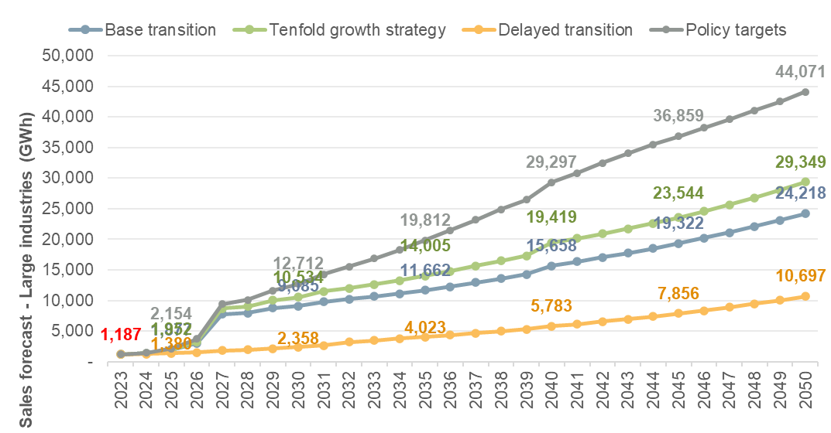
Source: ECA analysis
Figure 57 Sales forecast – Extra-large industries category
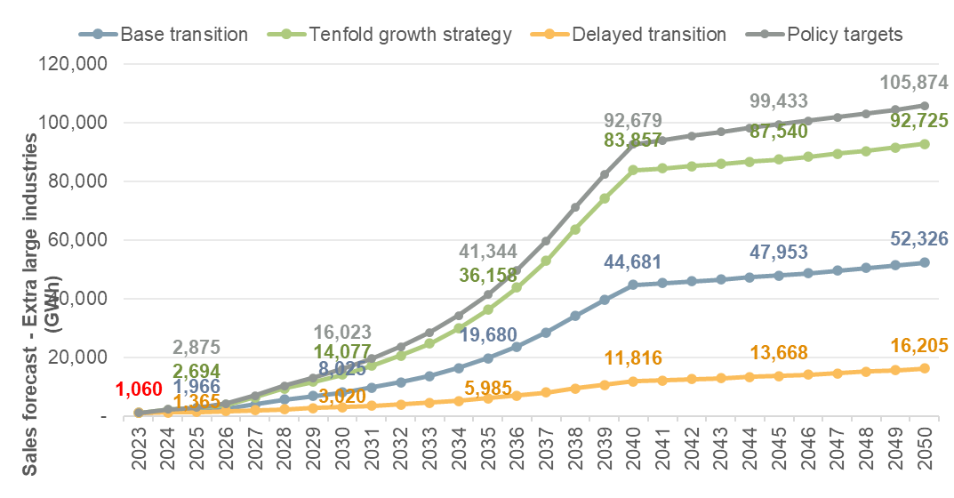
Source: ECA analysis

Streetlighting
Streetlighting sales are almost negligible when compared the other existing customer categories, adding to only 3 GWh in 2023. For the forecasted period, it is assumed that the energy demand increases alongside electrification rates in the country. This results in sales adding to between 17 and 22 GWh by 2050.
Figure 58 Sales forecast – Streetlighting category
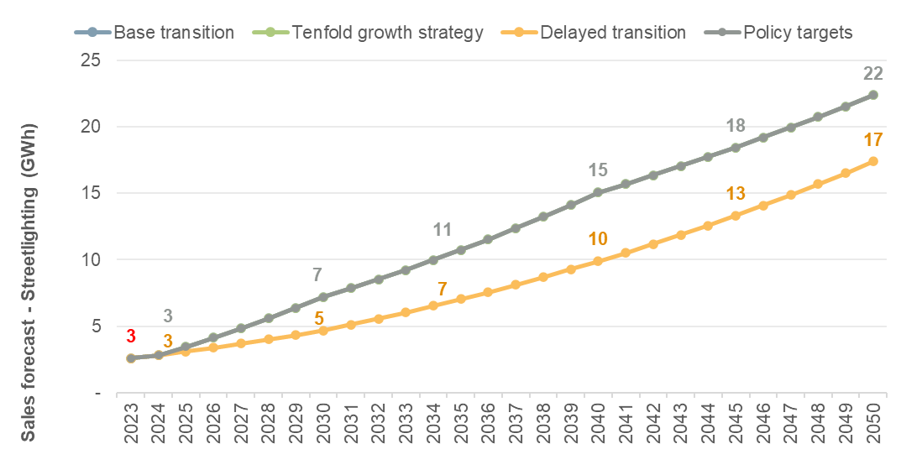
Source: ECA analysis

Electric vehicles
The sales forecast for charging of electric vehicles differs from other categories as it cannot be compared or benchmarked against historical data. In this case, the forecast follows the bottom-up approach described in sections 3 and 4, which relies on the average consumption per vehicle and the forecast rollout of vehicles. This category is expected to account for 0.7 TWh of electricity sales in the DT scenario, 3.5 TWh in the BT scenario, and almost 7 TWh in the TGS and PT scenarios.
Figure 59 Sales forecast – Electric vehicles category
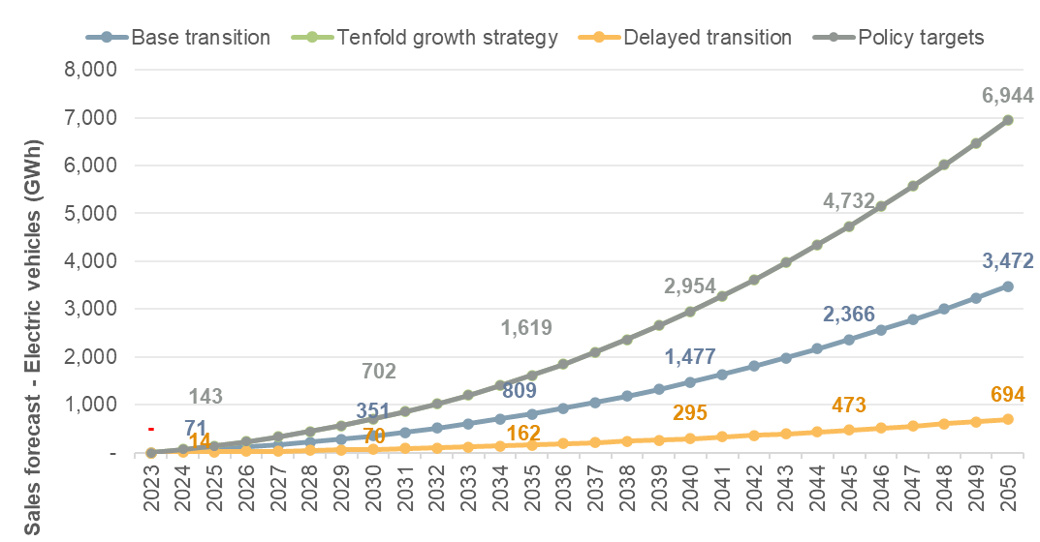
Source: ECA analysis

Consumer’s mix
As shown in the figure below, the consumer’s mix is expected to shift towards an increase of residential demand with the industrial demand remaining the main contributor of total electricity sales. Most changes are caused by the electrification and higher average consumption of households, the rapid adoption of EVs, and the connection of step-loads. This results in the residential share of sales in all scenarios up to 43% if the highest growth rates are maintained throughout the forecasted period. In the short term, additional exports to Rwanda, DRC, Tanzania, and South Sudan may take a considerable share of sales, though this is expected to rapidly reduce over time as domestic consumption increases.
Figure 60 Consumer’s mix forecast by scenario
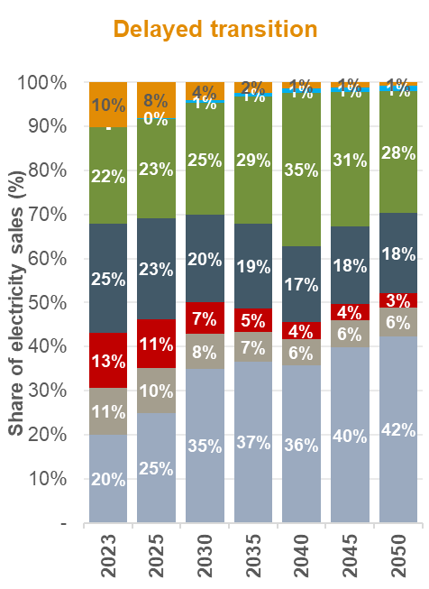 | 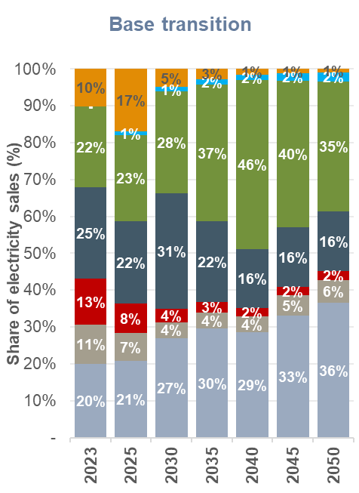
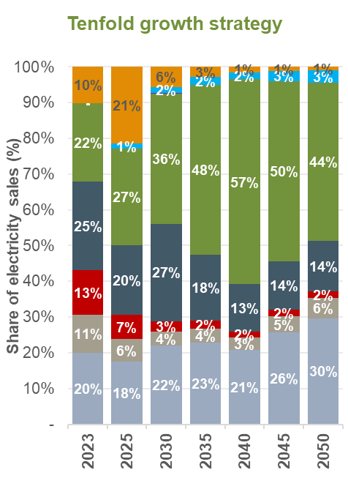 | 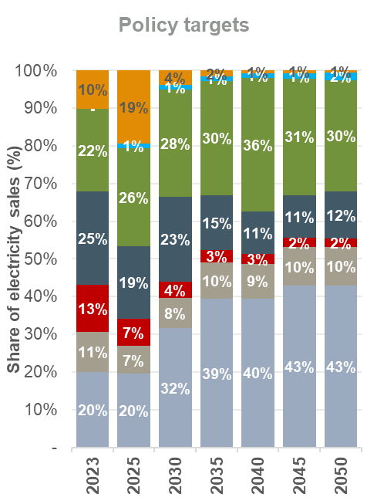
Source: ECA analysis

Demand forecast by sub-region
The geographical disaggregation of demand has been obtained for each scenario in order to inform the aggregation of demand by zone which will be used for the development of the transmission and distribution plan in the IERMP. For the energy demand forecast, this disaggregation is done based on the sub-regional population estimates from the 2024 Census and kept constant for the forecasting period.
For the peak demand forecast, on the other hand, it is assumed that all subregions follow the same load profile and thus present the same load factor as the overall country’s load factor. The forecast for representative years in each subregion is presented below.
Table 19 Load forecast by sub-region
Sub-region | Energy demand (GWh) |  |  | Peak demand (MW)
 | 2025 | 2035 | 2050 | 2025 | 2035 | 2050
Base transition
Kampala city | 390 | 2,334 | 6,422 | 69 | 352 | 1,005
Buganda | 2,427 | 14,506 | 39,911 | 428 | 2,190 | 6,248
Busoga | 948 | 5,665 | 15,588 | 167 | 855 | 2,440
Bukedi | 515 | 3,080 | 8,476 | 91 | 465 | 1,327
Bugisu | 397 | 2,373 | 6,530 | 70 | 358 | 1,022
Sebei | 82 | 490 | 1,348 | 14 | 74 | 211
Teso | 535 | 3,197 | 8,797 | 94 | 483 | 1,377
Karamoja | 325 | 1,943 | 5,345 | 57 | 293 | 837
Lango | 553 | 3,306 | 9,096 | 97 | 499 | 1,424
Acholi | 444 | 2,654 | 7,303 | 78 | 401 | 1,143
West Nile | 720 | 4,306 | 11,847 | 127 | 650 | 1,855
Madi | 120 | 718 | 1,976 | 21 | 108 | 309
Bunyoro | 607 | 3,626 | 9,977 | 107 | 547 | 1,562
Tooro | 468 | 2,797 | 7,696 | 82 | 422 | 1,205
Rwenzori | 268 | 1,602 | 4,407 | 47 | 242 | 690
Ankole | 784 | 4,686 | 12,893 | 138 | 707 | 2,018
Kigezi | 388 | 2,321 | 6,385 | 68 | 350 | 999
Tenfold growth strategy
Kampala city | 452 | 3,191 | 8,654 | 81 | 470 | 1,330
Buganda | 2,807 | 19,828 | 53,781 | 501 | 2,920 | 8,264
Busoga | 1,096 | 7,744 | 21,005 | 196 | 1,140 | 3,228
Bukedi | 596 | 4,211 | 11,421 | 106 | 620 | 1,755
Bugisu | 459 | 3,244 | 8,799 | 82 | 478 | 1,352
Sebei | 95 | 670 | 1,816 | 17 | 99 | 279
Teso | 619 | 4,370 | 11,854 | 110 | 644 | 1,821
Karamoja | 376 | 2,655 | 7,202 | 67 | 391 | 1,107
Lango | 640 | 4,519 | 12,257 | 114 | 665 | 1,883
Acholi | 514 | 3,628 | 9,841 | 92 | 534 | 1,512
West Nile | 833 | 5,886 | 15,964 | 149 | 867 | 2,453
Madi | 139 | 982 | 2,663 | 25 | 145 | 409
Bunyoro | 702 | 4,957 | 13,444 | 125 | 730 | 2,066
Tooro | 541 | 3,823 | 10,370 | 97 | 563 | 1,593
Rwenzori | 310 | 2,189 | 5,938 | 55 | 322 | 912
Ankole | 907 | 6,405 | 17,373 | 162 | 943 | 2,670
Kigezi | 449 | 3,172 | 8,604 | 80 | 467 | 1,322
Delayed transition
Kampala city | 293 | 969 | 2,707 | 51 | 156 | 438
Buganda | 1,823 | 6,020 | 16,824 | 319 | 970 | 2,720
Busoga | 712 | 2,351 | 6,571 | 125 | 379 | 1,062
Bukedi | 387 | 1,278 | 3,573 | 68 | 206 | 578
Bugisu | 298 | 985 | 2,752 | 52 | 159 | 445
Sebei | 62 | 203 | 568 | 11 | 33 | 92
Teso | 402 | 1,327 | 3,708 | 70 | 214 | 600
Karamoja | 244 | 806 | 2,253 | 43 | 130 | 364
Lango | 415 | 1,372 | 3,834 | 73 | 221 | 620
Acholi | 334 | 1,102 | 3,079 | 58 | 177 | 498
West Nile | 541 | 1,787 | 4,994 | 95 | 288 | 807
Madi | 90 | 298 | 833 | 16 | 48 | 135
Bunyoro | 456 | 1,505 | 4,206 | 80 | 242 | 680
Tooro | 351 | 1,161 | 3,244 | 62 | 187 | 525
Rwenzori | 201 | 665 | 1,858 | 35 | 107 | 300
Ankole | 589 | 1,945 | 5,435 | 103 | 313 | 879
Kigezi | 292 | 963 | 2,691 | 51 | 155 | 435
Policy targets
Kampala city | 506 | 5,984 | 15,303 | 90 | 929 | 2,422
Buganda | 3,143 | 37,186 | 95,102 | 556 | 5,772 | 15,054
Busoga | 1,228 | 14,523 | 37,143 | 217 | 2,254 | 5,879
Bukedi | 668 | 7,897 | 20,196 | 118 | 1,226 | 3,197
Bugisu | 514 | 6,084 | 15,559 | 91 | 944 | 2,463
Sebei | 106 | 1,256 | 3,212 | 19 | 195 | 508
Teso | 693 | 8,196 | 20,961 | 123 | 1,272 | 3,318
Karamoja | 421 | 4,980 | 12,736 | 74 | 773 | 2,016
Lango | 716 | 8,475 | 21,674 | 127 | 1,315 | 3,431
Acholi | 575 | 6,805 | 17,403 | 102 | 1,056 | 2,755
West Nile | 933 | 11,038 | 28,230 | 165 | 1,713 | 4,468
Madi | 156 | 1,841 | 4,709 | 28 | 286 | 745
Bunyoro | 786 | 9,296 | 23,773 | 139 | 1,443 | 3,763
Tooro | 606 | 7,170 | 18,337 | 107 | 1,113 | 2,903
Rwenzori | 347 | 4,106 | 10,500 | 61 | 637 | 1,662
Ankole | 1,015 | 12,012 | 30,722 | 180 | 1,865 | 4,863
Kigezi | 503 | 5,949 | 15,214 | 89 | 923 | 2,408
Source: ECA analysis

Demand forecast by transmission zone
The demand forecast by transmission zone considers the seven zones used by UETCL in the Energy Policy 2023. For the energy demand forecast, this demand is based on the aggregation of sub-regional demand reflecting the location of load centres and substations. The peak demand forecast assumes all transmission zones present the same load factor as the overall country’s load factor. The forecast for representative years in each zone is presented below.
Table 20 Load forecast by sub-region
Sub-region | Energy demand (GWh) |  |  | Peak demand (MW)
 | 2025 | 2035 | 2050 | 2025 | 2035 | 2050
Base transition
Central | 1,205 | 7,200 | 19,811 | 212 | 1,087 | 3,101
Eastern | 2,072 | 12,383 | 34,072 | 365 | 1,869 | 5,334
GKM | 1,404 | 8,394 | 23,095 | 247 | 1,267 | 3,615
Jinja Metro | 939 | 5,611 | 15,438 | 165 | 847 | 2,417
Northern | 975 | 5,826 | 16,030 | 172 | 880 | 2,509
West Nile | 942 | 5,632 | 15,496 | 166 | 850 | 2,426
Western | 2,435 | 14,557 | 40,053 | 429 | 2,198 | 6,270
Tenfold growth strategy
Central | 1,393 | 9,842 | 26,696 | 249 | 1,449 | 4,102
Eastern | 2,396 | 16,927 | 45,912 | 428 | 2,493 | 7,055
GKM | 1,624 | 11,474 | 31,121 | 290 | 1,690 | 4,782
Jinja Metro | 1,086 | 7,670 | 20,803 | 194 | 1,129 | 3,197
Northern | 1,127 | 7,964 | 21,601 | 201 | 1,173 | 3,319
West Nile | 1,090 | 7,698 | 20,881 | 194 | 1,134 | 3,209
Western | 2,817 | 19,899 | 53,973 | 503 | 2,930 | 8,293
Delayed transition
Central | 905 | 2,988 | 8,351 | 158 | 481 | 1,350
Eastern | 1,556 | 5,139 | 14,363 | 273 | 828 | 2,322
GKM | 1,055 | 3,484 | 9,736 | 185 | 561 | 1,574
Jinja Metro | 705 | 2,329 | 6,508 | 124 | 375 | 1,052
Northern | 732 | 2,418 | 6,757 | 128 | 389 | 1,093
West Nile | 708 | 2,337 | 6,532 | 124 | 376 | 1,056
Western | 1,829 | 6,041 | 16,884 | 320 | 973 | 2,730
Policy targets
Central | 1,560 | 18,458 | 47,207 | 276 | 2,865 | 7,472
Eastern | 2,683 | 31,745 | 81,187 | 475 | 4,928 | 12,851
GKM | 1,819 | 21,518 | 55,032 | 322 | 3,340 | 8,711
Jinja Metro | 1,216 | 14,384 | 36,786 | 215 | 2,233 | 5,823
Northern | 1,263 | 14,936 | 38,198 | 223 | 2,318 | 6,046
West Nile | 1,220 | 14,438 | 36,924 | 216 | 2,241 | 5,845
Western | 3,155 | 37,318 | 95,441 | 558 | 5,793 | 15,107
Source: ECA analysis

Comparison with previous demand forecasts
The most recent forecast considering final energy consumption in Uganda corresponds to the IEA Energy Transition Plan 2023, where trends such as the switch from biofuels and waste towards electricity and oil products is expected in the country, reducing the final energy consumption to 589 PJ in 2030 before increasing alongside economic growth to reach 982 PJ by 2050.
As can be seen in the figure below, the energy forecast for the IERMP captures a similar trend of decrease until 2030 with subsequent growth, especially in the BT scenario which assumes similar levels of economic growth to the IEA’s assumptions until 2040 (6.5% per annum). As can be seen, assuming considerably higher growth rates than the ETP results in a forecast that diverges rapidly from the ETP projections, reaching a final energy consumption 80% higher by 2050. A description of the previous forecasts is provided in Annex A1.
Figure 61 Final energy consumption forecast comparison
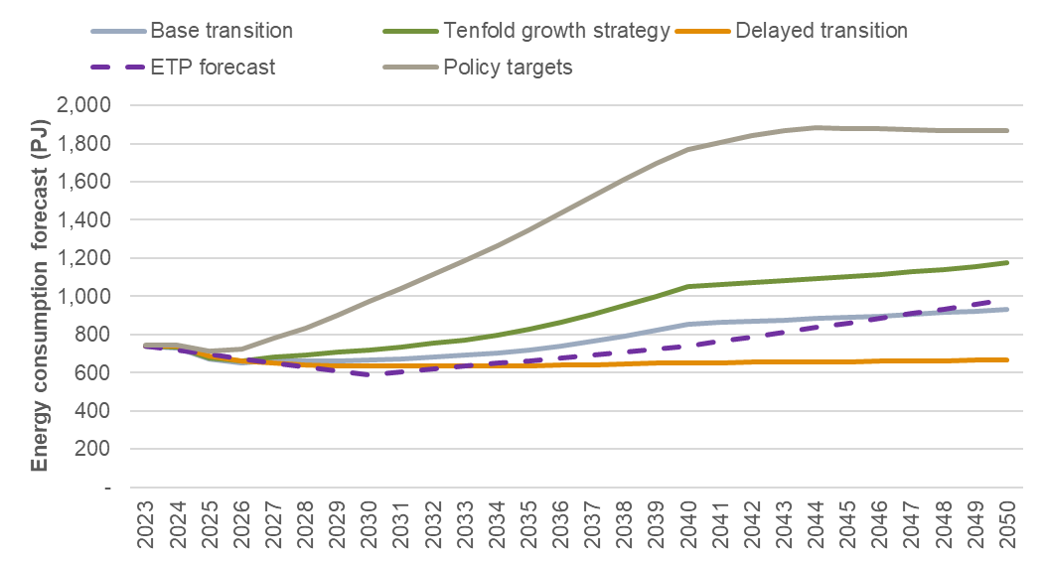
Source: ECA analysis and 2023 Energy Transition Plan. Note that the ETP only provides values for 2030, 2040, and 2050, thus, intermediate values have been linearly interpolated.
For the electricity demand forecast, the IERMP forecast is higher than the Base case of the Grid Development 2025-2040, as well as the Generation plan in the short and medium-term with the exception of the DT scenario, which resembles the Generation plan forecast. However, the uptake of electric stoves and high GDP growth rate assumptions in this forecast results in a considerably higher sent-out energy and peak demand forecasts that previous studies, as can be seen below. In the 2023 ETP, only the energy demand (TWh) for 2030, 2040, and 2050 is provided, with sent-out energy demand reaching around 31.9 TWh in 2030, 86.9 TWh in 2040, and 193 TWh in 2050, higher than the BT scenario in the IERMP due to higher economic growth assumed in later years, and the inclusion of off-grid electrification in the ETP projections. If the PT scenario is considered, the forecasted sent-out energy demand doubles the ETP projections by 2050.
Figure 62 Electricity sent-out energy demand and peak demand forecast comparison
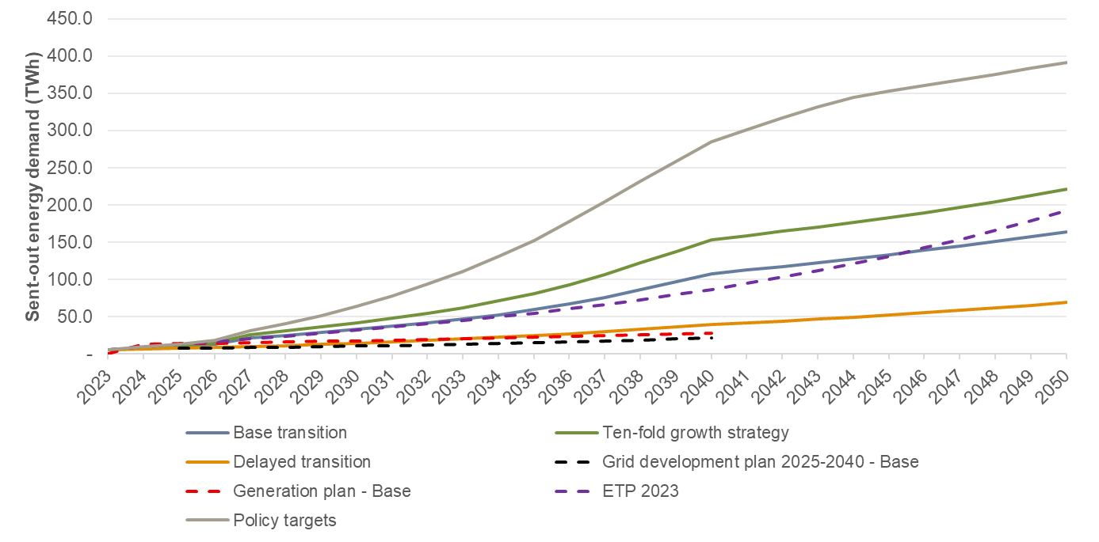
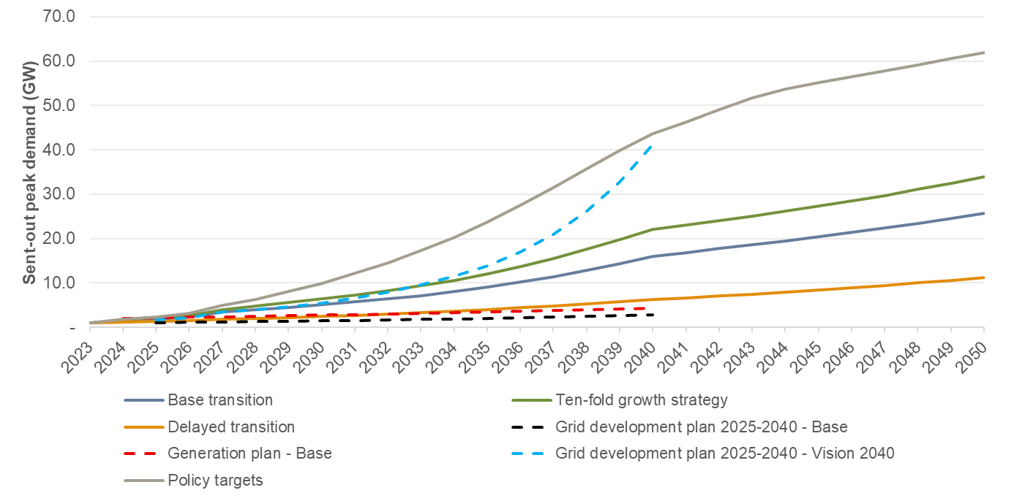
Source: ECA analysis. Note: The ETP does not include a peak demand forecast.

Annexes
- Review of previous demand forecasts
The most recent demand forecasts that are available were developed as part of the following planning studies:
- UETCL’s Grid Development Plan 2023-2040.
- Uganda’s ETP by IEA (2023), demand forecast up to 2050.
- Generation Plan Report of the project ‘Study on Integrating Nuclear Power in Generation Capacity Plan 2015-2040’ by MEMD, demand forecast up to 2040.
We provide two overview summary tables comparing these previous electricity and energy demand forecasts below.
Table 21 Summary of previous demand forecasts – peak demand
System peak demand (MW) | Generation Plan Report |  |  |  |  | Grid Development Plan 2023-2040
 | Low | Base | High | Grid Development | Base |  | NDP III and Vision 2040
2025 | 1,831 | 2,130 | 2,468 | 2,284 | 1,209 |  | 4,034
2030 | 2,444 | 2,728 | 3,148 | 2,970 | 1,626 |  | 7,892
2035 | 3,027 | 3,482 | 4,011 | 3,833 | 2,273 |  | 15,874
2040 | 3,597 | 4,227 | 4,872 | 4,694 | 3,334 |  | 31,928
Source: ECA analysis of ERA provided data, Grid Development Plan 2023-2040, Generation Plan Report 2015
Table 22 Summary of previous demand forecasts – energy demand
Total energy demand (GWh) | Generation Plan Report |  |  |  |  | Grid Development Plan 2023-2040
 | Low | Base | High | Grid Development | Base |  | NDP III and Vision 2040
2025 | 12,030 | 13,991 | 16,214 | 15,004 | 8,116 |  | -
2030 | 16,054 | 17,926 | 20,681 | 19,513 | 11,827 |  | -
2035 | 19,889 | 22,877 | 26,354 | 25,186 | 16,926 |  | -
2040 | 23,629 | 27,771 | 32,009 | 30,840 | 25,179 |  | -
Source: ECA analysis of ERA provided data, Grid Development Plan 2023-2040, Generation Plan Report 2015
Figure 63 Energy and peak demand forecast from previous MEMD forecasts
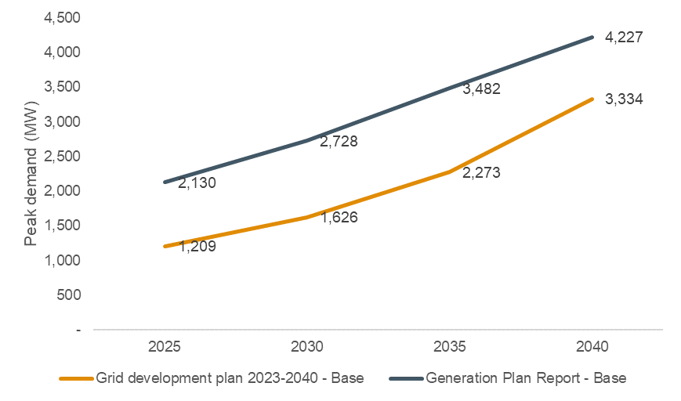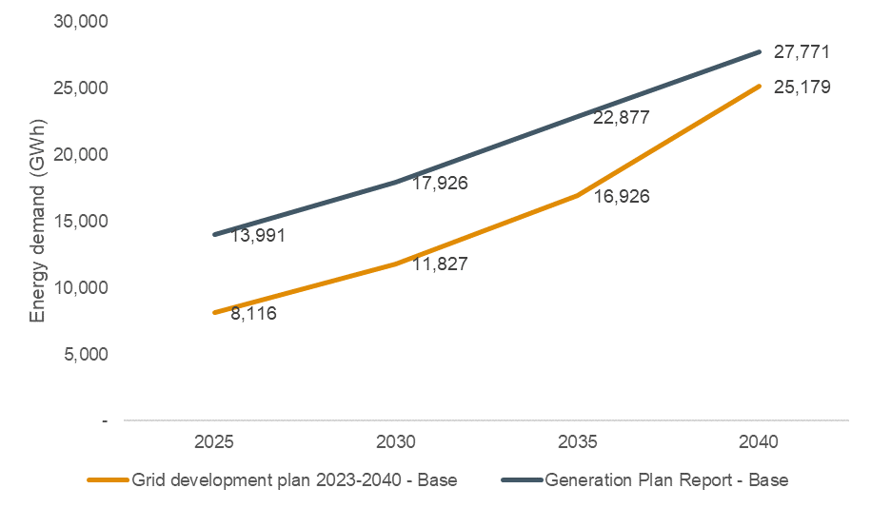
Source: Grid Development Plan 2023-2040, Generation Plan Report 2015
Moreover, comparisons between previous forecasts and actual outturn demand between 2015 and 2023 are shown below. We note that the historical outturn demand for both electricity and energy have been significantly below the previous forecasts.
Figure 64 Total peak demand (MW) outturn versus previous demand forecasts
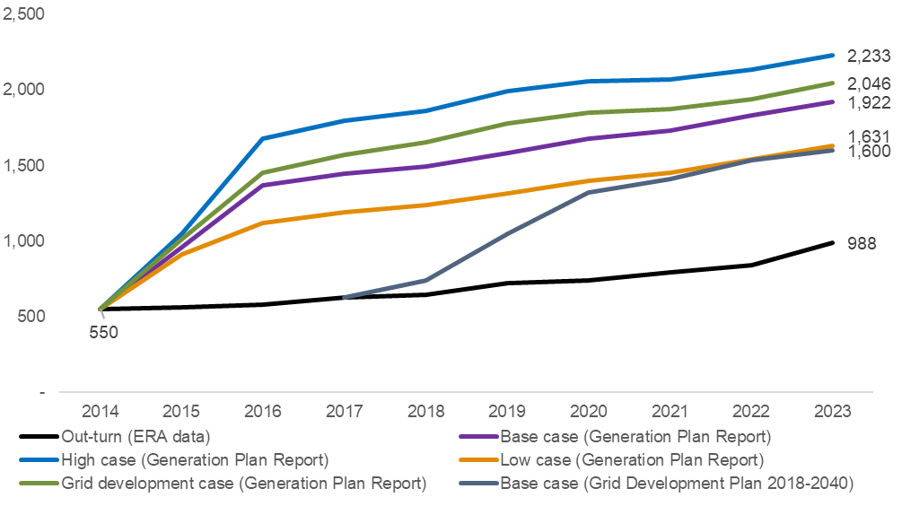
Source: ECA analysis of ERA provided data, Grid Development Plan 2023-2040, Generation Plan Report 2015. *2014 figure for all forecasts is the actual outturn as reported by ERA.
Figure 65 Total energy demand (GWh) outturn versus previous demand forecasts
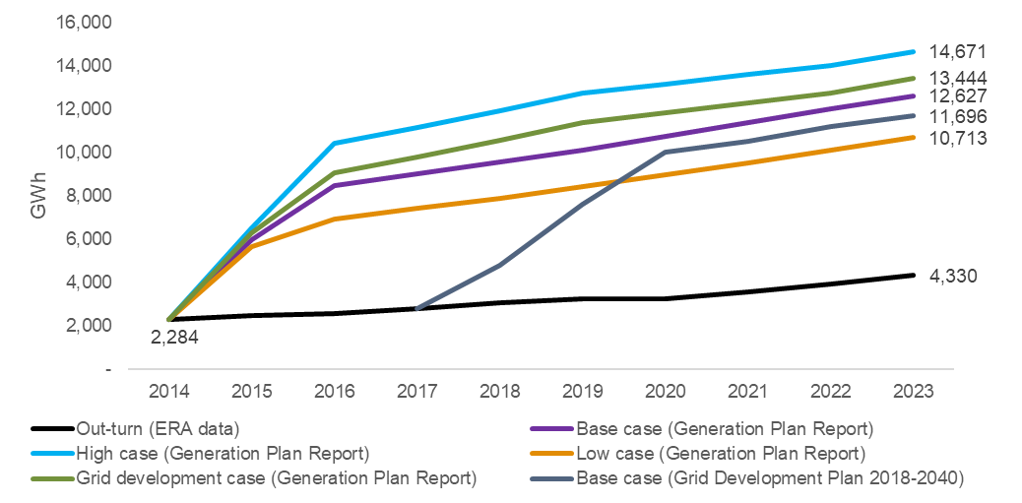Source: ECA analysis of ERA provided data, Grid Development Plan 2023-2040, Generation Plan Report 2015. *2014 figure for all forecasts is the actual outturn as reported by ERA.

UETCL’s Grid Development Plan 2023-2040
The demand forecast was prepared using 2022/23 as the base year, with a peak demand and domestic sales of 796 MW and 5,410 GWh, respectively. The average annual growth rate obtained for the planning period is 7.2% for domestic peak demand and 7.64% for domestic energy sales. A summary of the key assumptions used in the forecast is shown below.
Table 23 Grid Development Plan base scenario assumptions
Assumption | 2026/2030 | 2031/35 | 2036/40
GDP growth % | 8.2 | 8.1 | 7.8
Population growth % | The 2014 national census results indicated that Uganda’s population is estimated at 34.9 million showing that the country's population has grown by 10.7 million from 24.2 million since the last census in 2002. At an average annual growth rate of 3%, Uganda's population is projected to increase to 45.6 million in 2023 and to 69.7 million in 2040. The Grid Development Plan’s analysis revealed that the correlation between population and energy consumption, and that of a combination of population and GDP were lower than Gross Domestic Product alone. Population data was therefore not used while preparing the load forecast.
Transmission Losses (%)-without industries | Starts at 4.8% in 2023, dropping to 3.6% for the period 2029-2039 and then rising to 4.1% by 2040
Transmission Losses (%)- with industries | Starts at 4.8% in 2023, dropping to 3.9% in 2028 and then rising to 4.8% by 2040
Indicative Power Exports | - Kenya: 4-100 MW  - Tanzania: 40-180 MW  - Rwanda: 40-60 MW  - D.R Congo: 0-50MW  - S.Sudan: 45-260MW
Load factor | 79% between 2023 to 2029, and 80% between 2036-2040
Source: Grid Development Plan 2023-2040
A correlation factor between electricity consumption and the GDP was determined using historical values. In the base scenario, domestic demand grows from 878 MW in 2024 to reach 2,606 MW in 2040 while total system demand reaches 3,334 MW in 2040. A summary of the demand forecast results is shown in the figures below.
Figure 66 Grid Development Plan 2023-40 Peak Demand Forecast – Base case
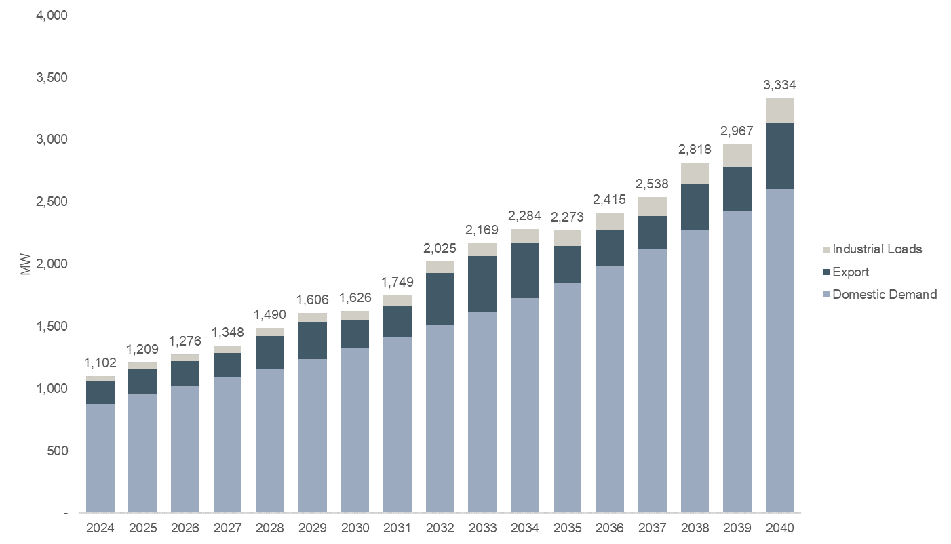
Source: Grid Development Plan 2023-2040
The total energy demand reaches 25,179 GWh in 2040, with 20,073 GWh being domestic energy demand.
Figure 67 Grid Development Plan 2023-40 Energy Demand Forecast (GWh) – Base case
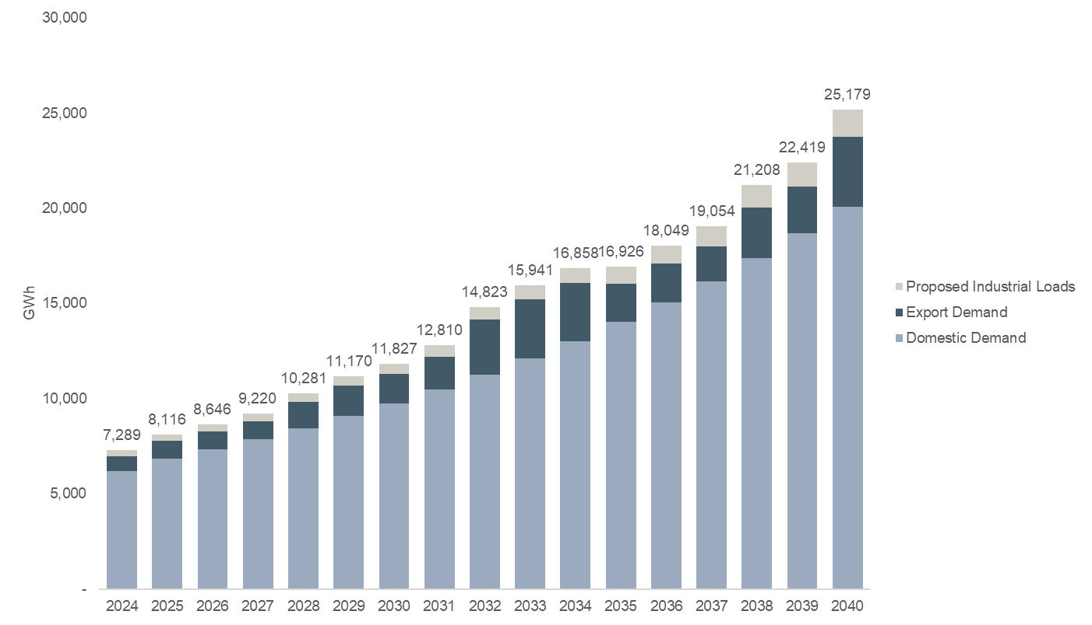
Source: Grid Development Plan 2023-2040
Two other scenarios considered in the Grid Development plan 2023-2040 are:
- NDPIII Scenario, designed to implement the Third National Development Plan (NDPIII) that was launched in 2020. The planning horizon of this scenario is five years starting from 2020 to 2025.
- Vision 2040 Scenario, Uganda Vision 2040 provides development paths and strategies to operationalize Uganda’s Vision statement which is “A Transformed Ugandan Society from a Peasant to a Modern and Prosperous Country”. It aims at transforming Uganda from a predominantly peasant and low-income country to a competitive upper-middle income country.
As the NDP III is the third in a series of six NDPs that will guide Uganda into achieving the targets set out in Uganda Vision 2040, the demand forecast reported under this scenario is only for the years of 2020 to 2025 and are the same as those forecasted under the Vision 2040 scenario. Specifically, demand is forecast to grow from 987 MW in 2020 to 4,034 MW in 2025. Vision 2040 scenario’s demand forecasts then extend to the year of 2040, and an annual growth rate of 15% is assumed for electricity demand between 2027 to 2040. These ambitious growth assumptions significantly increase the total demand, which is forecast to reach 31,928 MW in 2040. The table below also summarises other key assumptions adopted by the NDP III and Vision 2040 scenario.
Table 24 Other demand and supply assumptions for NDP III and Vision 2040 scenario
Category | NDP III | Vision 2040
Population | 46.8 million by 2025 | 60.4 million by 2040
Average energy consumption per capita | 578 kWh person/year by 2025 | 3,668 kWh/person/year by 2040
Access to national grid | 60% by 2025 | 80% by 2040
Installed generation capacity | 3,500 MW by 2025 | 41,738 MW by 2040
Source: Grid Development Plan 2023-2040; NDP III was published in 2020 and Vision 2040 was published in 2013 which affects the assumptions made at the time.

Energy Transition Plan (2023)
In the demand forecast developed as a part of the ETP, electricity demand grows across all sectors, and by 2050, Uganda requires about 40 times more electricity than it does today, reaching around 200 TWh. The forecast growth is fuelled by robust industrial activity and remains the largest electricity consumer in 2050. Residential buildings are the second-largest end use sector in 2050, followed by the services sector.
Figure 68 Electricity demand by sector in the ETP, 2010-2050
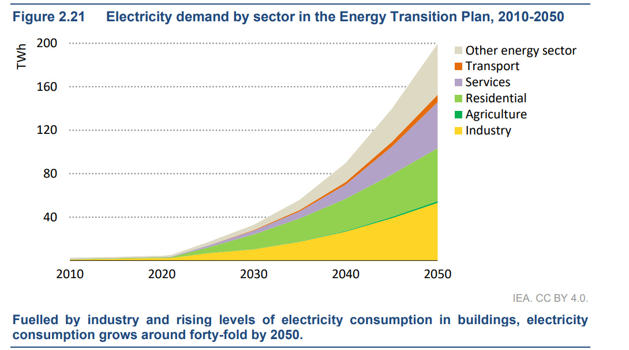
Source: Uganda Energy Transition Plan, IEA, 2023
With respect to energy demand, total final energy consumption grows in all sectors except residential, led by industrialisation and economic growth, industrial demand, in particular, more than doubles by 2050 and accounts for nearly 40% of Uganda’s final energy demand. This growth is mainly driven by increase activities in the mining, cement and steel sectors. More than three-quarters of this growth is driven by electrification, predominantly in light industries where electrified end use technologies are well developed and cost effective. Across all sectors, the ETP sees rising demand for modern energy.
Figure 69 Total final consumption by sector and by fuel in the ETP, 2021-2050
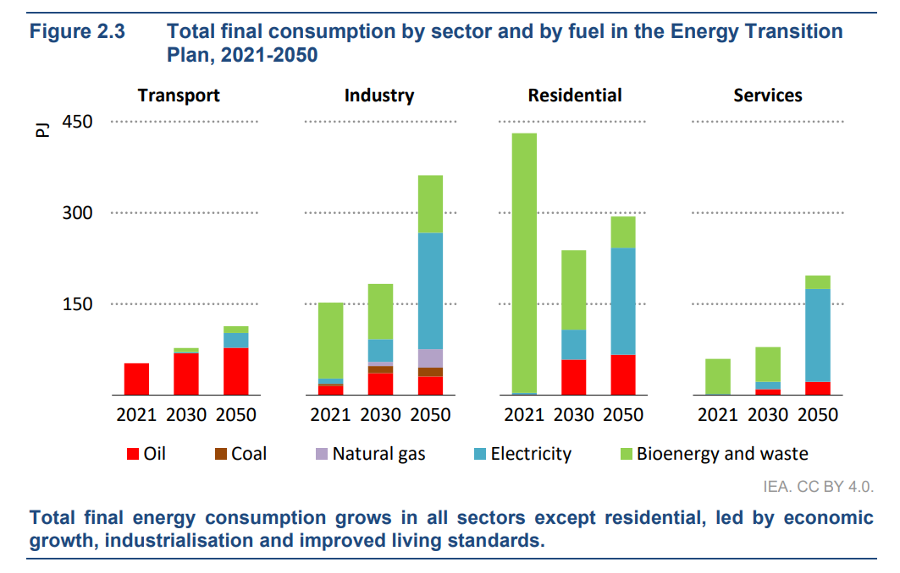
Source: Uganda Energy Transition Plan. IEA. 2023

Generation Plan Report (2015)
Five demand scenarios were considered in the Generation Plan 2015, the low, base, high, Grid Development Plan alignment and Vision 2040 alignment case. The forecasts obtained are shown in the figures below.
Figure 70 Gross energy consumption forecast (GWh) - Generation Plan Report (2015)
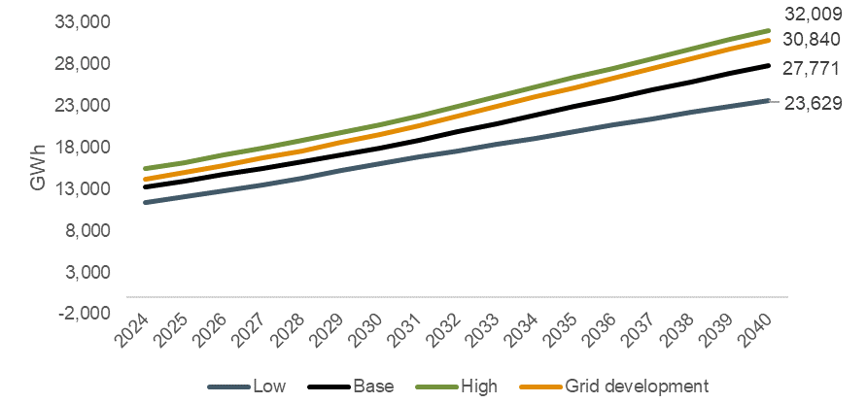
Source: Generation Plan Report 2015
Figure 71 Peak demand forecast (MW) - Generation Plan Report (2015)
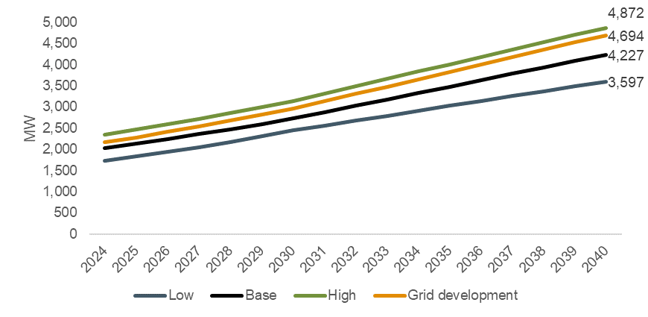
Source: Generation Plan Report 2015
- 2024-2050 Demand forecast
  - Energy demand forecast by sector and type of fuel
Table 25 Energy demand forecast by sector and in total, 2024-2050
 |  |  | By sector (TJ)
Year | Final energy  consumption (TJ) |  | Residential |  | Services |  | Transport | Industry |  |  | Others
 | Base transition
2023 | 738,317 |  | 448,211 |  | 62,766 |  | 51,252 | 167,866 |  |  | 8,221
2024 | 730,265 |  | 447,111 |  | 64,916 |  | 59,235 | 145,588 |  |  | 13,415
2025 | 673,204 |  | 390,348 |  | 65,602 |  | 61,930 | 141,764 |  |  | 13,560
2026 | 650,942 |  | 358,627 |  | 67,281 |  | 64,664 | 146,481 |  |  | 13,889
2027 | 667,264 |  | 338,776 |  | 72,178 |  | 67,408 | 174,226 |  |  | 14,677
2028 | 662,727 |  | 324,421 |  | 73,001 |  | 70,136 | 180,166 |  |  | 15,004
2029 | 663,668 |  | 314,002 |  | 73,704 |  | 72,822 | 187,781 |  |  | 15,359
2030 | 666,215 |  | 306,332 |  | 74,212 |  | 75,445 | 194,498 |  |  | 15,728
2031 | 672,638 |  | 300,214 |  | 75,123 |  | 77,982 | 203,129 |  |  | 16,190
2032 | 680,361 |  | 295,712 |  | 76,001 |  | 80,413 | 211,545 |  |  | 16,689
2033 | 690,775 |  | 292,567 |  | 76,850 |  | 82,723 | 221,412 |  |  | 17,224
2034 | 704,122 |  | 290,618 |  | 77,677 |  | 84,894 | 233,137 |  |  | 17,797
2035 | 720,846 |  | 289,774 |  | 78,489 |  | 86,913 | 247,262 |  |  | 18,409
2036 | 741,255 |  | 289,981 |  | 79,297 |  | 88,767 | 264,149 |  |  | 19,061
2037 | 765,613 |  | 291,376 |  | 80,113 |  | 90,447 | 283,921 |  |  | 19,756
2038 | 794,042 |  | 293,790 |  | 80,955 |  | 91,944 | 306,859 |  |  | 20,494
2039 | 822,909 |  | 297,258 |  | 81,841 |  | 93,250 | 329,280 |  |  | 21,280
2040 | 854,342 |  | 301,984 |  | 82,796 |  | 94,361 | 353,088 |  |  | 22,114
2041 | 862,443 |  | 304,931 |  | 82,849 |  | 95,274 | 356,569 |  |  | 22,820
2042 | 869,509 |  | 308,055 |  | 82,468 |  | 95,988 | 359,529 |  |  | 23,469
2043 | 876,316 |  | 311,586 |  | 81,842 |  | 96,503 | 362,298 |  |  | 24,087
2044 | 883,083 |  | 315,432 |  | 81,082 |  | 96,821 | 365,063 |  |  | 24,685
2045 | 890,166 |  | 319,740 |  | 80,267 |  | 96,947 | 367,943 |  |  | 25,270
2046 | 897,623 |  | 324,404 |  | 79,457 |  | 96,886 | 371,028 |  |  | 25,848
2047 | 905,720 |  | 329,555 |  | 78,707 |  | 96,647 | 374,390 |  |  | 26,421
2048 | 914,582 |  | 335,195 |  | 78,066 |  | 96,239 | 378,091 |  |  | 26,992
2049 | 924,232 |  | 341,232 |  | 77,580 |  | 95,672 | 382,186 |  |  | 27,562
2050 | 933,994 |  | 347,777 |  | 77,286 |  | 94,961 | 385,835 |  |  | 28,134
 | Tenfold growth strategy
2023 | 738,317 | 448,211 |  | 62,766 |  | 51,252 |  |  | 167,866 | 8,221
2024 | 734,808 | 447,111 |  | 64,916 |  | 59,355 |  |  | 147,417 | 16,010
2025 | 678,946 | 390,348 |  | 65,602 |  | 62,187 |  |  | 144,655 | 16,154
2026 | 659,149 | 358,627 |  | 67,281 |  | 65,078 |  |  | 151,681 | 16,483
2027 | 682,344 | 338,776 |  | 72,178 |  | 67,999 |  |  | 186,121 | 17,271
2028 | 693,053 | 325,137 |  | 76,113 |  | 70,927 |  |  | 202,879 | 17,996
2029 | 707,297 | 315,539 |  | 79,473 |  | 73,837 |  |  | 219,743 | 18,705
2030 | 720,557 | 308,633 |  | 81,746 |  | 76,708 |  |  | 234,144 | 19,326
2031 | 736,163 | 303,161 |  | 83,636 |  | 79,519 |  |  | 249,901 | 19,945
2032 | 752,660 | 299,274 |  | 85,108 |  | 82,252 |  |  | 265,470 | 20,556
2033 | 773,319 | 296,862 |  | 86,578 |  | 84,891 |  |  | 283,776 | 21,212
2034 | 798,797 | 295,787 |  | 88,054 |  | 87,420 |  |  | 305,618 | 21,917
2035 | 829,427 | 295,874 |  | 89,362 |  | 89,827 |  |  | 331,719 | 22,645
2036 | 864,755 | 296,857 |  | 90,217 |  | 92,100 |  |  | 362,233 | 23,349
2037 | 905,654 | 298,900 |  | 90,797 |  | 94,229 |  |  | 397,678 | 24,051
2038 | 953,512 | 302,010 |  | 91,402 |  | 96,205 |  |  | 439,099 | 24,795
2039 | 1,000,971 | 306,221 |  | 92,053 |  | 98,023 |  |  | 479,089 | 25,584
2040 | 1,052,009 | 311,728 |  | 92,776 |  | 99,679 |  |  | 521,408 | 26,419
2041 | 1,061,896 | 315,607 |  | 92,894 |  | 101,168 |  |  | 525,050 | 27,178
2042 | 1,071,484 | 319,875 |  | 92,732 |  | 102,490 |  |  | 528,479 | 27,909
2043 | 1,081,375 | 324,735 |  | 92,431 |  | 103,645 |  |  | 531,935 | 28,629
2044 | 1,091,736 | 330,114 |  | 92,080 |  | 104,635 |  |  | 535,561 | 29,346
2045 | 1,102,887 | 336,152 |  | 91,749 |  | 105,465 |  |  | 539,457 | 30,065
2046 | 1,114,901 | 342,773 |  | 91,495 |  | 106,140 |  |  | 543,703 | 30,790
2047 | 1,128,038 | 350,105 |  | 91,372 |  | 106,667 |  |  | 548,369 | 31,524
2048 | 1,142,444 | 358,166 |  | 91,434 |  | 107,055 |  |  | 553,519 | 32,268
2049 | 1,158,197 | 366,908 |  | 91,734 |  | 107,316 |  |  | 559,214 | 33,024
2050 | 1,174,510 | 376,437 |  | 92,315 |  | 107,461 |  |  | 564,503 | 33,794
 | Delayed transition
2023 | 738,317 |  | 448,211 |  | 62,766 |  | 51,252 | 167,866 |  |  | 8,221
2024 | 741,528 |  | 447,111 |  | 67,946 |  | 59,139 | 157,321 |  |  | 10,011
2025 | 688,017 |  | 400,004 |  | 67,640 |  | 61,725 | 148,613 |  |  | 10,035
2026 | 663,455 |  | 377,672 |  | 67,272 |  | 64,333 | 144,068 |  |  | 10,110
2027 | 650,049 |  | 363,520 |  | 66,842 |  | 66,935 | 142,529 |  |  | 10,223
2028 | 641,955 |  | 353,745 |  | 66,350 |  | 69,503 | 141,993 |  |  | 10,365
2029 | 637,311 |  | 346,667 |  | 65,797 |  | 72,011 | 142,305 |  |  | 10,531
2030 | 635,176 |  | 341,399 |  | 65,183 |  | 74,434 | 143,440 |  |  | 10,719
2031 | 633,611 |  | 337,646 |  | 64,466 |  | 76,752 | 143,827 |  |  | 10,920
2032 | 634,031 |  | 334,890 |  | 63,647 |  | 78,943 | 145,418 |  |  | 11,133
2033 | 633,937 |  | 332,896 |  | 62,732 |  | 80,989 | 145,964 |  |  | 11,356
2034 | 634,749 |  | 331,509 |  | 61,726 |  | 82,873 | 147,054 |  |  | 11,587
2035 | 636,170 |  | 330,622 |  | 60,634 |  | 84,582 | 148,506 |  |  | 11,826
2036 | 638,443 |  | 330,151 |  | 59,463 |  | 86,102 | 150,656 |  |  | 12,073
2037 | 641,528 |  | 330,248 |  | 58,220 |  | 87,422 | 153,312 |  |  | 12,325
2038 | 645,308 |  | 330,630 |  | 56,916 |  | 88,534 | 156,645 |  |  | 12,584
2039 | 649,017 |  | 331,258 |  | 55,559 |  | 89,431 | 159,923 |  |  | 12,847
2040 | 653,240 |  | 332,329 |  | 54,161 |  | 90,107 | 163,529 |  |  | 13,115
2041 | 653,772 |  | 333,594 |  | 52,732 |  | 90,560 | 163,500 |  |  | 13,387
2042 | 654,392 |  | 335,021 |  | 51,286 |  | 90,787 | 163,636 |  |  | 13,662
2043 | 655,338 |  | 336,820 |  | 49,837 |  | 90,790 | 163,951 |  |  | 13,941
2044 | 656,407 |  | 338,759 |  | 48,399 |  | 90,570 | 164,457 |  |  | 14,222
2045 | 657,830 |  | 341,037 |  | 46,987 |  | 90,133 | 165,168 |  |  | 14,505
2046 | 659,413 |  | 343,422 |  | 45,619 |  | 89,484 | 166,098 |  |  | 14,790
2047 | 661,400 |  | 346,121 |  | 44,312 |  | 88,631 | 167,260 |  |  | 15,076
2048 | 663,821 |  | 349,121 |  | 43,083 |  | 87,585 | 168,668 |  |  | 15,363
2049 | 666,484 |  | 352,187 |  | 41,953 |  | 86,357 | 170,337 |  |  | 15,650
2050 | 669,035 |  | 355,523 |  | 40,935 |  | 84,961 | 171,679 |  |  | 15,937
 | Policy targets
2023 | 738,317 |  | 448,211 |  | 62,766 |  | 51,252 | 167,866 |  |  | 8,221
2024 | 747,397 |  | 447,575 |  | 68,637 |  | 59,355 | 155,364 |  |  | 16,467
2025 | 711,716 |  | 391,848 |  | 75,579 |  | 62,187 | 164,722 |  |  | 17,381
2026 | 723,216 |  | 362,311 |  | 87,020 |  | 65,078 | 189,887 |  |  | 18,920
2027 | 779,300 |  | 345,900 |  | 102,058 |  | 67,999 | 242,364 |  |  | 20,978
2028 | 832,851 |  | 337,961 |  | 118,857 |  | 70,927 | 281,770 |  |  | 23,337
2029 | 899,783 |  | 337,182 |  | 137,481 |  | 73,837 | 325,272 |  |  | 26,011
2030 | 971,038 |  | 342,262 |  | 155,784 |  | 76,708 | 367,544 |  |  | 28,740
2031 | 1,042,513 |  | 351,084 |  | 172,775 |  | 79,519 | 407,734 |  |  | 31,402
2032 | 1,113,549 |  | 363,963 |  | 188,286 |  | 82,252 | 445,072 |  |  | 33,976
2033 | 1,186,822 |  | 380,716 |  | 202,502 |  | 84,891 | 482,235 |  |  | 36,478
2034 | 1,265,047 |  | 401,682 |  | 215,969 |  | 87,420 | 521,006 |  |  | 38,969
2035 | 1,347,989 |  | 426,414 |  | 228,349 |  | 89,827 | 561,999 |  |  | 41,399
2036 | 1,434,825 |  | 454,226 |  | 239,295 |  | 92,100 | 605,488 |  |  | 43,716
2037 | 1,523,972 |  | 484,120 |  | 248,452 |  | 94,229 | 651,306 |  |  | 45,865
2038 | 1,614,002 |  | 514,872 |  | 255,481 |  | 96,205 | 699,651 |  |  | 47,792
2039 | 1,695,457 |  | 545,069 |  | 260,072 |  | 98,023 | 742,847 |  |  | 49,445
2040 | 1,769,903 |  | 573,032 |  | 261,964 |  | 99,679 | 784,451 |  |  | 50,778
2041 | 1,805,319 |  | 598,565 |  | 264,312 |  | 101,168 | 789,103 |  |  | 52,172
2042 | 1,841,076 |  | 625,101 |  | 266,338 |  | 102,490 | 793,626 |  |  | 53,521
2043 | 1,868,396 |  | 648,111 |  | 266,291 |  | 103,645 | 795,758 |  |  | 54,591
2044 | 1,881,995 |  | 664,604 |  | 263,189 |  | 104,635 | 794,327 |  |  | 55,240
2045 | 1,880,503 |  | 673,239 |  | 256,998 |  | 105,465 | 789,356 |  |  | 55,445
2046 | 1,876,009 |  | 679,901 |  | 250,292 |  | 106,140 | 784,152 |  |  | 55,525
2047 | 1,872,642 |  | 686,484 |  | 244,013 |  | 106,667 | 779,884 |  |  | 55,594
2048 | 1,870,415 |  | 692,962 |  | 238,195 |  | 107,055 | 776,549 |  |  | 55,653
2049 | 1,868,761 |  | 699,151 |  | 232,696 |  | 107,316 | 773,922 |  |  | 55,677
2050 | 1,865,539 |  | 704,733 |  | 227,535 |  | 107,461 | 770,144 |  |  | 55,665
Source: ECA analysis
Table 26 Energy demand forecast by fuel and in total, 2024-2050
Year | Final energy  consumption (TJ) | By type of fuel (TJ)
 |  | Oil products | Electricity | Biofuels and waste | Coal | Others
 |  | Base transition
2023 | 738,317 | 68,138 | 16,567 | 640,855 | 4,536 | 8,221
2024 | 730,265 | 86,320 | 24,071 | 605,238 | 6,381 | 8,256
2025 | 673,204 | 97,650 | 30,283 | 529,690 | 7,183 | 8,398
2026 | 650,942 | 104,078 | 41,144 | 489,200 | 7,795 | 8,724
2027 | 667,264 | 111,720 | 68,934 | 468,420 | 8,680 | 9,510
2028 | 662,727 | 117,034 | 80,185 | 446,606 | 9,068 | 9,834
2029 | 663,668 | 122,100 | 92,801 | 429,153 | 9,428 | 10,186
2030 | 666,215 | 126,776 | 104,556 | 414,561 | 9,769 | 10,553
2031 | 672,638 | 130,650 | 118,759 | 402,358 | 9,859 | 11,012
2032 | 680,361 | 134,203 | 133,312 | 391,392 | 9,945 | 11,508
2033 | 690,775 | 137,551 | 149,888 | 381,265 | 10,030 | 12,041
2034 | 704,122 | 140,664 | 168,959 | 371,772 | 10,115 | 12,611
2035 | 720,846 | 143,520 | 191,136 | 362,771 | 10,199 | 13,220
2036 | 741,255 | 146,095 | 216,858 | 354,150 | 10,282 | 13,870
2037 | 765,613 | 148,370 | 246,336 | 345,980 | 10,365 | 14,561
2038 | 794,042 | 150,327 | 279,942 | 338,028 | 10,447 | 15,297
2039 | 822,909 | 151,953 | 314,099 | 330,248 | 10,529 | 16,079
2040 | 854,342 | 153,236 | 350,833 | 322,754 | 10,610 | 16,910
2041 | 862,443 | 153,505 | 366,549 | 314,192 | 10,583 | 17,614
2042 | 869,509 | 153,069 | 382,490 | 305,187 | 10,502 | 18,261
2043 | 876,316 | 152,052 | 398,887 | 296,117 | 10,385 | 18,876
2044 | 883,083 | 150,527 | 415,873 | 286,968 | 10,243 | 19,471
2045 | 890,166 | 148,550 | 433,540 | 277,938 | 10,083 | 20,054
2046 | 897,623 | 146,169 | 451,968 | 268,947 | 9,910 | 20,629
2047 | 905,720 | 143,430 | 471,217 | 260,148 | 9,726 | 21,200
2048 | 914,582 | 140,377 | 491,344 | 251,560 | 9,534 | 21,768
2049 | 924,232 | 137,057 | 512,428 | 243,076 | 9,336 | 22,335
2050 | 933,994 | 132,957 | 534,511 | 234,562 | 9,060 | 22,904
 |  | Tenfold growth scenario
2023 | 738,317 | 68,138 | 16,567 | 640,855 | 4,536 | 8,221
2024 | 734,808 | 86,320 | 28,614 | 605,238 | 6,381 | 8,256
2025 | 678,946 | 97,650 | 36,025 | 529,690 | 7,183 | 8,398
2026 | 659,149 | 104,078 | 49,352 | 489,200 | 7,795 | 8,724
2027 | 682,344 | 111,720 | 84,014 | 468,420 | 8,680 | 9,510
2028 | 693,053 | 118,794 | 102,108 | 452,484 | 9,435 | 10,233
2029 | 707,297 | 125,526 | 121,046 | 439,662 | 10,124 | 10,939
2030 | 720,557 | 131,445 | 138,982 | 427,876 | 10,698 | 11,557
2031 | 736,163 | 136,034 | 160,124 | 416,933 | 10,898 | 12,173
2032 | 752,660 | 140,056 | 182,284 | 406,494 | 11,045 | 12,781
2033 | 773,319 | 143,888 | 207,935 | 396,869 | 11,192 | 13,436
2034 | 798,797 | 147,500 | 237,969 | 387,851 | 11,339 | 14,138
2035 | 829,427 | 150,743 | 273,335 | 379,021 | 11,466 | 14,862
2036 | 864,755 | 153,392 | 314,391 | 369,871 | 11,538 | 15,563
2037 | 905,654 | 155,530 | 361,514 | 360,772 | 11,576 | 16,263
2038 | 953,512 | 157,324 | 415,661 | 351,909 | 11,613 | 17,004
2039 | 1,000,971 | 158,761 | 469,531 | 343,240 | 11,649 | 17,789
2040 | 1,052,009 | 159,831 | 526,996 | 334,878 | 11,683 | 18,621
2041 | 1,061,896 | 160,072 | 544,963 | 325,840 | 11,643 | 19,378
2042 | 1,071,484 | 159,687 | 563,596 | 316,531 | 11,563 | 20,106
2043 | 1,081,375 | 158,760 | 583,083 | 307,251 | 11,456 | 20,824
2044 | 1,091,736 | 157,347 | 603,574 | 297,947 | 11,330 | 21,538
2045 | 1,102,887 | 155,489 | 625,160 | 288,794 | 11,190 | 22,255
2046 | 1,114,901 | 153,227 | 647,962 | 279,697 | 11,038 | 22,978
2047 | 1,128,038 | 150,600 | 672,050 | 270,802 | 10,877 | 23,709
2048 | 1,142,444 | 147,650 | 697,514 | 262,121 | 10,709 | 24,450
2049 | 1,158,197 | 144,421 | 724,492 | 253,546 | 10,534 | 25,203
2050 | 1,174,510 | 140,322 | 753,041 | 244,906 | 10,273 | 25,969
 |  | Delayed transition
2023 | 738,317 | 68,138 | 16,567 | 640,855 | 4,536 | 8,221
2024 | 741,528 | 88,813 | 18,813 | 618,627 | 7,019 | 8,256
2025 | 688,017 | 100,119 | 21,735 | 550,095 | 7,790 | 8,279
2026 | 663,455 | 105,745 | 25,393 | 515,756 | 8,210 | 8,353
2027 | 650,049 | 110,629 | 29,863 | 492,594 | 8,498 | 8,464
2028 | 641,955 | 115,105 | 34,057 | 475,462 | 8,727 | 8,605
2029 | 637,311 | 119,294 | 38,288 | 462,030 | 8,929 | 8,770
2030 | 635,176 | 123,127 | 42,805 | 451,168 | 9,120 | 8,957
2031 | 633,611 | 125,844 | 48,109 | 441,484 | 9,017 | 9,156
2032 | 634,031 | 128,180 | 54,865 | 432,715 | 8,905 | 9,368
2033 | 633,937 | 130,236 | 60,776 | 424,550 | 8,786 | 9,588
2034 | 634,749 | 131,992 | 67,437 | 416,839 | 8,662 | 9,818
2035 | 636,170 | 133,429 | 74,667 | 409,485 | 8,533 | 10,056
2036 | 638,443 | 134,532 | 82,807 | 402,405 | 8,399 | 10,300
2037 | 641,528 | 135,290 | 91,671 | 395,755 | 8,261 | 10,551
2038 | 645,308 | 135,696 | 101,427 | 389,260 | 8,119 | 10,807
2039 | 649,017 | 135,745 | 111,343 | 382,889 | 7,972 | 11,068
2040 | 653,240 | 135,438 | 121,812 | 376,834 | 7,822 | 11,334
2041 | 653,772 | 134,777 | 128,861 | 370,861 | 7,669 | 11,603
2042 | 654,392 | 133,770 | 136,299 | 364,933 | 7,513 | 11,877
2043 | 655,338 | 132,427 | 144,148 | 359,255 | 7,355 | 12,153
2044 | 656,407 | 130,761 | 152,414 | 353,607 | 7,194 | 12,431
2045 | 657,830 | 128,790 | 161,121 | 348,176 | 7,031 | 12,712
2046 | 659,413 | 126,534 | 170,272 | 342,747 | 6,866 | 12,994
2047 | 661,400 | 124,016 | 179,894 | 337,512 | 6,700 | 13,277
2048 | 663,821 | 121,263 | 190,002 | 332,461 | 6,533 | 13,561
2049 | 666,484 | 118,304 | 200,596 | 327,373 | 6,366 | 13,845
2050 | 669,035 | 114,802 | 211,703 | 322,252 | 6,148 | 14,129
 |  | Policy targets
2023 | 738,317 | 68,138 | 16,567 | 640,855 | 4,536 | 8,221
2024 | 747,397 | 87,750 | 29,917 | 614,283 | 6,734 | 8,713
2025 | 711,716 | 102,166 | 39,986 | 551,708 | 8,233 | 9,624
2026 | 723,216 | 113,858 | 58,402 | 529,821 | 9,973 | 11,161
2027 | 779,300 | 127,458 | 100,150 | 526,412 | 12,063 | 13,217
2028 | 832,851 | 142,397 | 129,204 | 531,318 | 14,359 | 15,573
2029 | 899,783 | 158,808 | 164,103 | 541,742 | 16,886 | 18,244
2030 | 971,038 | 175,223 | 202,700 | 552,733 | 19,412 | 20,970
2031 | 1,042,513 | 189,175 | 247,772 | 560,780 | 21,156 | 23,630
2032 | 1,113,549 | 201,763 | 297,210 | 565,732 | 22,642 | 26,202
2033 | 1,186,822 | 213,258 | 353,266 | 567,688 | 23,909 | 28,701
2034 | 1,265,047 | 223,848 | 417,549 | 567,444 | 25,016 | 31,190
2035 | 1,347,989 | 233,239 | 490,581 | 564,617 | 25,934 | 33,617
2036 | 1,434,825 | 241,151 | 572,162 | 558,943 | 26,637 | 35,931
2037 | 1,523,972 | 247,334 | 661,017 | 550,440 | 27,104 | 38,077
2038 | 1,614,002 | 251,582 | 756,179 | 538,922 | 27,319 | 40,001
2039 | 1,695,457 | 253,745 | 848,296 | 524,491 | 27,273 | 41,651
2040 | 1,769,903 | 253,738 | 938,719 | 507,499 | 26,967 | 42,980
2041 | 1,805,319 | 253,128 | 990,266 | 490,893 | 26,661 | 44,372
2042 | 1,841,076 | 251,528 | 1,043,559 | 473,979 | 26,293 | 45,719
2043 | 1,868,396 | 248,181 | 1,092,009 | 455,680 | 25,740 | 46,786
2044 | 1,881,995 | 242,786 | 1,131,310 | 435,513 | 24,953 | 47,433
2045 | 1,880,503 | 235,506 | 1,159,416 | 413,994 | 23,951 | 47,635
2046 | 1,876,009 | 227,555 | 1,184,898 | 392,925 | 22,920 | 47,712
2047 | 1,872,642 | 219,382 | 1,210,552 | 373,009 | 21,920 | 47,779
2048 | 1,870,415 | 211,056 | 1,236,373 | 354,200 | 20,951 | 47,835
2049 | 1,868,761 | 202,584 | 1,262,070 | 336,249 | 20,003 | 47,856
2050 | 1,865,539 | 192,866 | 1,287,199 | 318,708 | 18,925 | 47,841
Source: ECA analysis
  - Electricity demand forecast
Table 27 Electricity demand forecast, 2024-2050
Year | Sent-out energy demand (GWh) | Sent-out peak demand (MW) | Sent-out load factor (%)
 | Base transition
2023 | 6,012 | 988 | 69.47%
2024 | 7,992 | 1,454 | 62.76%
2025 | 9,971 | 1,757 | 64.79%
2026 | 13,384 | 2,257 | 67.70%
2027 | 21,821 | 3,396 | 73.36%
2028 | 25,347 | 3,917 | 73.87%
2029 | 29,280 | 4,499 | 74.29%
2030 | 32,971 | 5,061 | 74.38%
2031 | 37,365 | 5,712 | 74.67%
2032 | 41,874 | 6,388 | 74.83%
2033 | 46,984 | 7,147 | 75.04%
2034 | 52,835 | 8,010 | 75.30%
2035 | 59,604 | 8,998 | 75.62%
2036 | 67,420 | 10,129 | 75.98%
2037 | 76,347 | 11,415 | 76.35%
2038 | 86,494 | 12,873 | 76.70%
2039 | 96,828 | 14,388 | 76.83%
2040 | 107,940 | 16,020 | 76.92%
2041 | 112,841 | 16,862 | 76.40%
2042 | 117,780 | 17,711 | 75.91%
2043 | 122,833 | 18,581 | 75.46%
2044 | 128,045 | 19,479 | 75.04%
2045 | 133,444 | 20,410 | 74.64%
2046 | 139,055 | 21,377 | 74.26%
2047 | 144,897 | 22,384 | 73.90%
2048 | 150,988 | 23,433 | 73.55%
2049 | 157,350 | 24,528 | 73.23%
2050 | 163,996 | 25,672 | 72.92%
 | Tenfold growth scenario
2023 | 6,012 | 988 | 69.47%
2024 | 9,274 | 1,716 | 61.69%
2025 | 11,532 | 2,058 | 63.96%
2026 | 15,571 | 2,638 | 67.37%
2027 | 25,875 | 4,007 | 73.71%
2028 | 31,333 | 4,789 | 74.69%
2029 | 37,016 | 5,616 | 75.24%
2030 | 42,368 | 6,407 | 75.48%
2031 | 48,589 | 7,306 | 75.92%
2032 | 55,072 | 8,244 | 76.25%
2033 | 62,543 | 9,318 | 76.62%
2034 | 71,257 | 10,559 | 77.04%
2035 | 81,473 | 11,998 | 77.52%
2036 | 93,273 | 13,643 | 78.04%
2037 | 106,763 | 15,513 | 78.56%
2038 | 122,226 | 17,653 | 79.04%
2039 | 137,561 | 19,826 | 79.21%
2040 | 153,702 | 22,120 | 79.32%
2041 | 159,047 | 23,061 | 78.73%
2042 | 164,583 | 24,036 | 78.17%
2043 | 170,370 | 25,057 | 77.62%
2044 | 176,456 | 26,130 | 77.09%
2045 | 182,870 | 27,260 | 76.58%
2046 | 189,650 | 28,454 | 76.09%
2047 | 196,820 | 29,716 | 75.61%
2048 | 204,407 | 31,049 | 75.15%
2049 | 212,456 | 32,462 | 74.71%
2050 | 220,987 | 33,956 | 74.29%
 | Delayed transition
2023 | 6,012 | 988 | 69.47%
2024 | 6,494 | 1,150 | 64.48%
2025 | 7,490 | 1,312 | 65.18%
2026 | 8,726 | 1,510 | 65.96%
2027 | 10,189 | 1,735 | 67.05%
2028 | 11,571 | 1,950 | 67.74%
2029 | 12,967 | 2,170 | 68.22%
2030 | 14,451 | 2,403 | 68.65%
2031 | 16,182 | 2,672 | 69.13%
2032 | 18,342 | 2,997 | 69.86%
2033 | 20,264 | 3,297 | 70.17%
2034 | 22,413 | 3,628 | 70.52%
2035 | 24,736 | 3,985 | 70.87%
2036 | 27,332 | 4,379 | 71.25%
2037 | 30,147 | 4,805 | 71.62%
2038 | 33,230 | 5,269 | 71.99%
2039 | 36,369 | 5,748 | 72.23%
2040 | 39,678 | 6,252 | 72.45%
2041 | 42,008 | 6,642 | 72.20%
2042 | 44,461 | 7,053 | 71.97%
2043 | 47,046 | 7,485 | 71.75%
2044 | 49,763 | 7,940 | 71.55%
2045 | 52,621 | 8,418 | 71.36%
2046 | 55,618 | 8,919 | 71.19%
2047 | 58,765 | 9,445 | 71.02%
2048 | 62,065 | 9,997 | 70.87%
2049 | 65,517 | 10,574 | 70.73%
2050 | 69,131 | 11,178 | 70.60%
 | Policy targets
2023 | 6,012 | 988 | 69.47%
2024 | 9,732 | 1,792 | 62.01%
2025 | 12,916 | 2,286 | 64.51%
2026 | 18,713 | 3,155 | 67.71%
2027 | 31,441 | 4,922 | 72.93%
2028 | 40,622 | 6,315 | 73.43%
2029 | 51,684 | 8,026 | 73.51%
2030 | 63,940 | 9,952 | 73.34%
2031 | 78,080 | 12,151 | 73.35%
2032 | 93,502 | 14,559 | 73.31%
2033 | 110,843 | 17,254 | 73.33%
2034 | 130,574 | 20,306 | 73.41%
2035 | 152,796 | 23,717 | 73.54%
2036 | 177,387 | 27,464 | 73.73%
2037 | 203,906 | 31,475 | 73.95%
2038 | 232,008 | 35,691 | 74.21%
2039 | 258,944 | 39,771 | 74.32%
2040 | 284,573 | 43,624 | 74.47%
2041 | 300,591 | 46,318 | 74.08%
2042 | 317,144 | 49,104 | 73.73%
2043 | 332,137 | 51,638 | 73.43%
2044 | 344,203 | 53,693 | 73.18%
2045 | 352,689 | 55,164 | 72.98%
2046 | 360,321 | 56,498 | 72.80%
2047 | 367,988 | 57,841 | 72.63%
2048 | 375,689 | 59,193 | 72.45%
2049 | 383,331 | 60,539 | 72.28%
2050 | 390,774 | 61,855 | 72.12%
Source: ECA analysis
Table 28 Electricity sales forecast, 2024-2050
 | Sales by customer category (GWh)
Year | Domestic | Commercial | Medium industries | Large industries | Extra-large industries | Street lighting | Electric vehicles | Exports
 | Base transition
2023 | 966 | 507 | 607 | 1,187 | 1,060 | 3 | 0 | 485
2024 | 1,053 | 565 | 634 | 1,352 | 1,615 | 3 | 33 | 1,430
2025 | 1,755 | 630 | 679 | 1,877 | 1,966 | 3 | 71 | 1,430
2026 | 2,785 | 724 | 739 | 3,027 | 2,606 | 4 | 115 | 1,430
2027 | 4,048 | 901 | 847 | 7,776 | 3,977 | 5 | 164 | 1,430
2028 | 5,211 | 1,011 | 909 | 7,973 | 5,514 | 6 | 220 | 1,430
2029 | 6,473 | 1,132 | 975 | 8,766 | 6,714 | 6 | 282 | 1,430
2030 | 7,838 | 1,264 | 1,042 | 9,085 | 8,025 | 7 | 351 | 1,430
2031 | 9,165 | 1,425 | 1,123 | 9,809 | 9,600 | 8 | 427 | 1,430
2032 | 10,600 | 1,608 | 1,209 | 10,207 | 11,458 | 9 | 511 | 1,430
2033 | 12,155 | 1,814 | 1,302 | 10,644 | 13,679 | 9 | 602 | 1,430
2034 | 13,845 | 2,046 | 1,402 | 11,127 | 16,372 | 10 | 702 | 1,430
2035 | 15,684 | 2,307 | 1,510 | 11,662 | 19,680 | 11 | 809 | 1,430
2036 | 17,691 | 2,602 | 1,626 | 12,255 | 23,696 | 12 | 926 | 1,430
2037 | 19,884 | 2,935 | 1,751 | 12,917 | 28,447 | 12 | 1,050 | 1,430
2038 | 22,283 | 3,311 | 1,886 | 13,599 | 34,056 | 13 | 1,184 | 1,430
2039 | 24,910 | 3,734 | 2,031 | 14,279 | 39,525 | 14 | 1,326 | 1,430
2040 | 27,794 | 4,212 | 2,187 | 15,658 | 44,681 | 15 | 1,477 | 1,430
2041 | 30,141 | 4,662 | 2,327 | 16,327 | 45,278 | 16 | 1,637 | 1,430
2042 | 32,506 | 5,111 | 2,462 | 17,019 | 45,896 | 16 | 1,806 | 1,430
2043 | 34,919 | 5,569 | 2,594 | 17,745 | 46,544 | 17 | 1,984 | 1,430
2044 | 37,397 | 6,040 | 2,725 | 18,511 | 47,228 | 18 | 2,171 | 1,430
2045 | 39,953 | 6,528 | 2,857 | 19,322 | 47,953 | 18 | 2,366 | 1,430
2046 | 42,597 | 7,035 | 2,990 | 20,183 | 48,722 | 19 | 2,570 | 1,430
2047 | 45,334 | 7,563 | 3,124 | 21,099 | 49,540 | 20 | 2,783 | 1,430
2048 | 48,170 | 8,115 | 3,260 | 22,074 | 50,411 | 21 | 3,005 | 1,430
2049 | 51,117 | 8,691 | 3,398 | 23,112 | 51,338 | 22 | 3,234 | 1,430
2050 | 54,175 | 9,293 | 3,538 | 24,218 | 52,326 | 22 | 3,472 | 1,430
 | Tenfold growth strategy
2023 | 966 | 507 | 607 | 1,187 | 1,060 | 3 | 0 | 485
2024 | 1,053 | 565 | 634 | 1,367 | 2,109 | 3 | 66 | 2,151
2025 | 1,755 | 630 | 679 | 1,952 | 2,694 | 3 | 143 | 2,151
2026 | 2,785 | 724 | 739 | 3,250 | 3,827 | 4 | 230 | 2,151
2027 | 4,048 | 901 | 847 | 8,722 | 6,335 | 5 | 328 | 2,151
2028 | 5,410 | 1,089 | 952 | 9,005 | 9,311 | 6 | 439 | 2,151
2029 | 6,900 | 1,293 | 1,060 | 10,054 | 11,596 | 6 | 564 | 2,151
2030 | 8,478 | 1,497 | 1,160 | 10,534 | 14,077 | 7 | 702 | 2,151
2031 | 9,984 | 1,719 | 1,263 | 11,463 | 17,037 | 8 | 854 | 2,151
2032 | 11,589 | 1,956 | 1,368 | 12,010 | 20,531 | 9 | 1,021 | 2,151
2033 | 13,348 | 2,225 | 1,481 | 12,612 | 24,729 | 9 | 1,204 | 2,151
2034 | 15,281 | 2,532 | 1,604 | 13,277 | 29,845 | 10 | 1,403 | 2,151
2035 | 17,379 | 2,871 | 1,733 | 14,005 | 36,158 | 11 | 1,619 | 2,151
2036 | 19,601 | 3,227 | 1,862 | 14,793 | 43,834 | 12 | 1,851 | 2,151
2037 | 21,974 | 3,607 | 1,994 | 15,657 | 52,924 | 12 | 2,101 | 2,151
2038 | 24,566 | 4,033 | 2,135 | 16,509 | 63,686 | 13 | 2,368 | 2,151
2039 | 27,400 | 4,509 | 2,287 | 17,297 | 74,114 | 14 | 2,652 | 2,151
2040 | 30,501 | 5,042 | 2,449 | 19,419 | 83,857 | 15 | 2,954 | 2,151
2041 | 33,107 | 5,571 | 2,604 | 20,148 | 84,508 | 16 | 3,274 | 2,151
2042 | 35,789 | 6,117 | 2,757 | 20,917 | 85,194 | 16 | 3,612 | 2,151
2043 | 38,571 | 6,689 | 2,911 | 21,735 | 85,925 | 17 | 3,968 | 2,151
2044 | 41,476 | 7,291 | 3,069 | 22,609 | 86,705 | 18 | 4,341 | 2,151
2045 | 44,512 | 7,928 | 3,229 | 23,544 | 87,540 | 18 | 4,732 | 2,151
2046 | 47,699 | 8,603 | 3,394 | 24,546 | 88,436 | 19 | 5,141 | 2,151
2047 | 51,042 | 9,319 | 3,563 | 25,622 | 89,396 | 20 | 5,567 | 2,151
2048 | 54,551 | 10,080 | 3,737 | 26,777 | 90,428 | 21 | 6,009 | 2,151
2049 | 58,249 | 10,889 | 3,916 | 28,017 | 91,535 | 22 | 6,469 | 2,151
2050 | 62,136 | 11,748 | 4,101 | 29,349 | 92,725 | 22 | 6,944 | 2,151
 | Delayed transition
2023 | 966 | 507 | 607 | 1,187 | 1,060 | 3 | 0 | 485
2024 | 1,053 | 565 | 634 | 1,259 | 1,220 | 3 | 7 | 485
2025 | 1,509 | 614 | 667 | 1,380 | 1,365 | 3 | 14 | 485
2026 | 2,074 | 667 | 702 | 1,529 | 1,570 | 3 | 23 | 485
2027 | 2,595 | 725 | 738 | 1,803 | 1,913 | 4 | 33 | 485
2028 | 3,107 | 788 | 777 | 1,944 | 2,311 | 4 | 44 | 485
2029 | 3,627 | 856 | 817 | 2,140 | 2,650 | 4 | 56 | 485
2030 | 4,163 | 931 | 860 | 2,358 | 3,020 | 5 | 70 | 485
2031 | 4,777 | 1,010 | 904 | 2,650 | 3,447 | 5 | 85 | 485
2032 | 5,426 | 1,095 | 949 | 3,240 | 3,938 | 6 | 102 | 485
2033 | 6,112 | 1,185 | 996 | 3,469 | 4,509 | 6 | 120 | 485
2034 | 6,836 | 1,282 | 1,044 | 3,757 | 5,182 | 7 | 140 | 485
2035 | 7,600 | 1,384 | 1,094 | 4,023 | 5,985 | 7 | 162 | 485
2036 | 8,407 | 1,493 | 1,146 | 4,340 | 6,939 | 8 | 185 | 485
2037 | 9,258 | 1,609 | 1,199 | 4,649 | 8,047 | 8 | 210 | 485
2038 | 10,154 | 1,731 | 1,253 | 4,972 | 9,335 | 9 | 237 | 485
2039 | 11,095 | 1,860 | 1,309 | 5,303 | 10,603 | 9 | 265 | 485
2040 | 12,086 | 1,996 | 1,366 | 5,783 | 11,816 | 10 | 295 | 485
2041 | 13,124 | 2,139 | 1,424 | 6,145 | 12,140 | 11 | 327 | 485
2042 | 14,212 | 2,290 | 1,484 | 6,532 | 12,485 | 11 | 361 | 485
2043 | 15,355 | 2,448 | 1,545 | 6,945 | 12,854 | 12 | 397 | 485
2044 | 16,550 | 2,614 | 1,608 | 7,386 | 13,248 | 13 | 434 | 485
2045 | 17,803 | 2,787 | 1,671 | 7,856 | 13,668 | 13 | 473 | 485
2046 | 19,109 | 2,969 | 1,736 | 8,356 | 14,115 | 14 | 514 | 485
2047 | 20,475 | 3,158 | 1,802 | 8,889 | 14,590 | 15 | 557 | 485
2048 | 21,902 | 3,355 | 1,868 | 9,456 | 15,097 | 16 | 601 | 485
2049 | 23,385 | 3,559 | 1,936 | 10,058 | 15,634 | 17 | 647 | 485
2050 | 24,931 | 3,772 | 2,004 | 10,697 | 16,205 | 17 | 694 | 485
 | Policy targets
2023 | 966 | 507 | 607 | 1,187 | 1,060 | 3 | 0 | 485
2024 | 1,182 | 625 | 676 | 1,437 | 2,171 | 3 | 66 | 2,151
2025 | 2,172 | 813 | 797 | 2,154 | 2,875 | 3 | 143 | 2,151
2026 | 3,808 | 1,146 | 987 | 3,683 | 4,213 | 4 | 230 | 2,151
2027 | 6,027 | 1,666 | 1,247 | 9,429 | 6,966 | 5 | 328 | 2,151
2028 | 8,972 | 2,384 | 1,561 | 10,094 | 10,283 | 6 | 439 | 2,151
2029 | 12,912 | 3,360 | 1,934 | 11,642 | 13,014 | 6 | 564 | 2,151
2030 | 17,819 | 4,553 | 2,338 | 12,712 | 16,023 | 7 | 702 | 2,151
2031 | 23,296 | 5,928 | 2,756 | 14,280 | 19,553 | 8 | 854 | 2,151
2032 | 29,558 | 7,468 | 3,182 | 15,511 | 23,658 | 9 | 1,021 | 2,151
2033 | 36,641 | 9,176 | 3,617 | 16,833 | 28,499 | 9 | 1,204 | 2,151
2034 | 44,696 | 11,087 | 4,067 | 18,268 | 34,303 | 10 | 1,403 | 2,151
2035 | 53,640 | 13,171 | 4,526 | 19,812 | 41,344 | 11 | 1,619 | 2,151
2036 | 63,314 | 15,381 | 4,982 | 21,457 | 49,786 | 12 | 1,851 | 2,151
2037 | 73,424 | 17,653 | 5,424 | 23,194 | 59,657 | 12 | 2,101 | 2,151
2038 | 83,694 | 19,911 | 5,841 | 24,896 | 71,176 | 13 | 2,368 | 2,151
2039 | 93,747 | 22,066 | 6,221 | 26,476 | 82,312 | 14 | 2,652 | 2,151
2040 | 103,085 | 24,022 | 6,551 | 29,297 | 92,679 | 15 | 2,954 | 2,151
2041 | 111,706 | 26,153 | 6,899 | 30,828 | 94,046 | 16 | 3,274 | 2,151
2042 | 120,574 | 28,345 | 7,245 | 32,444 | 95,490 | 16 | 3,612 | 2,151
2043 | 128,398 | 30,309 | 7,545 | 34,037 | 96,912 | 17 | 3,968 | 2,151
2044 | 134,390 | 31,827 | 7,767 | 35,521 | 98,238 | 18 | 4,341 | 2,151
2045 | 138,148 | 32,815 | 7,904 | 36,859 | 99,433 | 18 | 4,732 | 2,151
2046 | 141,346 | 33,648 | 8,016 | 38,193 | 100,625 | 19 | 5,141 | 2,151
2047 | 144,481 | 34,469 | 8,124 | 39,585 | 101,868 | 20 | 5,567 | 2,151
2048 | 147,550 | 35,278 | 8,230 | 41,036 | 103,163 | 21 | 6,009 | 2,151
2049 | 150,538 | 36,039 | 8,327 | 42,531 | 104,499 | 22 | 6,469 | 2,151
2050 | 153,330 | 36,748 | 8,415 | 44,071 | 105,874 | 22 | 6,944 | 2,151
Source: ECA analysis

- Demand forecast model
The Demand Forecast Model is an Excel-based model built to support the development of this forecast. The model incorporates a wide range of energy, load, economic, financial, and demographic data to produce the energy and electricity demand forecasts by sector providing charts and tables summarising the results for the user.
Figure 72 Demand forecast model cover tab
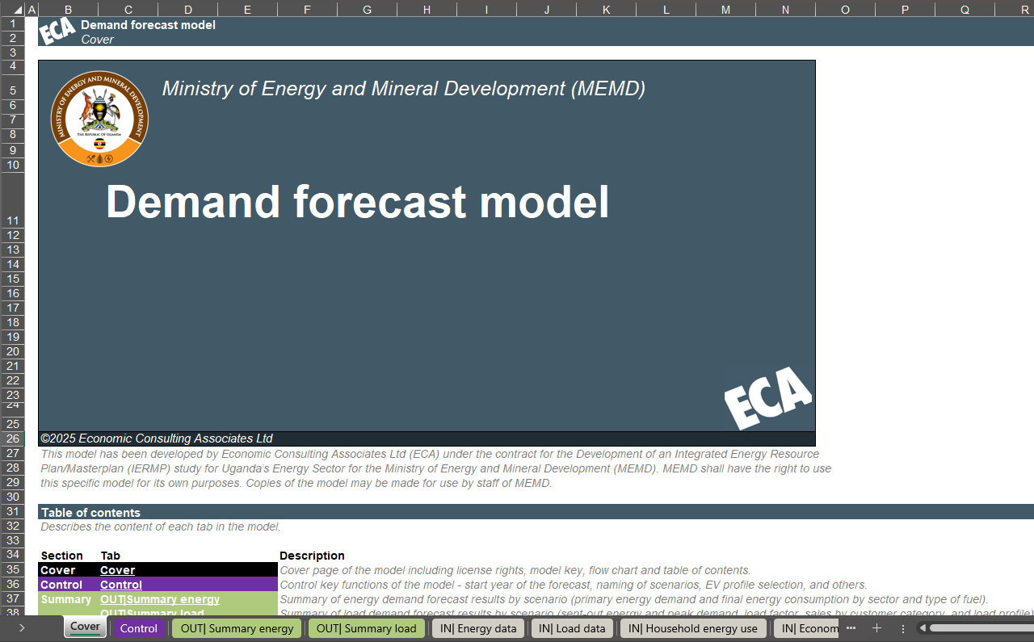
Source: ECA
Figure 73 Demand forecast model summary tabs
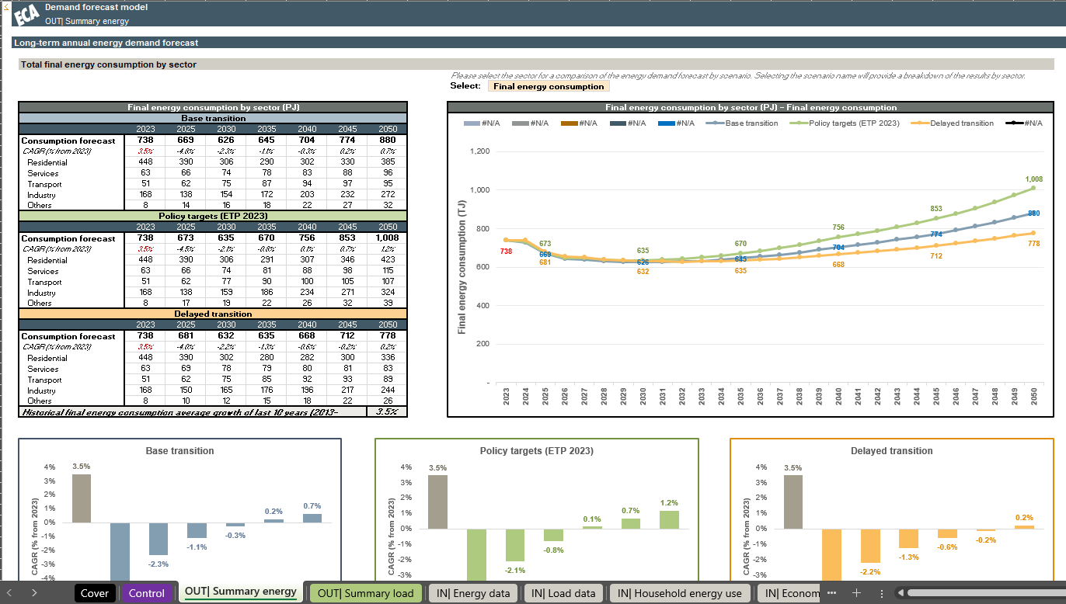

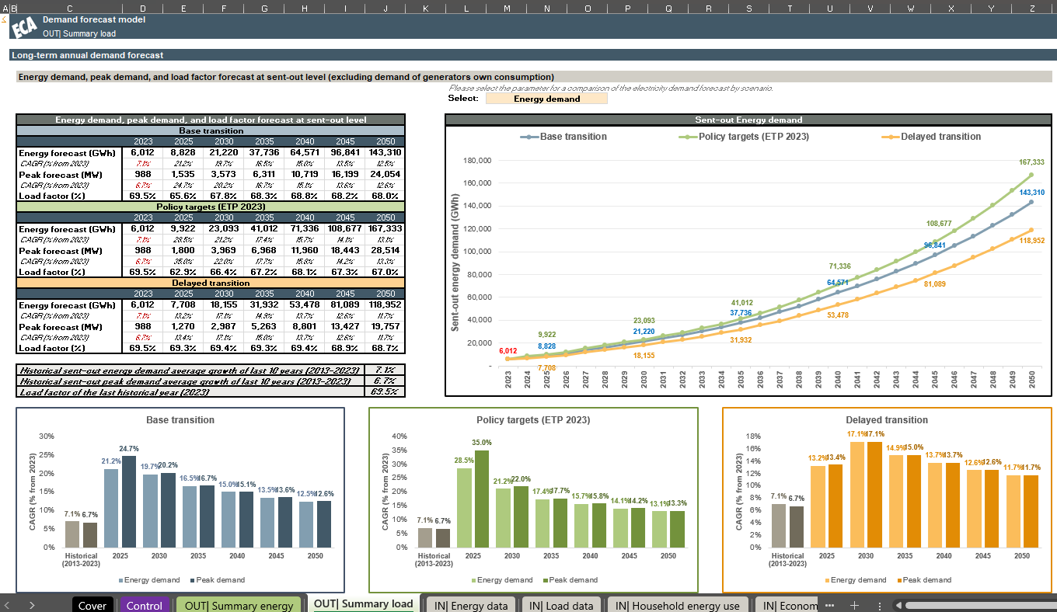

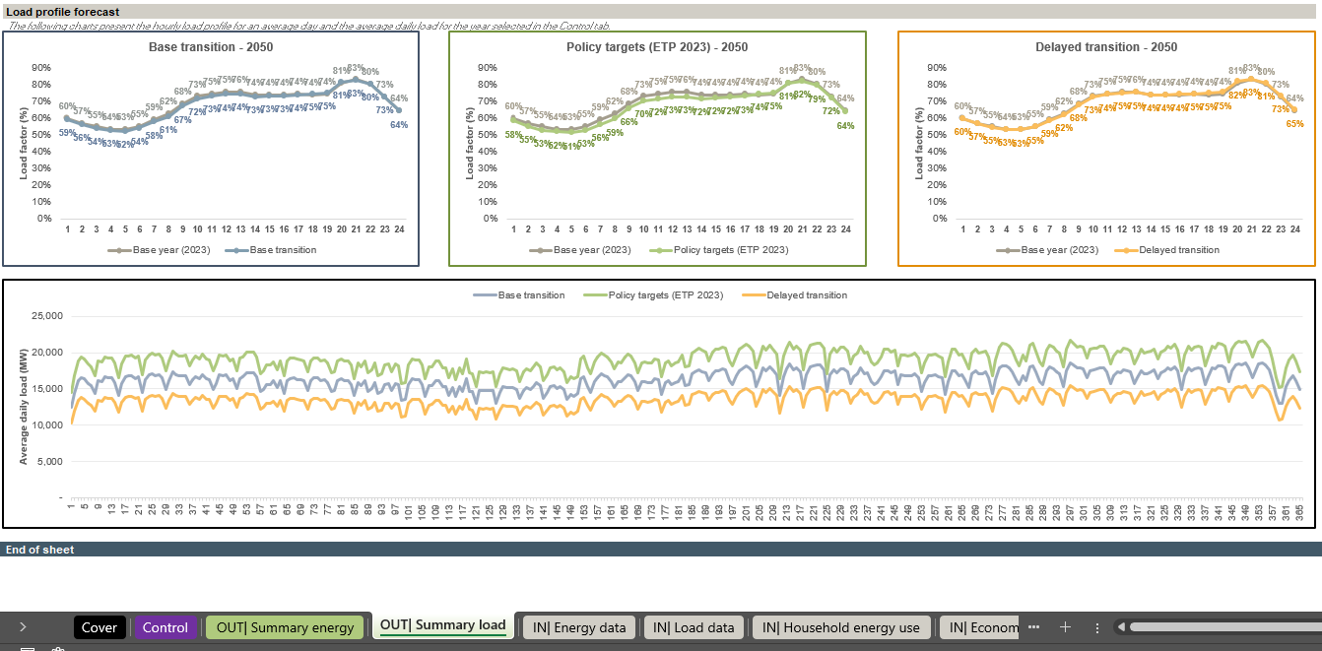
Source: ECA
The model is structured following the FAST standard with inputs separated from calculations and outputs to ensure that the model is easy to use, update, and fix while minimising disruption to the model user. The model is structured as follows:
- Control tab – Contain parameters and conversion factors that will be used throughout the model, this includes the scenario names and the charging profile in use for EVs.
- Input tabs – The following tabs contains all inputs required from the user for the development of the energy and electricity forecasts:
  - IN| Energy data – Includes historical energy balance, forecasted energy intensity by sector (exc. electricity), and forecasted fuel usage ratios.
  - IN| Load data – Includes historical sales and losses, forecasted level of losses and load factor, historical and forecasted number of customers, and load profiles for charging of EVs and for the hourly load in a representative year.
  - IN| Household energy use – Includes cooking patterns and appliance usage data for urban and rural households.
  - IN| Economic data – Includes historical and forecasted GDP by sector, Historical and forecasted exchange and inflation rates, historical and forecasted population growth, household size, and electrification rates; as well as historical and forecasted average electricity tariffs by customer category.
  - IN| Econometric – Includes the definition of explanatory variables, dummy variables, and coefficients for econometric equations to be used in the energy and electricity forecasts as required.
  - IN| Step-loads and DSM – Includes the definition of step-loads, firm export agreements, EV rollout, and DSM measures to be included on top of the electricity demand forecast.
- Calculation tabs – The following tabs contain all the calculations required for the development of the energy and electricity forecasts; no further user inputs are required in these tabs.
  - CALC| Data management – Arranges the input data by scenario for usage in the forecast.
  - CALC| Step-loads and DSM – Calculates the annual impact of DSM measures and other loads on the electricity energy and peak demand forecasts.
  - CALC| Elec sales forecast – Calculates the electricity sales forecast for each customer category based on the approach described in Section 3.4.
  - CALC| Energy cons forecast – Calculates the energy consumption forecast for each sector based on the approach described in Section 3.3.
  - CALC| Energy forecast – Aggregates the electricity demand forecast to calculate the final energy forecast by fuel type for each sector.
  - CALC| Load forecast – Aggregates the sectorial sales forecast with the forecasted losses and contributions of DSM and step-loads to develop the sent-out energy and peak demand forecasts.
  - CALC| Load profile – Forecasts the annual hourly load profile based on the base profile provided in the input tabs, the forecasted energy and peak demand, and the forecasted hourly contribution of EVs.
- Output tabs – The following tabs compile the results from the calculation tabs providing explanatory charts to compare scenarios, no new calculations or inputs are required:
  - OUT| Load forecast – Compiles the results of the electricity demand forecast, including sent-out energy demand, peak demand, load factor, sales, and losses forecast for each scenario.
  - OUT| Energy forecast – Compiles the results of the energy forecast, including forecasts by sector and type of fuel for each scenario.
  - OUT| Summary energy – Provides explanatory charts from the energy demand forecast comparing scenarios and illustrating the evolution of the forecast by sector and type of fuel.
  - OUT| Summary load – Provides explanatory charts from the electricity demand forecast comparing scenarios and illustrating the evolution of the forecast by customer category, as well as the forecasted load profile.
The structure is summarised in the diagram below.
Figure 74 Flow-chart of the demand forecast model
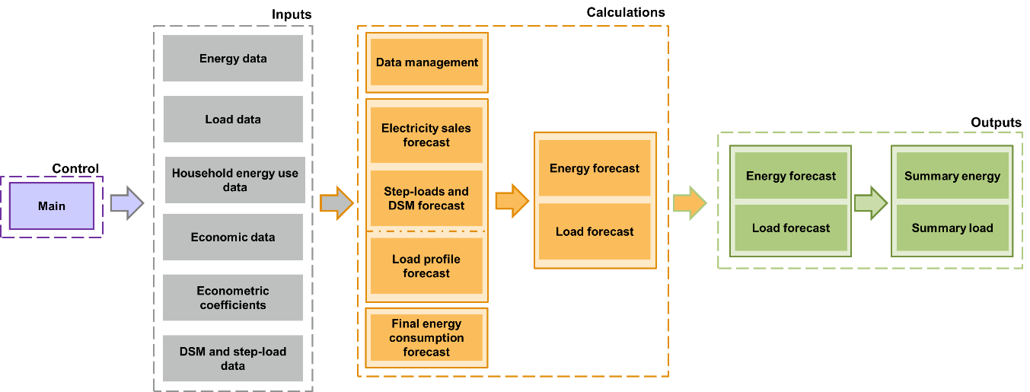
Source: ECA

- Statistical results from the regression analysis
  - Criteria used in the analysis
The assessment of each econometric equation involves a combination of statistical indicators and judgement to ensure that the equation chosen captures the key determinants of demand growth, while also showing the expected impact both in terms of trend and magnitude based on economic theory. For each equation, multiple specifications are tested using known key determinants and dummy variables if any anomalies ought to be considered, then, each specification is assessed following the criteria:
- The variables tested should offer a clear explanation of causality for their impact on demand (e.g. rising incomes allow for increasing purchase of appliances and increased use of existing appliances, or rising prices decrease consumption by reducing the available budget to purchase new appliances or using existing ones).
- The p-value of all variables should ideally be below 5%, with a maximum of 15% allowed for a maximum of one variable if the overall specification presents an adjusted R-squared of above 95% and no better specifications are found.
- The overall statistical significance of the equation measured through the adjusted R-squared should be above 95%.
- The magnitude of the coefficients, which represent the elasticities of each variable, should reflect results similar to those found in other countries.
  - Residential econometric equation
The statistical results of the econometric analysis for the chosen equation for Residential average consumption per household together with a comparison of a historical forecast using the econometric equation against actual sales is shown in the table below.
Table 29 Statistical results for the residential equation
Variables | Coefficients | Std. Error | t-statistic | p-value
Intercept | -21.261 | 7.120 | -2.986 | 0.017
LN(GDP per capita) | 2.143 | 0.501 | 4.279 | 0.003
LN(Domestic customers) | -0.303 | 0.049 | -6.136 | 0.000
LN(Domestic tariff (real, inc only)-1) | -0.153 | 0.089 | -1.716 | 0.124
Adjusted R-squared | 0.976
Source: ECA analysis
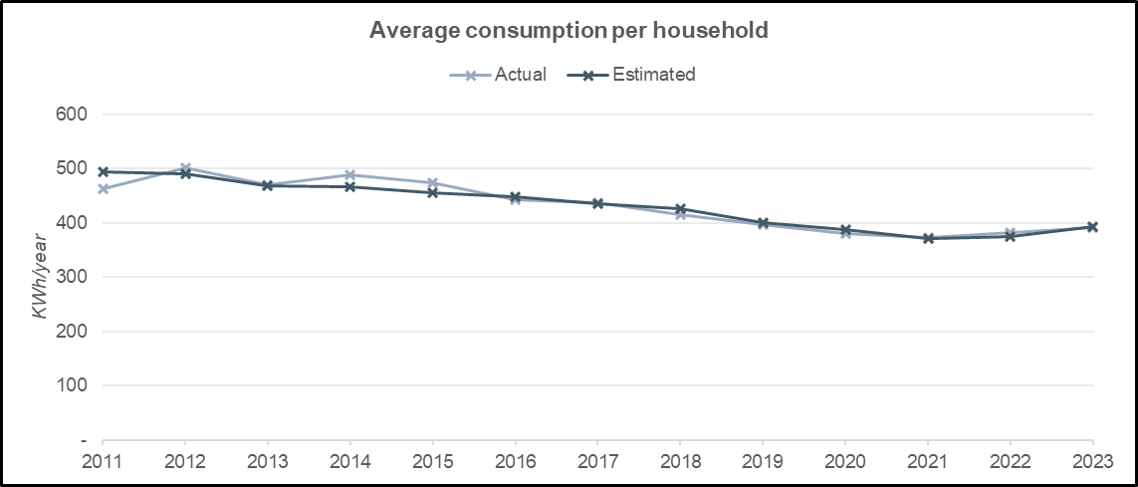
  - Commercial sales econometric equation
The statistical results of the econometric analysis for the chosen equation for commercial sales together with a comparison of a historical forecast using the econometric equation against actual sales is shown in the table below.
Table 30 Statistical results for the commercial sales equation
Variables | Coefficients | Std. Error | t-statistic | p-value
Intercept | -13.429 | 0.892 | -15.049 | 0.000
LN(Services GDP) | 1.867 | 0.148 | 12.572 | 0.000
LN(Commercial tariff (real, inc only)-1) | -0.206 | 0.122 | -1.688 | 0.130
Pandemic | -0.120 | 0.025 | -4.762 | 0.001
2012 commercial sales anomaly | -0.084 | 0.031 | -2.674 | 0.028
Adjusted R-squared | 0.995
Source: ECA analysis
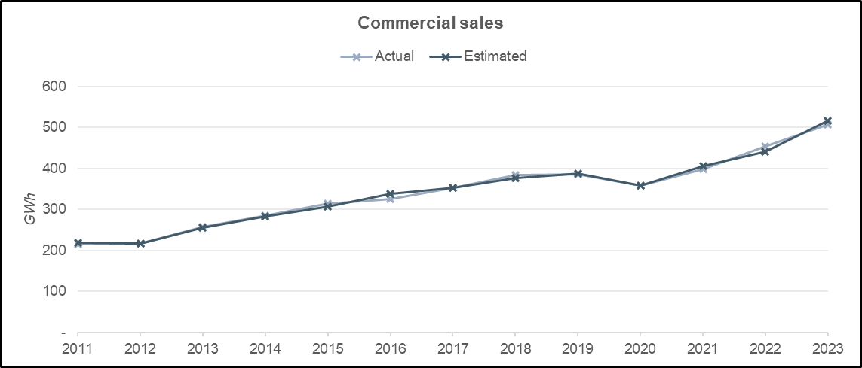
  - Medium industries sales econometric equation
The statistical results of the econometric analysis for the chosen equation for medium industries sales together with a comparison of a historical forecast using the econometric equation against actual sales is shown in the table below.
Table 31 Statistical results for the medium industries sales equation
Variables | Coefficients | Std. Error | t-statistic | p-value
Intercept | -7.918 | 0.605 | -13.084 | 0.000
LN(GDP total) | 1.176 | 0.051 | 23.171 | 0.000
Pandemic | -0.094 | 0.019 | -4.888 | 0.001
Adjusted R-squared | 0.980
Source: ECA analysis
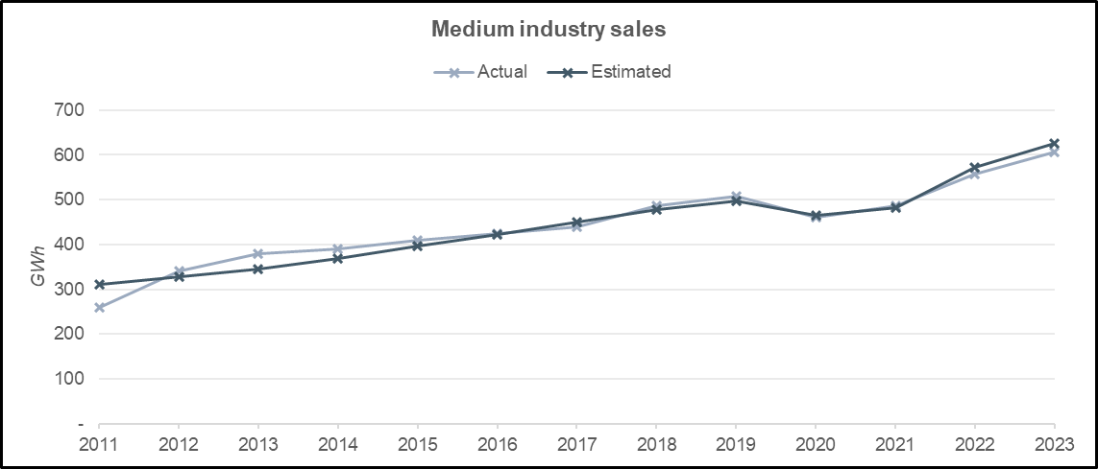
  - Unsuccessful specifications considered in the analysis
Table 31 compiles the econometric model specifications tested for residential, commercial, and medium industries. In most cases, the specifications proved to have too little statistical significance (ie p-value above 10% for all variables in the equation). For others, the magnitude of coefficients vastly exceeded the effect seen in other countries.
Table 32 Unsuccessful models considered in the analysis
Dependent Variable | GDP | Sectorial GDP | GDP per capita | Electricity tariff | Connections | Covid | Population
Average consumption per household per year (kWh/year) | x
 |  |  | x
 |  |  |  |  | x
 |  |  |  |  |  |  | x
 | x |  |  | x
 |  |  | x | X
 |  |  |  | x | X
 |  |  |  | X |  |  | x
 | x |  |  |  |  | x
 |  |  | x |  |  | X
 |  |  |  | x |  | x
 |  |  |  |  | x | x
 |  |  |  |  |  | X | x
 |  |  |  | X |  | x | x
 |  |  | x | x |  | x
 | x |  |  | x |  | X
 |  |  |  | X | x | x
 | x |  |  |  |  | X | x
 | x |  |  | X |  |  | x
 | x |  |  | x | x | X
 | x |  |  |  | x | x
 |  |  |  | X | x |  | x
 |  |  |  | x | X | x | x
Commercial sales (GWh) |  | X
 |  |  | x
 |  |  |  |  | x
 |  |  |  |  |  |  | x
 | x |  |  | x
 |  |  | x | X
 |  |  |  | x | X
 |  |  |  | X |  |  | x
 | x |  |  |  |  | x
 |  |  | x |  |  | X
 |  |  |  | x |  | x
 |  |  |  |  | x | x
 |  |  |  |  |  | X | x
 |  |  |  | X |  | x | x
 |  | X |  |  |  |  | X
 |  | X |  | X
 |  | X |  |  |  | X
 |  | X |  |  | x | x
 |  |  | x | x |  | X
 | X |  |  | x
 | x |  |  |  |  | X
 |  | x |  |  |  |  | x
Medium industrial sales (GWh) |  | X
 |  |  | x
 |  |  |  |  | x
 |  |  |  |  |  |  | x
 | x |  |  | x
 |  |  | x | X
 |  |  |  | x | X
 |  |  |  | X |  |  | x
 | x |  | x |  |  | X
 |  |  | x |  |  | X
 |  |  |  | x |  | X
 |  |  |  |  | x | x
 |  |  |  |  |  | X | x
 |  |  |  | X |  | x | x
 |  | X
 |  | X |  | X
 |  | X |  |  |  | X
 |  | X |  |  | x | x
 |  | x |  | x |  | X
 | X |  |  | x
 | x |  |  | x |  | X
Source: ECA analysis. Note: The lagged explanatory variables described in the table were also considered in all specifications, nominal and real tariffs were also considered

Uganda Energy Transition Plan IEA 2023
The ETP refers to Buildings as a separate demand sector. For the benefit of the reader and to avoid confusion this is often referred to as Households.
Uganda 2023 Energy Policy Review, IEA, 2023
IEA, Uganda Energy transition Plan (ETP) 2023
See Energy Use Survey report developed under the Energy Sector Master Plan in Uganda study.
The results of the Energy Use survey revealed that energy for a typical household in Uganda is used for lighting, cooking and other typical household appliances (eg TV, refrigerator, computers, mobile phone charging, radio, electric fan, iron, kettle, hair dryer, etc).
Includes lighting and heating/cooling, corresponds to the energy equivalent of the forecasted average electricity consumption per household
Includes the categories medium industries, large industries, extra-large industries, as well as any additional sales from upcoming step-loads
No electric vehicles existed in this period in Uganda.
A detailed view of the criteria applied, statistical results, and other econometric specifications tested can be found in Annex A4
By aggregating the demand of the appliances used in a typical urban and rural household.
No decreases are considered, with the average tariff remaining constant if any real-term decrease is observed in historical data
By allowing the consumers to purchase more appliances or by increasing the utilisation of appliances already purchased
No decreases are considered, with the average tariff remaining constant if any real-term decrease is observed in historical data
With secured funding
Potential measure without a current commitment to implement them
At the entry points of the grid.
Following IMF projections up to 2030 and then reflecting the IEA CAGR up to 2040. Between 2040 and 2050 GDP growth slows to 3% to reflect the economy reaching maturity.
Reflecting the historical average growth over the past 10 years until 2030 with a slow-down of the growth until 2050.
World Economic Outlook (October 2024)
Population estimates and projections | DataBank
UBOS did not have any publicly available information for the split of the population to urban and rural.
Uganda - Energy, International Trade Association
Uganda - Countries & Regions - IEA
The IEA 2023 Policy review states that the price of charcoal has tripled over the past 20 years, the corresponding average annual growth rate has been assumed to continue for the forecasted period
Long-Term price and dynamics for LPG markets, 2024, FGE
Uganda’s ethanol producer in $4 million expansion programme – Uganda Investment Authority
Minimum wage - Uganda - WageIndicator.org
A social discount rate of 8% has been assumed, this corresponds to the discount rate used in economic analysis by the South Africa government as stated in Discounting Costs and Benefits in Economic Analysis of World Bank Projects, 2016
The 2023 Energy Policy Review states that no LPG production for cooking is currently taking place in Uganda, with the existing demand being recovered through imports. With the opening of the Tilenga and Kingfisher oil field in 2025, associated gas is planned to be used for power generation for use at the oil field and the remaining to be transformed to LPG to supply the market. The estimated volume of associated gas from Tilenga is 2.5 kb/d, of which half would be allocated to cooking LPG, from Kingfisher 0.5 kb/d, and a new refinery 1.7 kb/d. This results in a maximum LPG for cooking availability of 5,560 TJ nationwide.
Improved Cookstoves and Energy Saving Cooking Equipment
2nd CEER Report on Power Losses - CEER
Potential measure without a current commitment to implement them
This is assumed for 2027 to 2040, growth rates of 35%,47% and 12% are assumed for 2023/24, 2024/25 and 2025/26, respectively.
Uganda Energy Transition Plan. IEA. 2023
The Vision 2040 scenario’s forecasts are not shown graphically as they greatly differ from the other scenarios, with peak demand and gross energy consumption reaching 49,315 MW and 323,997 GWh by 2040, respectively. As explained by the Generation Plan Report 2015, a combination of some very challenging assumptions on the number of generation facilities and nuclear capacity has resulted in the very ambitious nature of the scenario.

